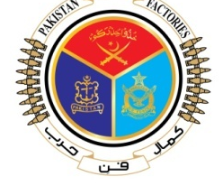 | GOVERNMENT OF PAKISTAN
 | PAKISTAN ORDNANCE FACTORIES
 | WAH CANTT

INVITATION TO BID
- POF Supply Chain Management Department invites sealed bids from the original Manufacturers/authorized Dealers/Suppliers registered with income tax and sales tax Department for supply of Cutting Tools against TE # 0110-LP-CMC-50-Pur-A, dt. 28.03.2022.
- Bidding documents containing itemwise detail, specifications and all other terms & conditions are available for the interested bidders at the office of the undersigned OR can also be downloaded from POF website (www.pof.gov.pk) free of cost.
- The bids completed in all respects, must reach Bid Center adjacent to Rabita Hall on or before 21.04.2022 but not later than closing time
1030 hrs. The Tenders will be opened at 1100 hrs on the same date.

DIRECTOR-SCM
Tele: 051-9055-21088
Fax: 051-9314100
E-Mail: procurement@pof.gov.pk

