CENTRAL ORDNANCE DEPOT – RAWALPINDI
Central Ordnance Depot
Rawalpindi
Tel : GHQ 34729
16 Normal / LP
29 Mar 2022

SUBJECT: INVITATION TO TENDER AND GENERAL INSTRUCTIONS 16 NORMAL 2022

1. DATE AND TIME OF CLOSING OF TENDER IS 13 Apr 2022 UPTO 1030 HOURS.
2. DATE AND TIME OF OPENING OF TENDER IS 13 Apr 2022 AT 1100 HOURS AT THE PREMISES OF CENTRAL ORDNANCE DEPOT RAWALPINDI.
3. RATES ARE INVITED FOR SUPPLY OF ITEMS MENTIONED AT ANX “A” TO THIS TENDER INQUIRY.
4. TERMS AND CONDITIONS GOVERNING BIDDING/PURCHASES AND GENERAL INSTRUCTIONS FOR BIDDERS:-
- THE PURCHASER CAN WAIVE OFF ANY OF THE CONDITIONS STIPULATED IN THIS TENDER INQUIRY AND RESERVES THE RIGHT TO ACCEPT OR REJECT THERETO.
- BIDDERS SHOULD NOTE THAT DECISION OF COMMANDANT CENTRAL ORDNANCE DEPOT RAWALPINDI WILL BE FINAL IN RESPECT OF ACCEPTANCE / REJECTION OF THE OFFERS.
- ALL SAMPLES AND SUPPLIES WILL BE SUBJECT TO TESTS AND INSPECTIONS EITHER BY CONCERNED INSPECTORATES OR A BOARD OF OFFICERS CONSTITUTED FOR THE PURPOSE AND ANY COST INCURRED ON TESTS / INSPECTIONS AND STORES CONSUMED IN THE SAME WILL BE BORNE BY SUPPLIERS. DEPOT MAY TEST/INSPECT SAMPLES BEFORE PLACING OF PURCHASE ORDERS.
- SUCCESSFUL BIDDERS WILL HAVE TO COMPLETE THE SUPPLIES WITHIN PERIOD AS SPECIFIED IN THE PURCHASE ORDERS, FAILING WHICH APPROPRIATE PENALTY AS DECIDED BY COMMANDANT CENTRAL ORDNANCE DEPOT RAWALPINDI WILL BE IMPOSED AND NECESSARY / APPROPRIATE DISCIPLINARY ACTION WILL ALSO BE TAKEN.
- DURING WARRANTY PERIOD (IF STORES) SUPPLIED IS/ARE BACKED BY WARRANTY) IF A FAULTS OCCURS IN SUPPLIED STORES THEN SUPPLIER WILL BE RESPONSIBLE TO EITHER RECTIFY THE FAULTS COMMUNICATED OR GET THE FAULTY PARTS REPLACED WITH IN 7 (SEVEN) DAYS OF RECEIPT OF INFORMATION IN THIS REGARD FROM THE PURCHASER AT HIS SPECIFIED PLACES WHICH CAN BE OTHER THAN THE PLACE OF DELIVERY OF STORES. IN CASE SUPPLIER FAILS TO RECTIFY THE FAULTS OR REPLACE THE FAULTY PARTS IN A SPECIFIED TIME THAN PURCHASER WILL HAVE THE RIGHT TO TAKE DISCIPLINARY ACTION AGAINST THE SUPPLIER AND ALSO IMPOSE PENALTY IF CONSIDERED NECESSARY/ APPROPRIATE.
- DURING WARRANTY PERIOD IT WILL BE THE RESPONSIBILITY OF THE SUPPLIER TO CARRY OUT PERIODIC MAINTENANCE OF SUPPLIED STORES AS PRESCRIBED BY THE MANUFACTURERS FREE OF COST AT PURCHASER’S SPECIFIED PLACES WHICH CAN BE OTHER THAN THE PLACE OF DELIVERY OF STORES.
- SAMPLE AND STORE OFFERED WOULD BE BRAND NEW, UNUSED, AS PER APPROVED SPECIFICATIONS, DRAWING AND SAMPLES WHERE APPLICABLE.
- IN CASE OF AN ITEM HAS NO SPECIFICATIONS, DRAWING OR APPROVED SAMPLE THEN A BOARD OF OFFICERS APPOINTED FOR THE PURPOSE

- WILL DECIDE ITS ACCEPTABLE STANDARDS.
- MAKE / MODEL / BRAND AND COUNTRY OF ORIGIN OF STORES MUST BE MENTIONED WHERE APPLICABLE.
- MANUFACTURER CERTIFICATE OF BRANDED ITEMS MUST BE PROVIDED.
- PRICES / RATES WILL BE QUOTED ON DELIVERY BASIS AT LOCATIONS AS MENTIONED IN PARA 4 ABOVE.
- PRICES / RATES QUOTED MUST BE INCLUSIVE OF ALL APPLICABLE TAXES / DUTIES.
- PRICES / RATES QUOTED MUST BE AS PER ACCOUNTING UNIT.
- MORE THAN ANY MANUFACTURE/MODEL MAY ALSO BE QUOTED GIVING SEPARATE PRICE OF EACH MANUFACTURE/MODEL.
- PRICES/RATES WILL BE QUOTED IN PAKISTANI CURRENCY.
- PRICES/RATES QUOTED WILL BE APPLICABLE TO COMPLETE ZONE.
- PRICES / RATES QUOTED WILL BE VALID FOR SIX MONTHS FROM DATE OF OPENING OF TENDERS.
- BID SECURITY / PERFORMANCE GUARANTEE MAY BE ASKED, IF REQUIRED. SUCCESSFUL BIDDERS WILL HAVE TO SUPPLY STORES AS PER PRICES / RATES QUOTED FOR SIX MONTHS FROM DATE OF OPENING OF TENDER’S OR ELSE APPROPRIATE DISCIPLINARY ACTION WILL BE TAKEN AGAINST THE FIRM.
- DRAWING OF SAMPLES FOR TEST/INSPECTION FOR ACCEPTANCE OF STORES TO BE SUPPLIED AGAINST PURCHASE ORDERS FOR TEST / INSPECTION PROCESSES WILL ONLY COMMENCE WHEN COMPLETE / ORDERED QUANTITIES HAS BEEN SUPPLIED.
- PART DELIVERY / PART PAYMENT WILL NOT BE ACCEPTED / MADE.
- PAYMENT WILL BE MADE AFTER ACCEPTANCE OF ORDERED STORES.
- IF STORES ARE NOT DELIVERED WITHIN DELIVERY PERIOD, PENALTY WILL BE IMPOSED.
- ITEMS SHOULD BE PACKED PROPERLY AT THE TIME OF DELIVERY.

5. SPECIAL INSTRUCTIONS.
- AS FAR AS POSSIBLE PRICE(S) / RATE(S) MUST BE QUOTED AGAINST EACH ITEM, WHERE PRICES / RATES ARE NOT BEING QUOTED THIS SHOULD BE REFLECTED BY WORDS “NOT QUOTED”.
- LIST OF STORE(S) (HARD COPY) WILL BE SUBMITTED DULY TYPED, (NOT HAND WRITTEN) SIGNED AND DULY STAMPED ON EACH PAPER OR ELSE OFFER WILL BE REJECTED.
- PRICES / RATES QUOTED MUST BE TYPED AND NOT HAND WRITTEN ON HARD COPY OR ELSE OFFER WILL BE REJECTED.
- QUOTED RATES ARE ONLY VALID ON FIRM’S LETTER HEAD.
- NO CHANGE SHOULD BE MADE IN SOFT COPY OF TENDER INQUIRY PROVIDED (LIST OF STORES AND BIDDERS SHOULD FILL PRICES) / RATES IN FRONT OF THE ITEMS WITHOUT DELETING / AMENDING ANY COLUMN / ROW AND WITHOUT DISTURBING THE SERIAL NUMBERS.
- THE BID AGAINST ITEMS AT SERIAL 1, 2, 3, 4, 5 & 6 TO ANNEXURE A SHALL COMPRISE TWO SEPARATE ENVELOPES. EACH ENVELOPE SHALL CONTAIN SEPARATELY THE FINANCIAL PROPOSAL AND THE TECHNICAL PROPOSAL.
- THE ENVELOPES SHALL BE MARKED AS “FINANCIAL PROPOSAL” AND “TECHNICAL PROPOSAL” IN BOLD AND LEGIBLE LETTERS TO AVOID CONFUSION. INITIALLY, ONLY THE ENVELOPE MARKED “TECHNICAL PROPOSAL” SHALL BE OPENED.
- THE ENVELOPE MARKED AS “FINANCIAL PROPOSAL” SHALL BE OPENED AFTER ACCEPTANCE OF “TECHNICAL PROPOSAL”.
6. PURCHASER’S RIGHT. PURCHASER DOES NOT PLEDGE TO ACCEPT THE LOWEST OR ANY TENDER AND RESERVES THE RIGHT OF ACCEPTING THE WHOLE OR ANY PART OF THE OFFER MADE.
7. DELIVERY OF TENDER. THE OFFER IS TO BE SUBMITTED AS PER PARA 5 OF THE TENDER INQUIRY.

8. DATE AND TIME OF RECEIPT OF TENDER. YOUR TENDER MUST REACH THIS DEPOT / DROPPED IN TENDER BOX PLACED AT FORT GATE COD RAWALPINDI BY TIME AND DATE AS SPECIFIED IN PARA 1 ABOVE. THIS OFFICE WILL NOT ACCEPT ANY EXCUSE OF DELAY OCCURRING IN POST. TENDERS RECEIVED AFTER THE APPOINTED / FIXED TIME WILL NOT BE ENTERTAINED. THE APPOINTED TIME WILL FALL ON NEXT WORKING DAY IN CASE OF CLOSED / FORCED HOLIDAY.

LIEUTENANT COLONEL
LOCAL PURCHASE OFFICER
(MUNEEB KHALID)

Anx A
TENDER 16 NORMAL 2022 - COD RWP
Ser | Nomenclature | A/U | Qty | Rate | Remarks
 | Red Box 4000 | Nos | 02 |  | Technical Specification  - 1500 Amps during Starting, 28V DC.
 | Hel Compressor Wash Kit | Nos | 03 |  | Technical Specification  - Gen purpose compressor wash cleaning kit. Uses two pressurized tanks for water and cleaning solvent. Comprises of high water jet nozzle. Hose length of 50 ft. Water capacity of 20 ltrs each tank. Operating power of 220V or 12V DC.
 | Hel Main Rotors Blades Stand | Nos | 02 |  | Technical Specification  - Gen purpose main rotor blade stand. Each stand shall have min 4 trestles with padding. Length 35 ft. Min 5 blades.  - Sample available at Army Aviation base Dhamial.
 | Hel Tail Rotors Blades Stand | Nos | 05 |  | Technical Specification  - Gen purpose main rotor blade stand. Each stand shall have min 3 trestles with padding. Length 6ft. Min 5 blades.  - Sample available at Army Aviation base Dhamial.
 | Marshaling Torch (Set) | Nos | 10 |  | Technical Specification  - Battery operated marshaling torches Green and red color. 3 ft length.
 | IPLEX Borescope Kit / IPLEX Digital Video Recorder | Nos | 01 |  | Technical Specification  - High Resolution 6.3” Display. Cast Magnesium alloy Chassis for impact resistance. Wt up to 12 Lbs. Portable / Lt wt. Lithium-ion-bty. Op time 2.5 hrs.

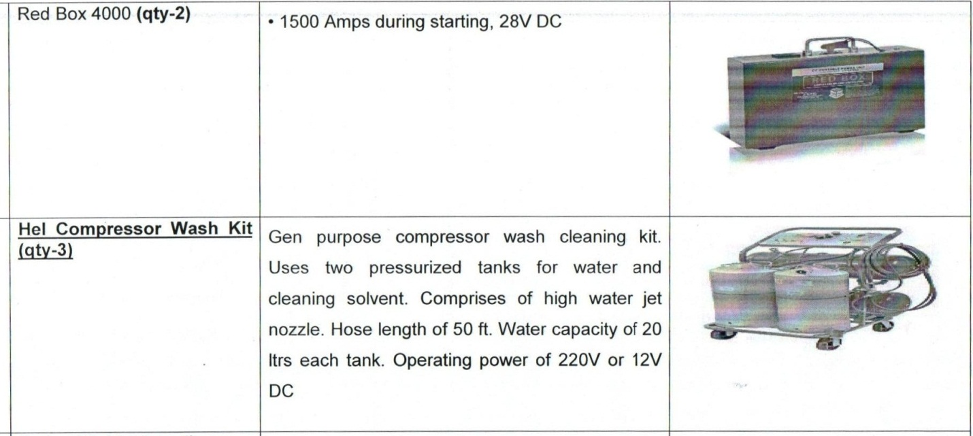
Specification Of serial No 1 & 2
Specification Of serial No 3 & 4
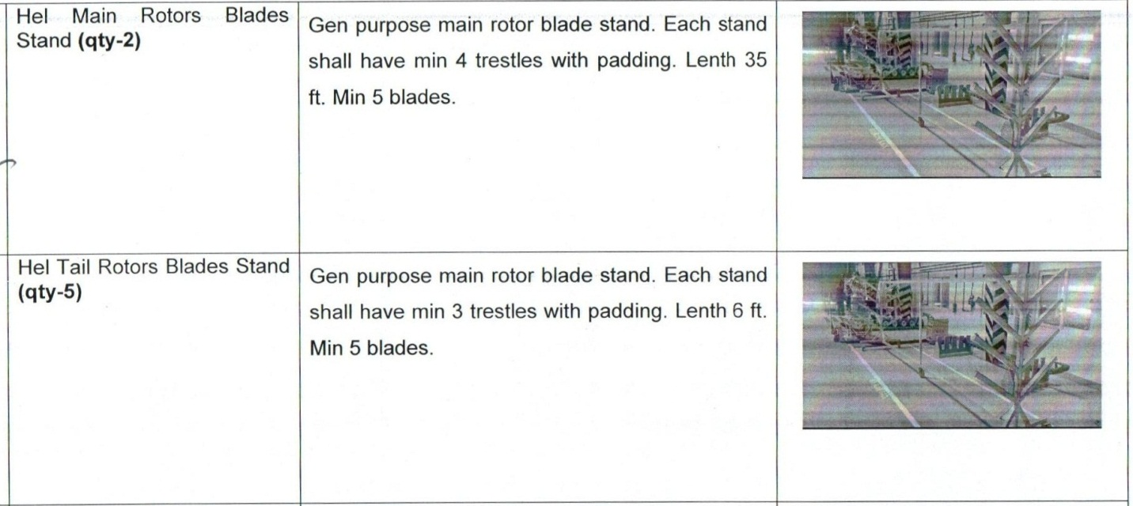

Specification Of serial No 5
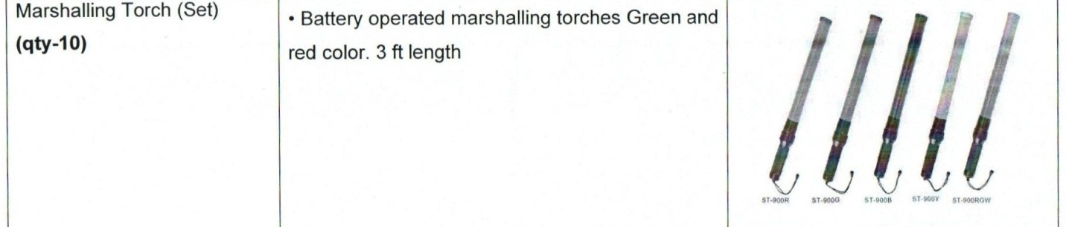
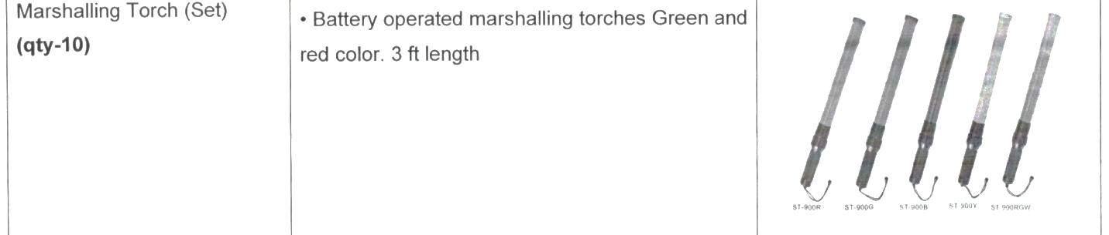

Specification Of serial No 6
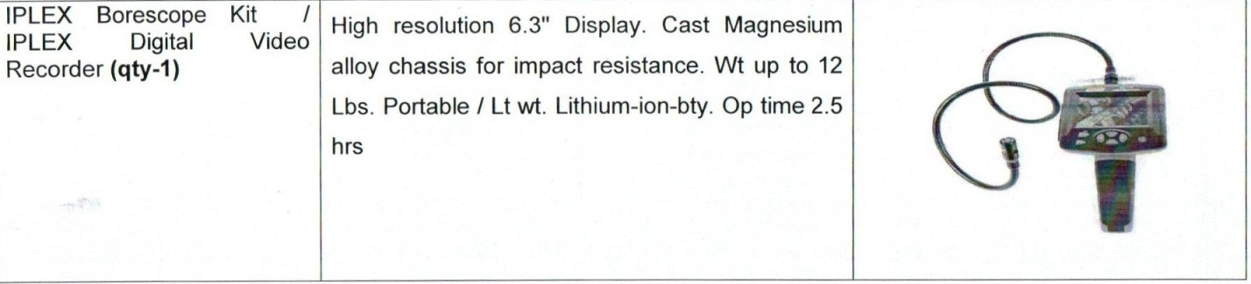

CERTIFICATE

To: ISPR
Info: Creative Junction News Agency Pvt Ltd
Subj: Advertisement
Attached tender notice is forwarded herewith for publish in English and Urdu Newspaper by 30 Mar 2022 please.

Central Ordnance Depot
Rawalpindi | Lieutenant Colonel
Tel: GHQ: 34729 | Local Purchase Officer
16 Normal/LP dated 29 Mar 2022 | (Muneeb Khalid)

ٹینڈر نوٹس
سنٹرل آرڈنینس ڈپو راولپنڈی کی تمام رجسٹرڈ فرموں سےمتفرق سٹورز کی خریداری کیلئے سربمہر ٹینڈرمطلوب ہے۔سٹور کی تفصیل پیپراکی ویب سائیڈ پر موجود ہے۔ ٹینڈر کھلنے کی تاریخ مورخہ 13 اپریل 2022 صبح 11:00 تک ہے۔۔ ٹینڈر 13 اپریل 2022 صبح 1030 بجےتک جمع کروائے جاسکتے ہیں۔
لوکل پرچیز آفیسر/سنٹرل آرڈنینس ڈپوراولپنڈی،
فون نمبر34729- 561
موبا ئل نمبر 03215314791
Central Ordnance Depot
Rawalpindi | Lieutenant Colonel
Tel: 34729 | Local Purchase Officer
16 Normal/LP dated 29 Mar 2022 | (Muneeb Khalid)

TENDER NOTICE

1. Central Ordnance Depot (COD) Rawalpindi invites sealed bid from registered Firms with this Depot for supply of misc stores for which details are available on PPRA website.
2. Tender will open at 1100 hrs on 13 Apr 2022.
3. Tender deposit before at 1030 hrs on 13 Apr 2022.

Contact:
Local Purchase Officer
Central Ordnance Depot Rawalpindi
Contact Mob No: 0321-5314791.
Phone No: 561-34729

Central Ordnance Depot
Rawalpindi | Lieutenant Colonel
Tel: 34729 | Local Purchase Officer
16 Normal/LP dated 29 Mar 2022 | (Muneeb Khalid)

