 |  | MOST IMED
 |  | Garrison Engineer (Army)-II
 |  | Bahawalpur Cantt
 |  | Tel: 35187
 |  | No 6000/ /E6
 |  | 25 Mar 2022
To: | HQ 31 Corps - PR Branch
Subj: | Publication of Tender

1. Please arrange publication of the attached Notice of Tender under classified columns of leading daily News Papers “Nawa-e-Waqat” Multan in Urdu and “The Nation” Lahore in English on 28 Mar 2022 in the lt of Govt of Pak policy ltr already fwd vide CMES (A) Bwp ltr no 6044-A/71/E-6 dated 3 Jan 2011.
2. Following is cfm that:-
a. | Date of insertion | - | 28 Mar 2022
b. | Size of Colour of advt | - | 12x3 (B/W)
c. | Language of advt | - | Nawa-e-Waqt Multan (Urdu) and The Nation Lahore (English)
d. | Contact no | - | 062-89135187
e. | Loc | - | Ord
f. | Stas for pub of advt | - | Bahawalpur
g. | Designing | - | NA
h. | Budgetary constraints | - | NA
3. It is added that:-
a. Necessary funds are available to meet the entire cost of the advertisement.
b. Payment to respective parties will be promptly made on receipt of relevant bill.
4. Also arrange publication at PPRA website of the attached notice of tender if deemed necessary, please.

MILITARY ENGINEER SERVICES – NOTICE OF TENDER
1. Applications are invited by the Garrison Engineer (Army)-II Bahawalpur Cantt up to 11 Apr 2022 for issue of Tender to carry out the following works. Tender documents must reach to this office on 18 Apr 2022 at 1130 hrs and tender will be opened at 1200 hrs on the same date:-
Description of Work
- Const works and Provn of Misc Facilities
- Repair / Maint / Renovation Works and Addition / Alteration works at Different Locations.
- TC / DC works under AOR of GE (A)-II Bwp

2. Firms / Contractors borne on approved list ‘C’ & ‘B’ and above of MES having experience of this type of work may apply.
3. Firms / Contractor borne on approved list of MES will furnish with their applications proof of their being on approved list of MES and statement of previous experience giving details of similar works executed in the last two years and in hand on the proforma appended below:-
Ser | Name of Works Executed during Last Two Years and in Hand | Amount of Work | Time Allowed in Months | Date of Commencement | Date of Completion | Percentage / Progress of Works in hand

Contact No. 062-891-35187

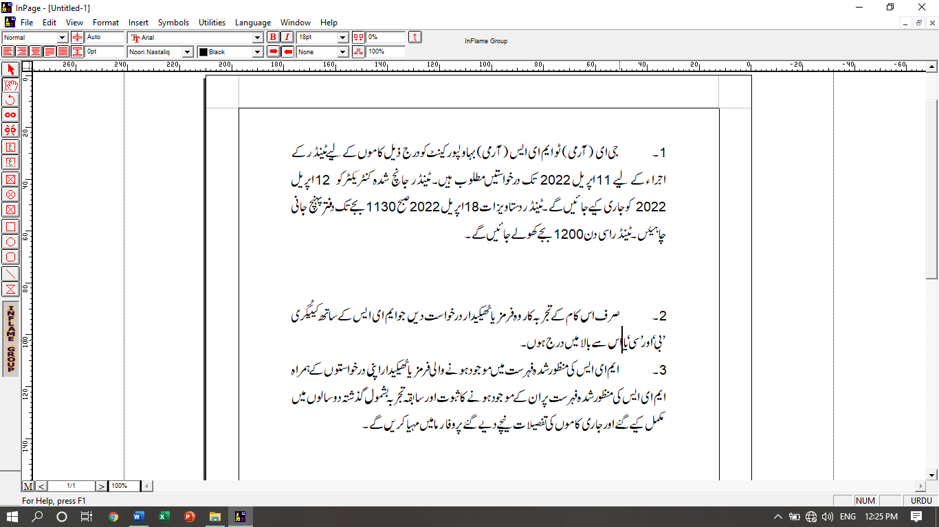

Description of Work
- Const works and provn of Misc Facilities
- Repair / Maint / Renov works and addition / alteration work at different location
- TC/DC works under AOR of GE (A)-II Bwp

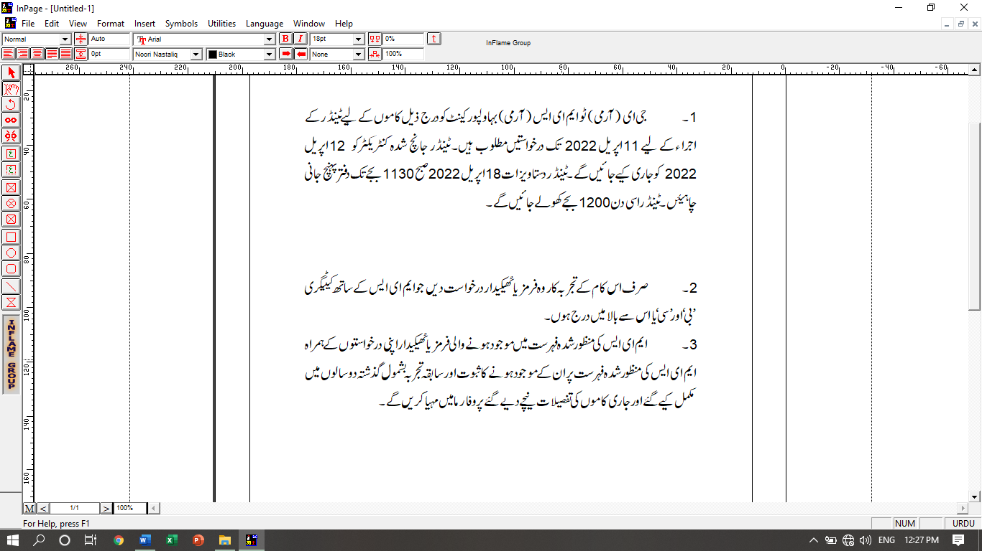

Ser | Name of Works Executed during last 2 years and in hand | Amount of Work | Time Allowed in months | Date of Commencement | Date of Completion | Percentage / Progress of work in hand

