GOVERNMENT OF PAKISTAN

PAKISTAN ORDNANCE FACTORIES

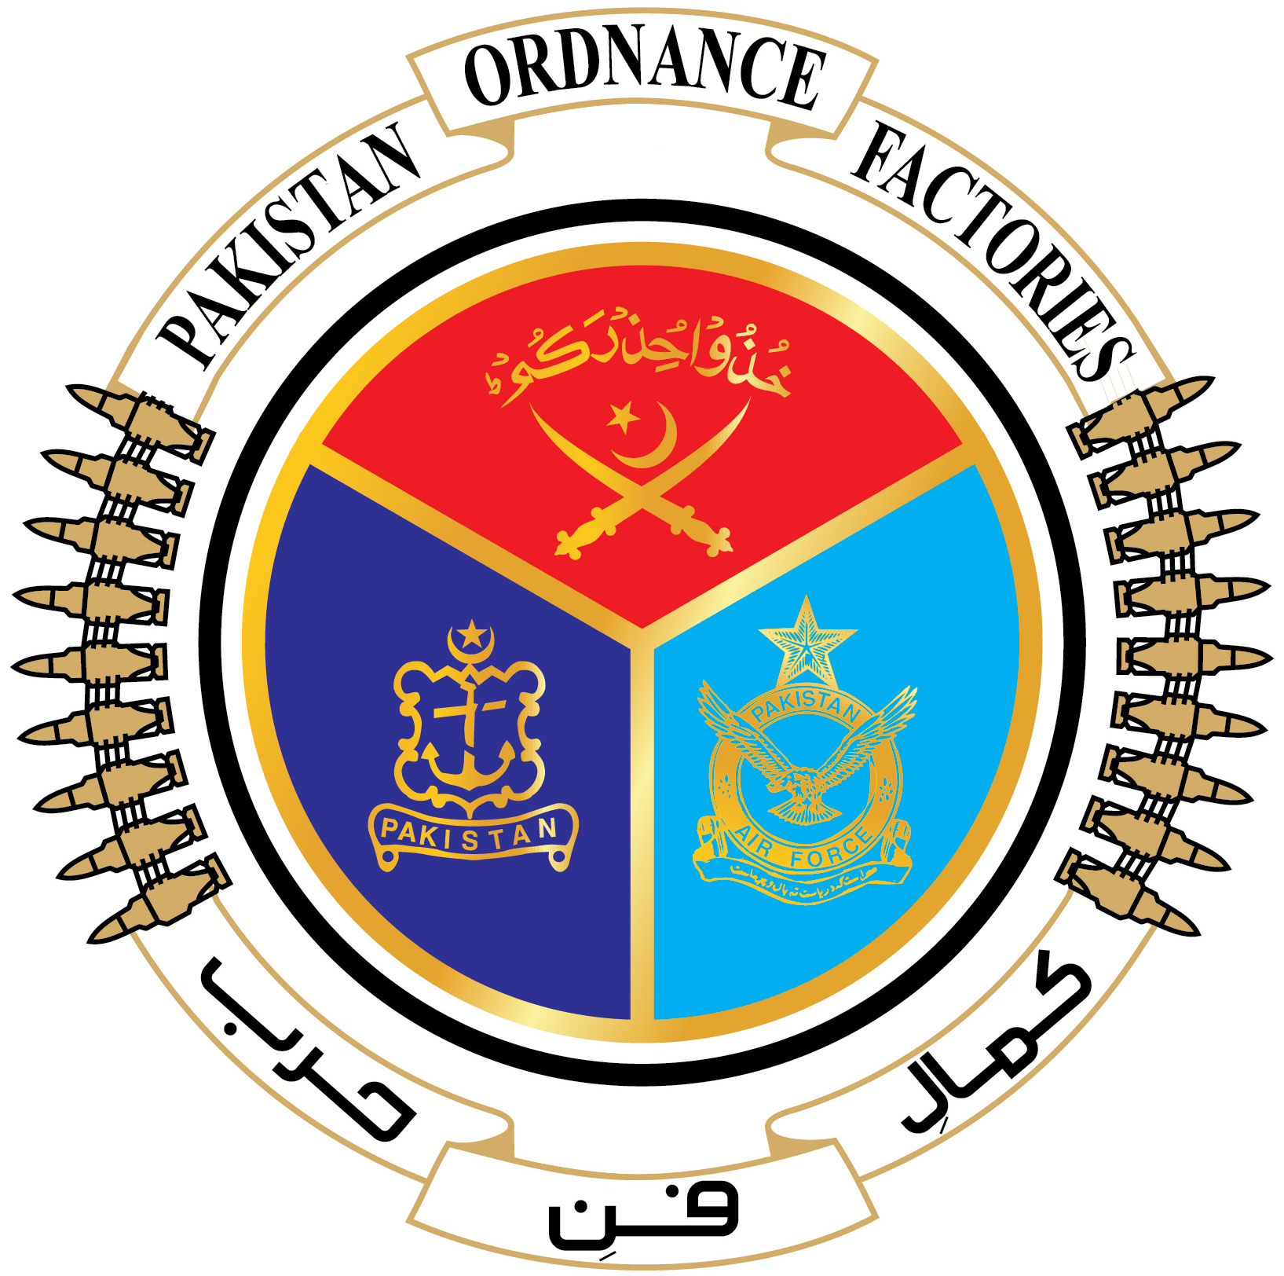
WAH CANTT

INVITATION TO BID

1. POF-Machine Gun Factory invites sealed bids from the original Manufacturers/ authorized Dealers/Suppliers registered with income tax and sales tax Department for supply of Metal Ferrous (03x items) against T.E No.0001-FP-50-PUR-MGFy,
dated 30.03.2022.

2. Bidding documents containing item wise detail, specifications and all other terms & conditions are available for the interested bidders at the office of the undersigned OR can also be downloaded from POF website www.pof.gov.pk free of cost.

3. The bids completed in all respects, must reach Bid Centre adjacent to Rabta Hall POF Wah Cantt on or before 11.05.2022 but not later than closing time 1030 Hrs. Tenders will be opened at 1100 Hrs on the same date.

--xxsdxx--
M.D -Machine Gun Factory
Tel: +92-51-9055-22125
Fax: +92-51-9314100/9271400 E-mail: mdmgf@pof.gov.pk

