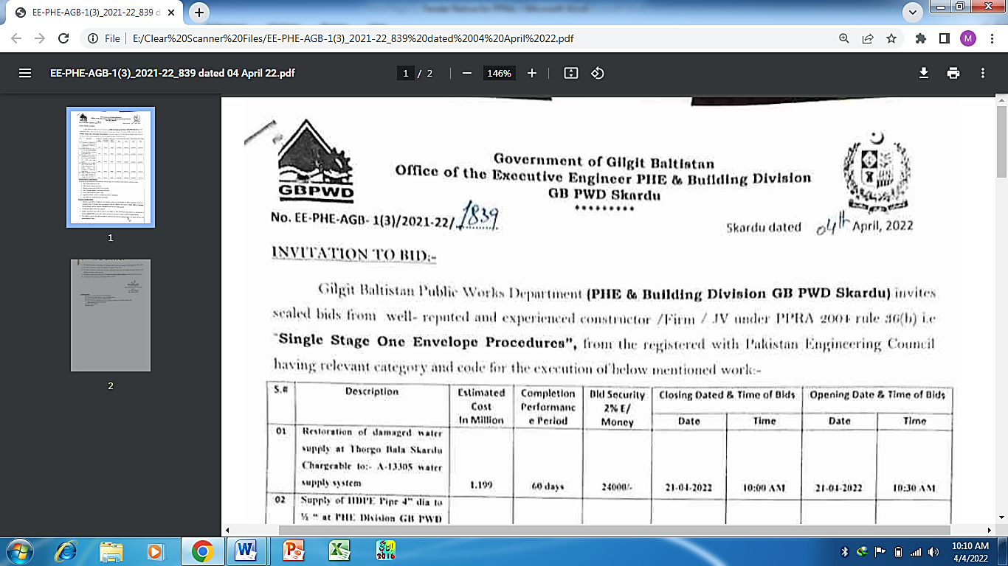

INVITATION TO BID:-

Gilgit Baltistan Public Works Department (PHE & Building Division GB PWD Skardu) invites sealed bids from well- reputed and experienced constructor /Firm / JV under PPRA 2004 rule 36(b) i.e “Single Stage One Envelope Procedures”, from the registered with Pakistan Engineering Council having relevant category and code for the execution of below mentioned work:-
S.# | Description | Estimated Cost  In Million | Completion Performance Period | Bid Security 2% E/ Money | Closing Dated & Time of Bids |  | Opening Date & Time of Bids
 |  |  |  |  | Date | Time | Date | Time
01 | Restoration of damaged water supply at Thorgo Bala Skardu Chargeable to:- A-13305 water supply system | 1.199 | 60 days | 24000/- | 21-04-2022 | 10:00 AM | 21-04-2022 | 10:30 AM
02 | Supply of HDPE Pipe 4” dia to ½ “ at PHE Division GB PWD Skardu Chargeable to:- A-13305 water supply system | 1.993 | 60 days | 40000/- | 21-04-2022 | 11:00 AM | 21-04-2022 | 11:30 AM
03 | Providing & Fixing of Pipe at Kushmarah Gond and Hargissa Near Storage Tank Chargeable to:- A-13305 water supply system | 0.948 | 60 days | 18968/- | 21-04-2022 | 01:00 PM | 21-04-2022 | 01:30 PM
04 | Replacement of 3” dia HDPE Pipe at Kacho Haider Khan Chowk to Bismillah ICE Cream Chowk Skardu Char Chargeable to:- A-13305 water supply system | 0.750 | 60 days | 15000/- | 22-04-2022 | 10:00 AM | 22-04-2022 | 10:30 AM
05 | Supply of Material of Existing water supply Installation in Roundu Valley. Chargeable to:- A-13305 water supply system | 0.786 | 60 days | 16500/- | 22-04-2022 | 11:00 AM | 22-04-2022 | 11:30 AM
MANDATROY CONDITIONS:
The bidder shall be screened out in the preliminary checking subject to not fulfillment of all conditions, rendered as under:
- PEC valid registration for CFY.
- PEC relevant Category and Code.
- Receipt of renewal fee for 2021-22 (in original).
- NOC “No Sick Project” from Works Secretariat
- CNIC of the Prospective bidder / firm.
- Signature of bidder / witness on bidding documents is mandatory.
- Late submission of bid will not be entertained.
TERM & CONDITIONS:
- The bid security 2% of Engineers cost estimate in form of Call Deposit or Bank Guarantee issued by a scheduled bank of Pakistan duly accompanied with the TB/Bid in the name of XEN PHE & Building Division Skardu valid for a period of 28 days beyond the bid validity period.
- Conditional tenders shall not be accepted.
- Tenders documents shall only be issued to the bidders or their authorized representative on production of his/her original CNIC having valid / registered power of attorney in original and 2% Earnest Money.
- The employer reserves the right to accept or reject any bid and the bidding process and reject all bids with reasons thereof (if any).
- The approved policy of Guidelines for bidding Tenders issued by Secretory Works department GB / PAO circulated vide letter no. Sec-SO-D-9(28)2021-22 dated 20th Oct, 2021.
- No bidder is allowed to offer item wise rate on Schedule items rate in the bidding documents otherwise his bidding documents will be rejected.
- Bid shall be opened in the office of the "Executive Engineer PHE & Building" Division GB PWD Skardu.
- Any tenders with correction / overwriting shall be rejected.

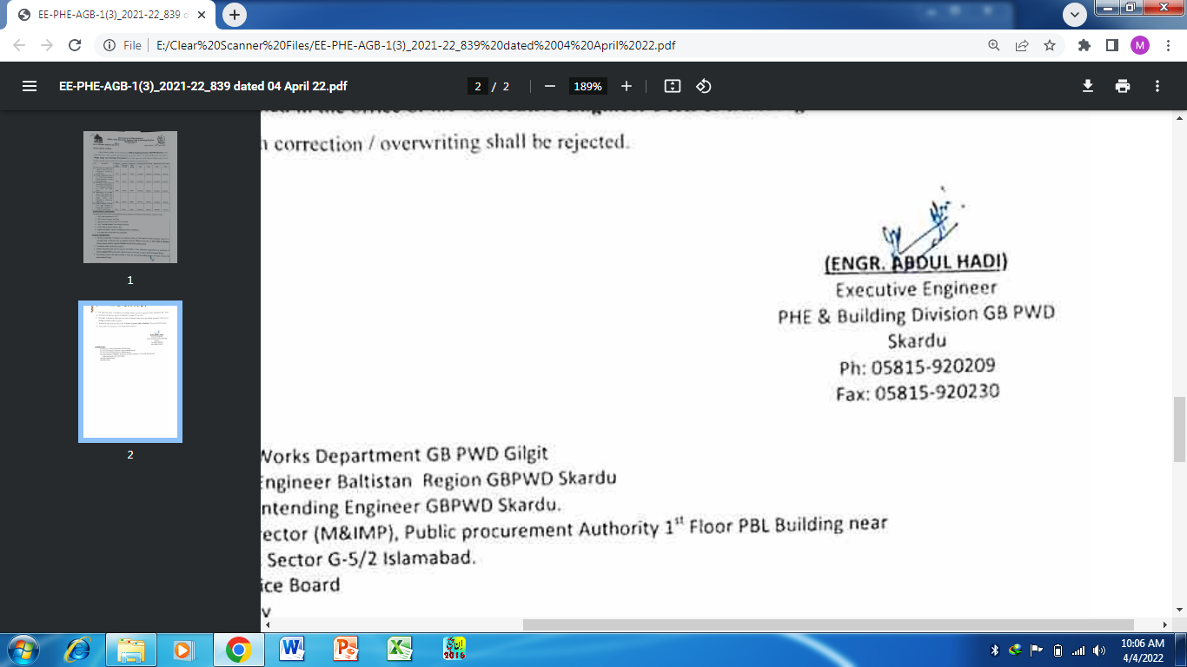

DISTRIBUTIONS:-
- Secretory Works Department GB PWD Gilgit
- The Chief Engineer Baltistan Region GBPWD Skardu
- The Superintending Engineer GBPWD Skardu.
- Deputy Director (M&IMP), Public procurement Authority 1st Floor PBL Building near
State Bank Sector G-5/2 Islamabad.
- Office Notice Board
- Office Copy

