PPRA/POF WEBSITES & PRINT MEDIA

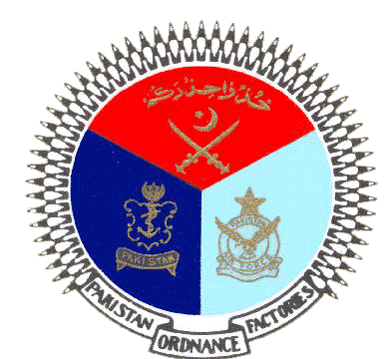 | GOVERNMENT OF PAKISTAN
 | PAKISTAN ORDNANCE FACTORIES
 | WAH CANTT

INVITATION TO BID

- POF-AA Factory invites sealed bids from the original Manufacturers/authorized Dealers/Suppliers registered with income tax and sale tax department for supply of Pure Al. Ingot & Al. Mg Master Alloy (qty.02 Items) against TE No. 0002-LP-B-52-P-AA, Dt.06-04-2022.

2. Bidding documents containing item wise detail, specifications and all other terms & conditions are available for the interested bidders at the office of the undersigned OR can also be downloaded from POF website (www.pof.gov.pk) free of cost.
3 The bids completed in all respects, must reach on or before
28-04-2022 but not later than closing time 1100 hrs. The tenders will be opened at 1130 hrs on the same date.

Managing Director
Artillery Ammunition Factory
Tele:051-9055-21035 Fax #.0092-51-9271400
E-Mail.mdaa@pof.gov.pk 06-04-2022

