PPRA / POF WEBSITE
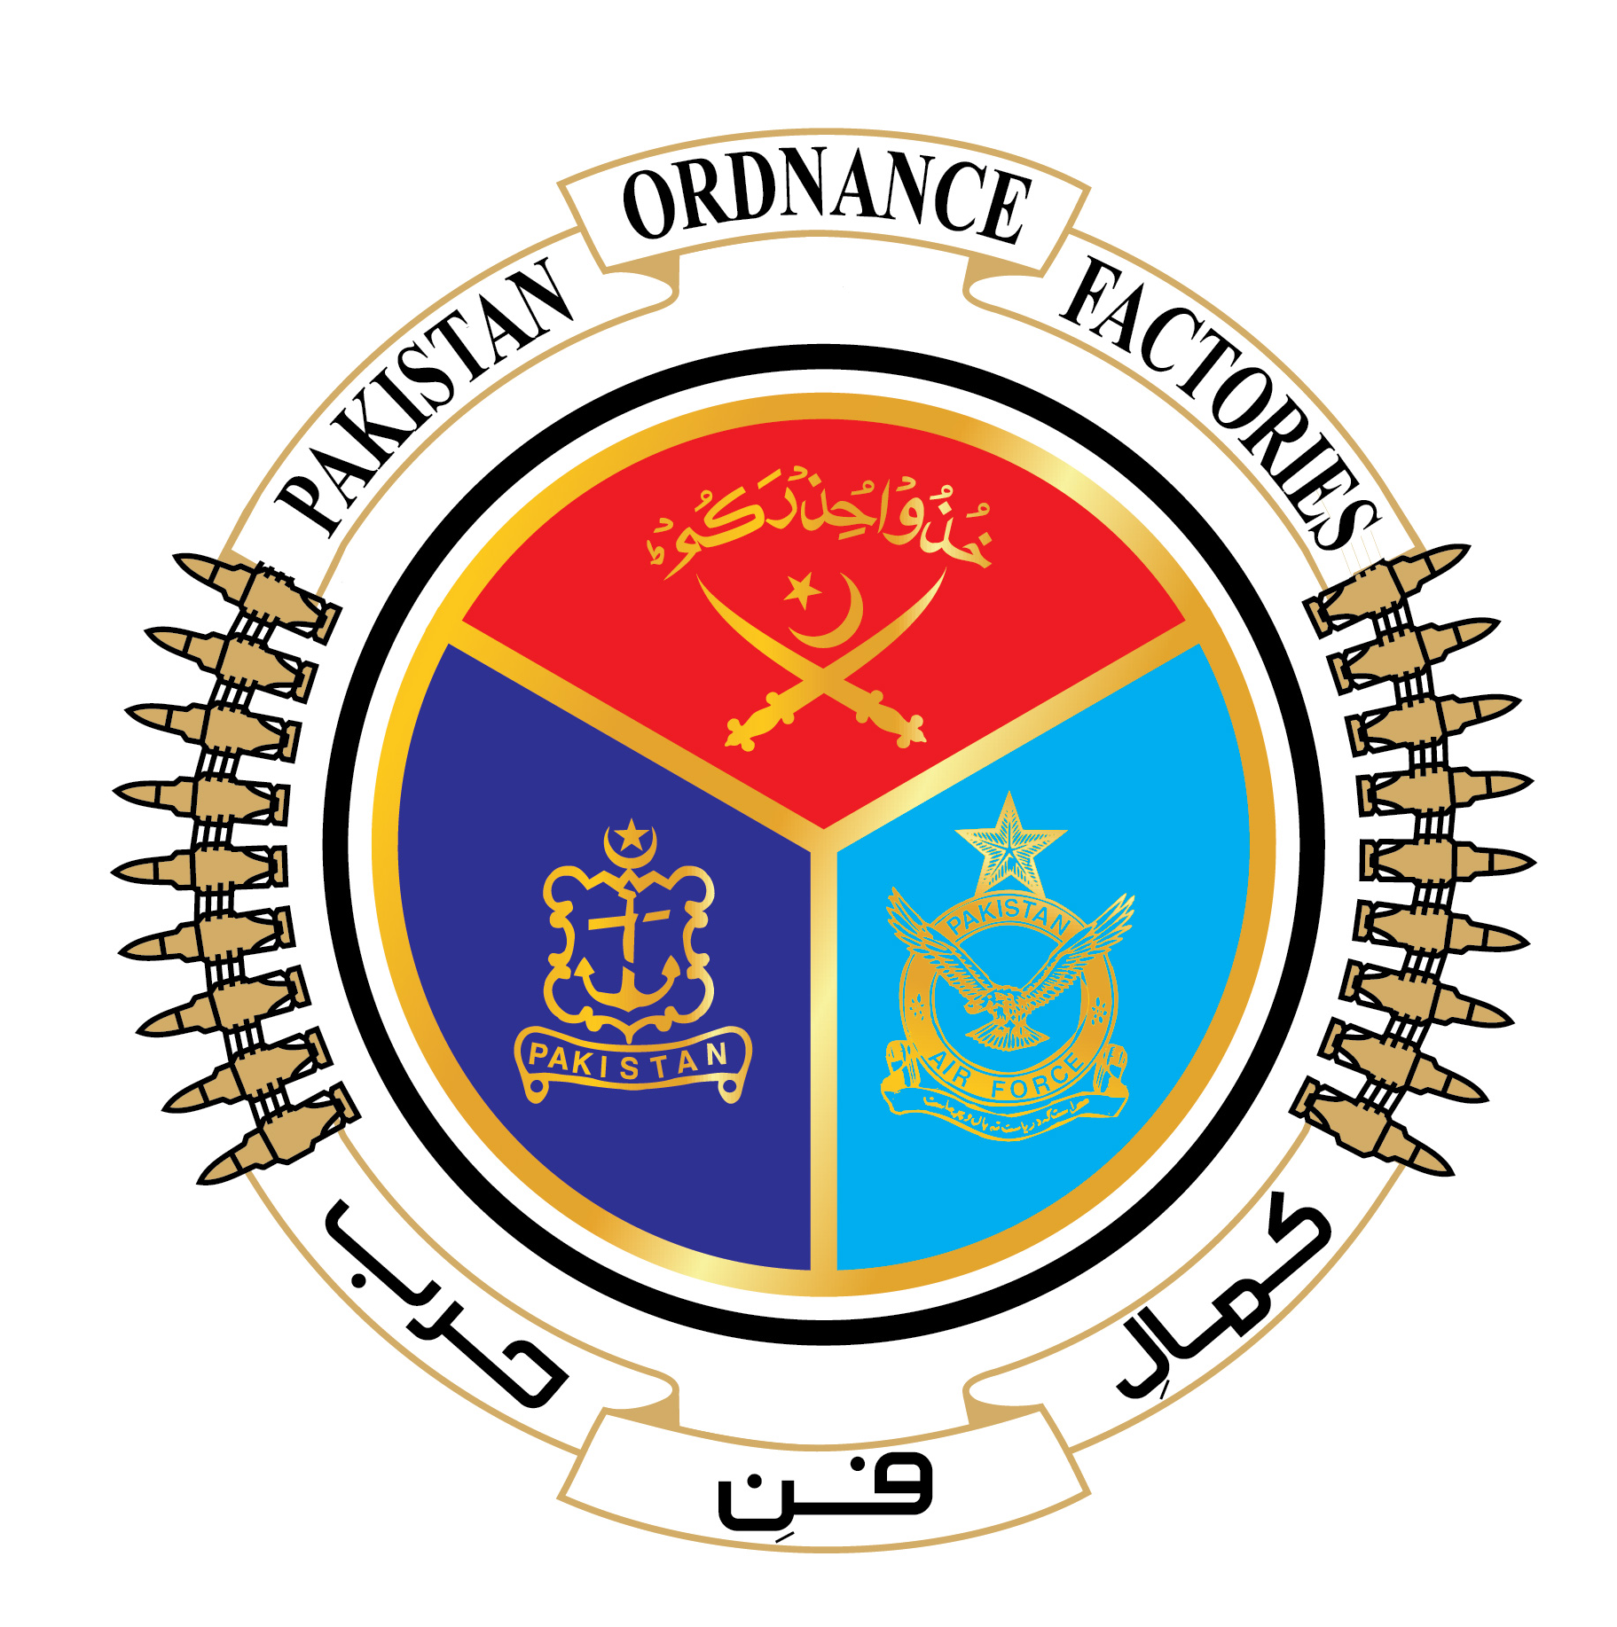

GOVERNMENT OF PAKISTAN
PAKISTAN ORDNANCE FACTORIES WAH CANTT

INVITATION TO BID

POF-AA Factory invites sealed bids from the original manufacturers/authorized dealers/suppliers registered with income tax and sales tax department for supply of different machine spares against following T.Es:-

Sr.# | T.E No. & date | Description of Store | Qty. | Opening date
1 | 0406-FP-A-52-P-AA,  Dt. 11-04-2022 | Simatic Field Siemens | 01 No | 17-05-2022
2 | 0425-FP-A-52-P-AA,  Dt. 11-04-2022 | Electrical Spares | 06 Items | 17-05-2022

2. Bidding documents containing item wise detail, specification and all other terms & conditions are available for the interested bidders at the office of the undersigned or can also be downloaded from POF website (www.pof.gov.pk) free of cost.

3. The bids completed in all respects, containing technical and commercial offers separately sealed must reach in Bid Center adjacent to Rabta Hall on or before
17-05-2022 but not later than closing time 12:00 hrs. Technical envelopes will be opened at 12:30 hrs on the same date.

Managing Director-AA-Fy
Tel: 0092-51-9055-21035, Fax: 0092-51-9271400,
E-mail:- mdaa@pof.gov.pk
Dated 11-04-2022

