REGISTERED
CMES (PAF) SARGODHA
(E-6 SECTION)

No.6015-PPRA/ 01 /E-6 | _12 Apr 2022

Assistant Director PPRA
Federal Bank for Co-operative
Building 1st Floor, Sector G-5/2
Near SBP, Islamabad.

REQUISITION FOR ADVERTISEMENT : NOTICE OF TENDER

Please arrange to download the enclosed Notice of Tender on PPRA website on
14 Apr 2022 according to the requirements, please.

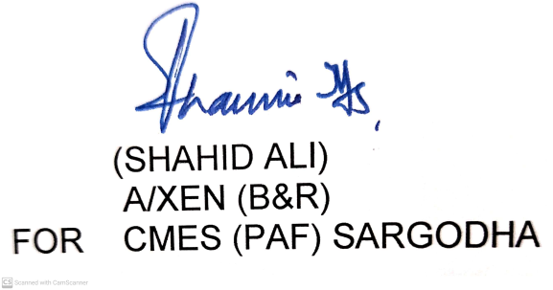

Copy to:-
1. AGE (Air) Risalewala
Please ensure making of payment on receipt of invoice from respective agencies.
2. AGE (Air) Multan

No.6015-PPRA/ 01 /E-6 |  |  |  |  |  |  | _12_Apr 2022
MILITARY ENGINEER SERVICES
NOTICE OF TENDER
01 The office of CMES (PAF) Sargodha invites sealed tenders for the following EMERGENCY WORKS in the light of PPRA Rule 42(c) (v):-
02 | (i) | Provision of Certain Facilities at PAF |  |  |  |  |  |  | (AA) |  | Rs.1.512 (Million)
 | (ii) | Provision of Certain Facilities at PAF |  |  |  |  |  |  | (W) |  | Rs.1.251 (Million)
03 The contractor are required to submit their applications for issuance of tender documents alongwith their complete credentials as shown at (Serial 9). The application shall be scrutinized and the tender documents will only be issued to the firms who have sufficient experience in the
relevant field and satisfy other special conditions required for the job and area. Tenders will only be issued to the scrutinized contractors. The tender must be received in the accepting office by
1130 Hrs on _29_ Apr 2022 and will be opened at 1200 Hrs on the same date.
NOTE:- Contractors shall provide certificate that they are not involved in any type of litigation with Government Department in the Court of Law and that no special report of Directorate of Inspection and Evaluation (E-in-C’s Branch GHQ) is outstanding against them.
04 All Contractors, will certify in writing that they are registered with Pakistan Engineering Council (PEC), and will submit a copy of their registration. Contractors not registered with PEC are ineligible to apply.

05 Contractors born on approved List of MES in Categories ‘D’ and also having experience of this type of work may only apply.

06 Contractor who desire may be present at the time of opening of tenders.

07 The accepting officer reserves the right to accept or reject the tender. Rejected tenders will be dealt with as per Para 33 (i) of PPRA Rules.

08 The interested parties can contact AGE (Air) Risalewala and AGE (Air) Multan authorized representative for further details from 0715 to 1335 hours on all working days.
09  Sl No | Name of Work Executed during the Last 2 Years and in hand |  | Agency | Amount of Work | Time Allowed (Months) | Date of Commen-cement |  | Date of Completion |  | Percentage Progress of Works in Hand |  | Departmental Performance Report on each Work by the Engineer in Charge

