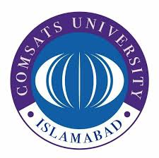
INVITATION TO BIDS

COMSATS University Islamabad, Abbottabad Campus a public sector University of Ministry of Science & Technology (MoST) invites sealed bids from Active Taxpayer Suppliers / Distributors, registered with FBR for supply of the following item:

Sr. No | Title | Re-Tender  Reference No | Bid Receiving &  Opening Date Time | Tender Document Fee
01 | Procurement of DSP hardware kits | Re- 25-ERC  (2021-2022) | April 29 , 2022, 1100 Hrs  &  April 29, 2022, 1130 Hrs | Rs. 500/-

2. Bidding documents containing detailed terms and conditions, method of procurement etc. can be obtained from “Purchase Office, Administration Block, CUI, Abbottabad Campus” on submission of request for issuance of tender document on company’s letterhead along with Demand draft /Pay order in favor of CUI Abbottabad Campus as per fee mentioned above.

3. Single Stage, Single Envelope bidding procedure. Bid prepared in accordance with instructions given in the bidding document, must reach at Purchase Office, Administration Block, CUI, Abbottabad Campus on or before date and time mentioned above. Bids will be opened on the same day at the time mentioned above. This advertisement is available on PPRA website: www.ppra.org.pk as well as on on campus website (www.cuiatd.edu.pk/tender). Queries can be asked on purchase@cuiatd.edu.pk.

Purchase Officer
COMSATS University Islamabad, (Abbottabad Campus)
University Road, Tobe Camp, Abbottabad
Ph: 0992-383863
Fax: 0992-383441

