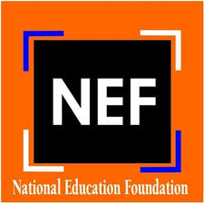

Government of Pakistan
National Education Foundation
Ministry of Federal Education and Professional Training
Islamabad
****
TENDER NOTICE
FOR PROCUREMENT OF SCHOOL FURNITURE

National Education Foundation invites sealed bids on single stage- one envelope containing, separately, financial and technical bids from the vendors/ companies / firms / Authorized agents / Sole distributors / Business Partners of Manufacturers, registered with Income Tax and Sales Tax Departments and who are on the active tax payer list of FBR for the procurement of School Furniture during the FY 2021-22. All bids received shall be opened and evaluated in the manner prescribed in the bidding documents

2. Bidding documents, containing detailed terms and conditions, method of procurement, procedure for submission of bids, bid security, bid validity, opening of bid, evaluation criteria, clarification / rejection of bids, performance guarantee etc. are available for the interested bidders on www.mofept.gov.pk or www.nef.gov.pk.

3. All the bids prepared in accordance with instructions as per bidding documents must be submitted to the office of the undersigned at or before 1:00 PM on 30th April, 2022. Bids will be opened at 1:30 PM on the same day. This advertisement is also available on PPRA website at www.ppra.org.pk

Syed Yawar Abbas
Assistant Director (Finance & Planning)
NATIONAL EDUCATION FOUNDATION
Taleemi Chowk, G-8/4 Islamabad
Tel: 051-9261556

