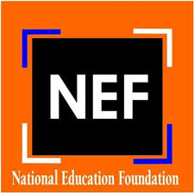

Government of Pakistan
National Education Foundation
Ministry of Federal Education and Professional Training
Islamabad
****
TENDER NOTICE
FOR PROCUREMENT OF IT EQUIPMENT/ TABLETS

National Education Foundation invites sealed bids on single stage- one envelope containing, separately, financial and technical bids from the companies / firms / Authorized agents / Sole distributors / Business Partners of Manufacturers, registered with Income Tax and Sales Tax Departments and who are on the active tax payer list of FBR for the procurement of IT equipments/ tablets. All bids received shall be opened and evaluated in the manner prescribed in the bidding documents.

2. Bidding documents, containing detailed terms and conditions, method of procurement, procedure for submission of bids, bid security, bid validity, opening of bid, evaluation criteria, clarification / rejection of bids, performance guarantee etc. are available for the interested bidders on www.nef.gov.pk or www.mofept.gov.pk.

3. All the bids prepared in accordance with instructions as per bidding documents must be submitted to the office of the undersigned at or before 10:00 AM on 30th April, 2022. Bids will be opened at 10:30 AM on the same day. This advertisement is also available on PPRA website at www.ppra.org.pk

Syed Yawar Abbas
Assistant Director (Finance & Planning)
NATIONAL EDUCATION FOUNDATION
Taleemi Chowk, G-8/4 Islamabad, Tel: 051-9261556

