PPRA & POF WEBSITE

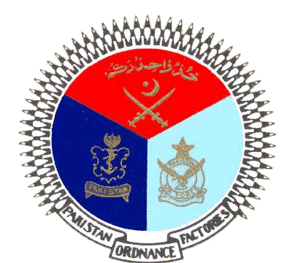 | GOVERNMENT OF PAKISTAN
 | PAKISTAN ORDNANCE FACTORIES
 | WAH CANTT

INVITATION TO BID

1. POF-AA Factory invites sealed bids from the original manufacturers potential firms registered with income tax and sales tax department for Repair and Maintenance of Styropore Plants against TE No.3590-Gen-02-P-AA, dated
26-04-2022.
2. Bidding documents containing all terms & conditions and scope of work are available for the interested bidders at the office of the undersigned OR can also be downloaded from POF website (www.pof.gov.pk) free of cost. Any further technical clarification will be furnished upon request.
- The bids completed in all respects, containing technical and commercial offers separately sealed must reach Bid Centre adjacent to Rabita Hall this office on or before 26-05-2022 but not later than closing time 1200 hrs. The Tenders will be opened at 1230 hrs on the same date.

Managing Director
Artillery Ammunition Factory
Tele:051-9055-21035 Fax #.0092-51-9271400
E-Mail.mdaa@pof.gov.pk 22-04-2022

