PPRA WEBSITE

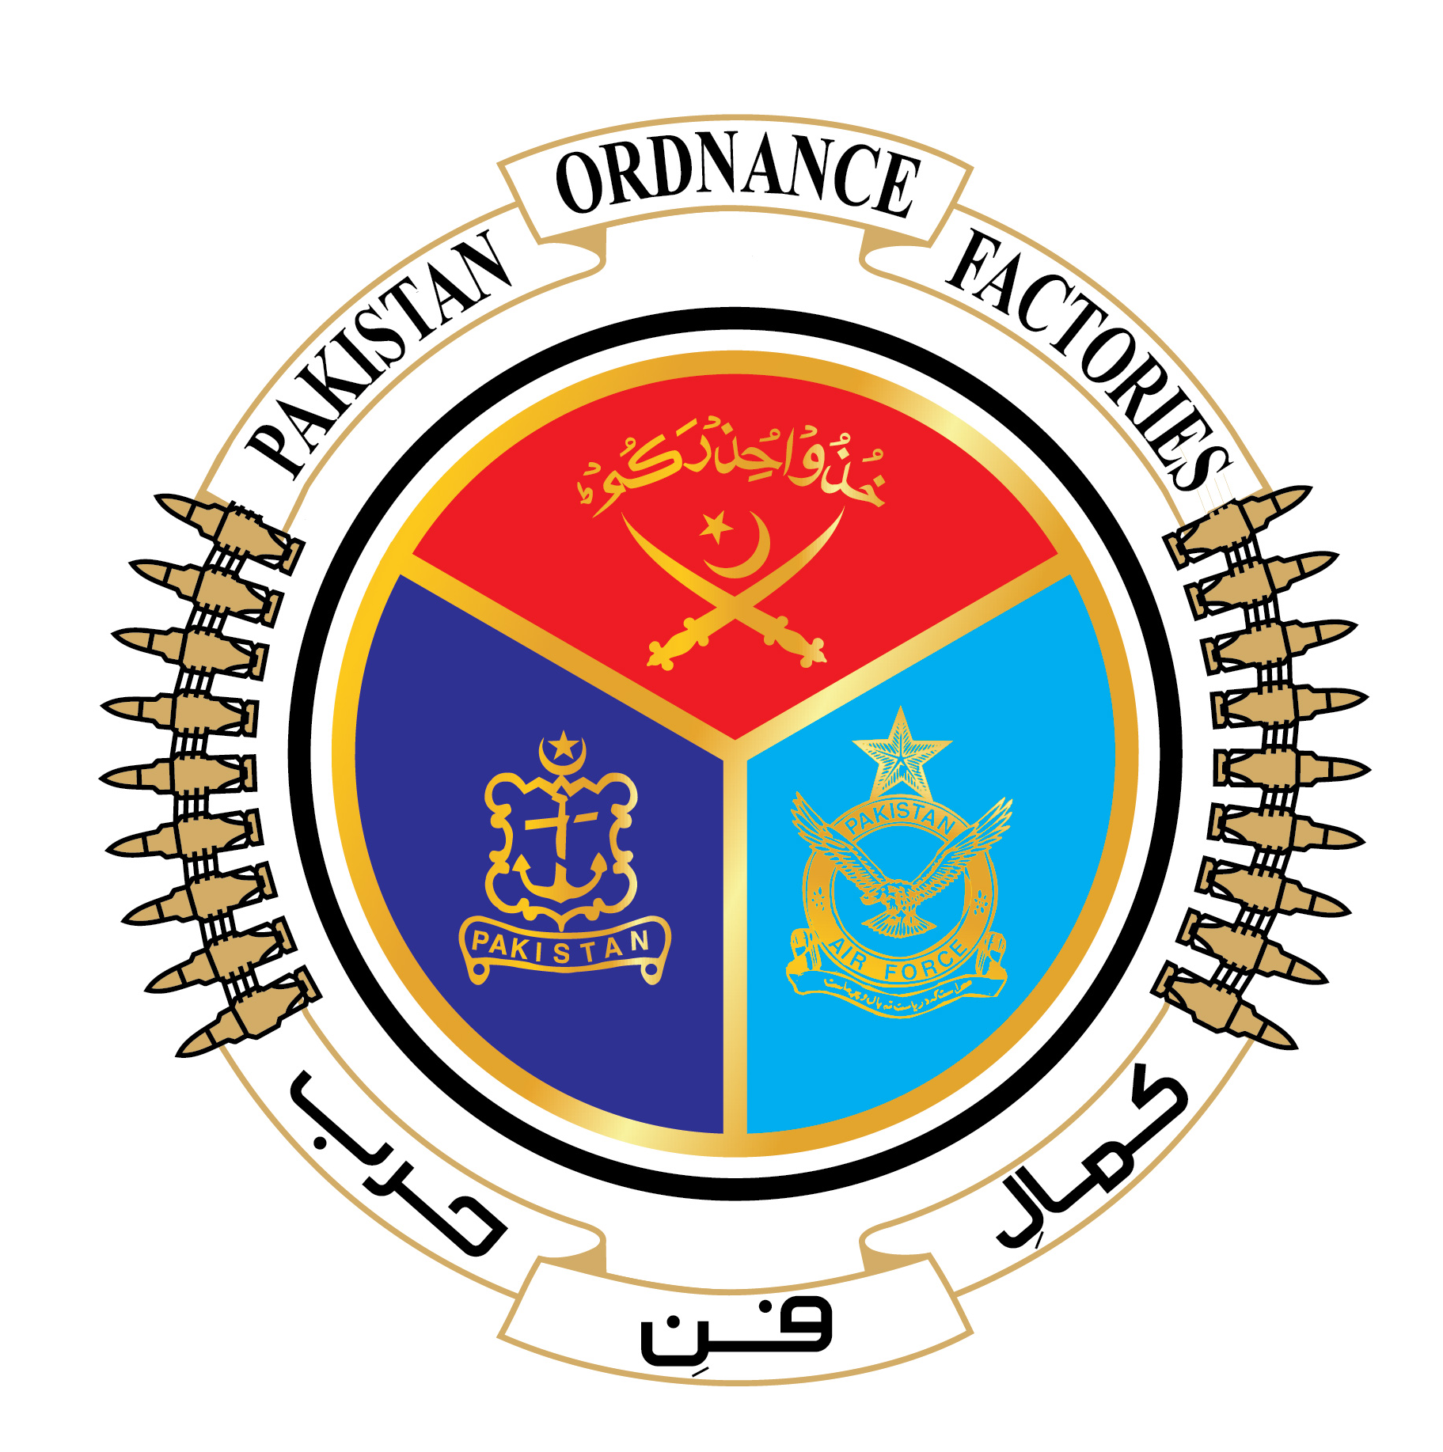
GOVERNMENT OF PAKISTAN
PAKISTAN ORDNANCE FACTORIES WAH CANTT
INVITATION TO BID

POF-AA Factory invites sealed bids from the original Manufacturers/ authorized Dealers/Suppliers for the supply of Steel Wire 4 mm dia, Steel Bar 5 mm dia and Steel Strip 35 mm wide (03 items) against 0006-FP-A-51-P-AA, 22-04-2022.

2. Bidding documents containing item wise detail, specification and all other terms & conditions are available for the interested bidders at the office of the undersigned or can also be downloaded from POF website (www.pof.gov.pk) free of cost.

3. The bids completed in all respects, must reach this office on or before
26-05-2022 but not later than closing time 1200 hrs. The tender will be opened at 1230 hrs on the same date.

Managing Director-AA-Fy
Tel: 0092-51-9055-21035, Fax: 0092-51-9271400,
E-mail:- mdaa@pof.gov.pk
Dated 22-04-2022

