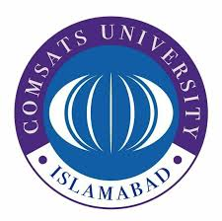
INVITATION TO BIDS

COMSATS University Islamabad, Abbottabad Campus a public sector University of Ministry of Science & Technology (MoST) invites sealed bids from the Active Tax payer Suppliers/Distributor/Manufacturers, having active status on ATL for supply of the following items.

Sr. No | Title | Tender  Reference No | Bid Receiving &  Opening Date Time | Tender Document Fee
01 | Procurement of Consumables for vehicles:  (Air Freshener, Polishes, Cloth, washing powder etc) | Consumable/ 29 (2021-2022) | May 16, 2022,  1500 Hrs  &  May 16, 2022  1530 Hrs | Rs. 500/-

2. Bidding documents containing detailed terms and conditions, method of procurement etc. can be obtained from “Purchase Office, Administration Block, CUI, Abbottabad Campus” on submission of application on company letterhead along with DD/PO in favor of CUI Abbottabad Campus as per fee mentioned above.

3. Single Stage, Single Envelope bidding procedure. Bid prepared in accordance with instructions given in the bidding document must reach at Purchase Office, Administration Block, CUI, Abbottabad Campus on or before date and time mentioned above. Bids will be opened on the same day at the time mentioned above. This advertisement is available on PPRA website: www.ppra.org.pk as well as on campus website (www.cuiatd.edu.pk/tender). All the tender related corresponding and queries will be entertained on purchase@cuiatd.edu.pk.

Purchase Officer
COMSATS University Islamabad, (Abbottabad Campus)
University Road, Tobe Camp, Abbottabad
Ph: 0992-383863
Fax: 0992-383441

