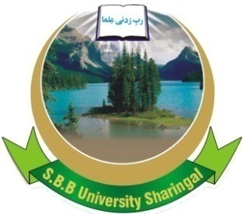 | SHAHEED BB UNIVERSITY,  SHERINGAL, DIR UPPER  Adv No. Sbbu/adv/22-170  INVITATION TO BID | 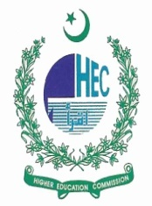

- Shaheed BB University Sheringal, Dir Upper (The Employer) invites sealed bids from the eligible firms or persons duly registered with FBR/Tax Departments & are active tax payer and Pakistan Engineering Council in appropriate category for the following works;
Ser | Name of Works | Completion Time | Last Date & Time of Submission
 | Const. of Micro Hydel Power | Three (03) Months | 20/5/2022 (1100 hours)
 | Const. of Tube well | Three (03) Months | 23/5/2022 (1100 hours)

- Complete sets of Bidding Documents may be downloaded from the Shaheed BB University Sheringal, Dir Upper official Website by the interested eligible Bidders free of cost.

- All bids must be accompanied by a Bid Security in the amount, equal to 2% of the total bid cost in the shape of deposit at call or Bank guarantee and must be delivered on the following address on or before the dates & time mentioned above and shall be opened by the Bid Evaluation Committee at 11:30 hours of the same days in the presence of Bidder’s/Bidder’s representatives who choose to attend, at the Committee Room, Guest House of Shaheed BB University Sheringal, Dir Upper.

PROJECT DIRECTOR
SBBU, Sheringal, Dir Upper
0321-9017286

