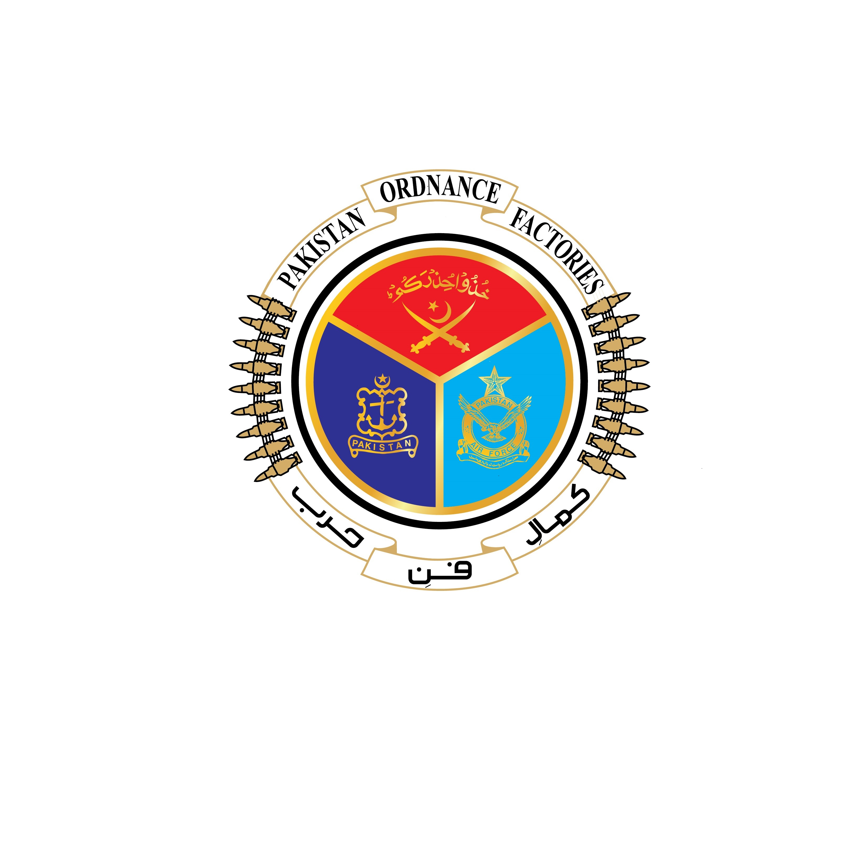
GOVERNMENT OF PAKISTAN

PAKISTAN ORDNANCE FACTORIES
WAH CANTT

Invitation to Bid

1. POF (Supply Chain Management) invites sealed bids from the original manufacturers/authorized dealers/Suppliers registered with Income Tax and Sales Tax Department for supply of the stores as per detail given below:-

Sr. No. | T.E No. & Date | Stores | Opening date
i. | 0011-LP-B-52-SCM(R&D)-Capt-Pur-III  Dt:30-04-2022 | Electronics Equipment  (11 Items). | 30-05-2022
ii. | 0012-LP-B-52-SCM(R&D)-Capt-Pur-III  Dt:30-04-2022 | I.T. Equipments  (20 Items). | 30-05-2022

2. Bidding documents contained item wise detail, specifications and all other terms & conditions are available for the interested bidders at the office of the under signed OR can also be downloaded from POF website (www.pof.gov.pk) free of cost.

3. The bids completed in all respects, must reach Bid Centre Adjacent to Rabita Hall, POF Wah Cantt on or before 30-05-2022, but not later than closing time 1130 hrs. The Tenders will be opened at 1200 hours on the same date.

Director - Supply Chain Management
Tele: 051-905521088
Fax: 051-9314100
Email: procurement@pof.gov.pk

