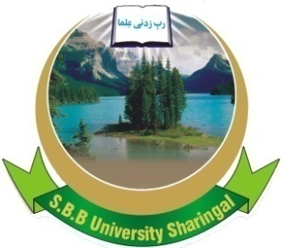 | SHAHEED BB UNIVERSITY,  SHERINGAL, DIR UPPER  Adv No. Sbbu/adv/22-171 | 

INVITATION TO BID

- Shaheed BB University Sheringal, Dir Upper invites sealed bids from the eligible firms /persons/ authorized distributers /suppliers duly registered with Income Tax and Sales Tax Departments and who are on Active Taxpayers List of the FBR for the “supply of Books’’ to Shaheed BB University Sheringal, Dir Upper”, which shall be completed in three months.
- A complete set of Bidding Documents containing detailed terms and conditions may be downloaded from the Shaheed BB University Sheringal, Dir Upper official Website by the interested eligible Bidders free of cost.
- All bids must be accompanied by a Bid Security of an amount, equal to 2% of the total bid cost in the shape of deposit at call or Bank guarantee and must reached on the following address on or before 26/05 /2022 (1100 hours) and shall be opened by the Bid Evaluation Committee at 11:30 hours of the same day in the presence of Bidder’s or their representatives who choose to attend, at the Committee Room, Guest House of Shaheed BB University Sheringal, Dir Upper. This advertisement is also available on PPRA website at www.ppra.org.pk.

Secretary Purchase Committee
SBBU, Sheringal, Dir Upper
Khyber Pakhtunkhwa

