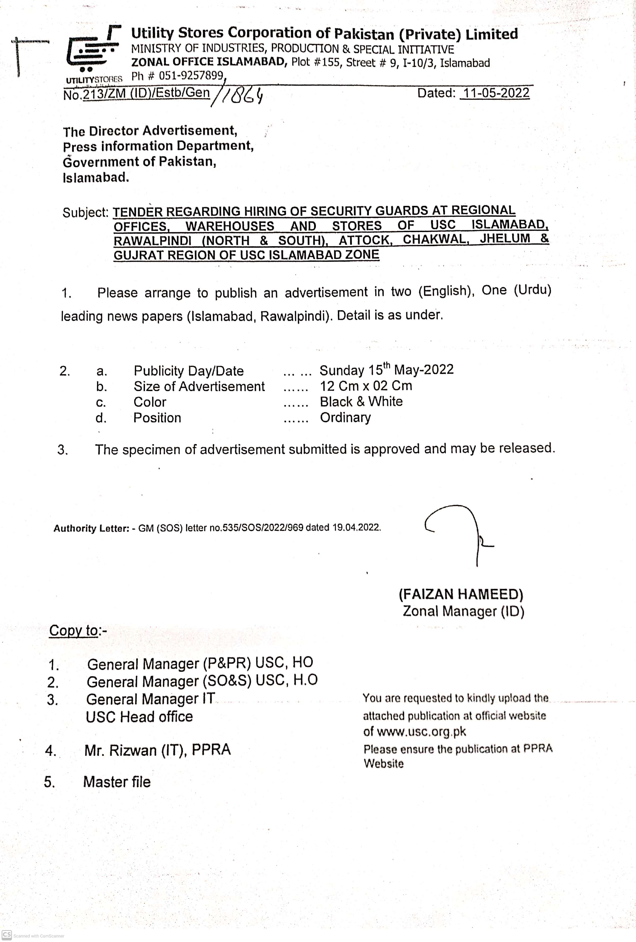


Section I
Invitation to Bid

1. Sealed tenders are invited from reputed Security Companies / Firms for hiring of Security Guards at Regional offices, warehouses and stores of USC Islamabad, Rawalpindi (North & South), Attock Chakwal, Jhelum &Gujrat Region of USC Islamabad Zone.
2. Tender documents containing detailed terms & conditions of bidding can be obtained from Zonal Manager Office Utility Stores Corporation at Plot No 155, St.# 09, Sector I-10/3, Islamabad against the payment of tender fee Rs.1,500/-. The Tender documents can also be obtained through mail by submitting an application along with tender fee in the shape of DD/Pay order. The tender documents in this case will be sent to the bidder through courier.
3. The tender is also available at PPRA website i.e. www.ppra.org.pk and USC website i.e. www.usc.org.pk.

4. The tenders / bids must reach to Zonal Office Islamabad on before 11:00 Hours on 07-06-2022, which will be opened on the same day at 11:30 Hours in the presence of the tenders / bidders or their authorized representatives who wish to attend. The tender document must be accompanied with Earnest money of one percent of the total value of bid work out for complete year in the shape of demand draft / pay order. Tender without earnest money shall not be entertained.

(Zonal Manager)
Utility Stores Corporation of Pakistan
Plot No 155, St. # 09, Sector I-10/3, Phone No. 051-9258120,
Fax No. 051-9257899 Islamabad

