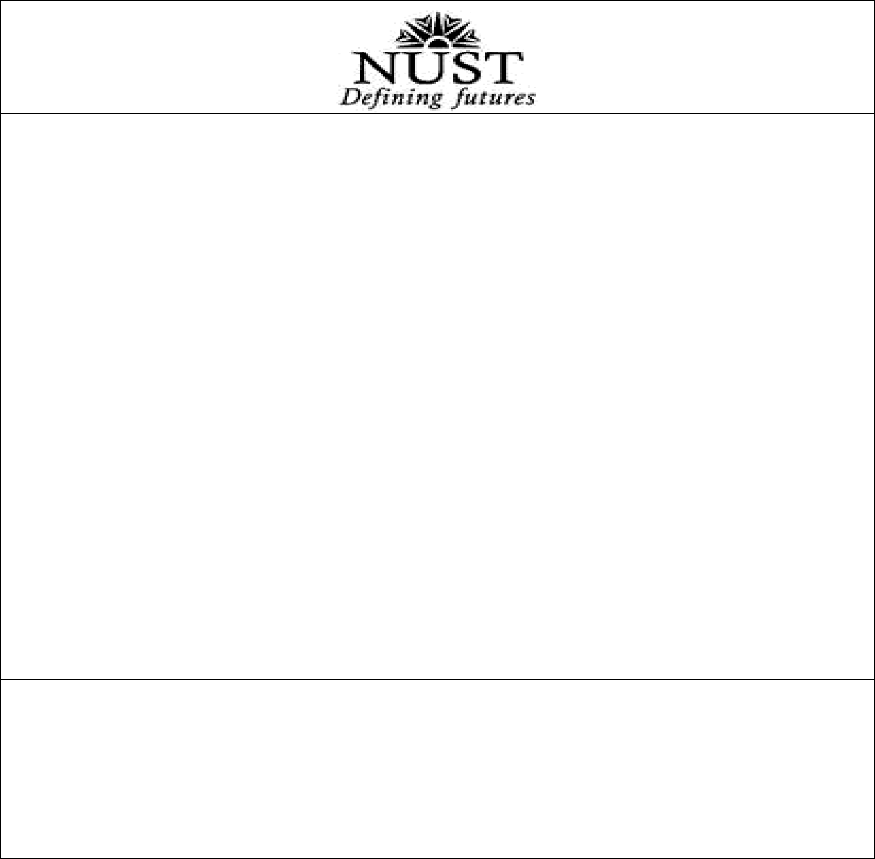

TENDER NOTICE

School of Interdisciplinary Engineering and Sciences (SINES), constituent school of National University of Sciences and Technology (NUST) invites quotations from registered firms for

PURCHASE OF BRANDED DESKTOP COMPUTERS

The details of equipment are given below: -

Description | Qty
Branded Desktop Computers with 24” LED Display | 05

Tender Document can be obtained during working hours (0900Hrs to 1700Hrs) after 18 May 2022 from SINES through Pay Order/Bank Draft/Cash in the name of SINES at cost of Rs. 3000/- (non-refundable). Last time and date for bids submission is 1100 hrs on 07 June 2022. Sealed quotations will be opened on 07 June 2022 at 1130 hrs in the presence of firm’s reps at SINES, NUST Islamabad. The competent authority / procuring agency may reject all bids of proposal as per rules.

Principal
School of Interdisciplinary Engineering and Sciences (SINES), National University of Sciences and Technology,
NUST Campus, H-12, Islamabad
Phone: 051-90855701, Fax: 051-90855702

