
PPRA Advertisement

NFC Institute of Engineering & Technology,
P.O. Fertilizer Project (59060)
Khanewal Road, Multan, Pakistan
Tel: PABX (061) 9220012-16
Fax: 9220018
Email: nfciet@nfciet.edu.pk.

Tender Notice

Tender No. NFC IET/F-03/T-27 & T-28 May 19, 2022

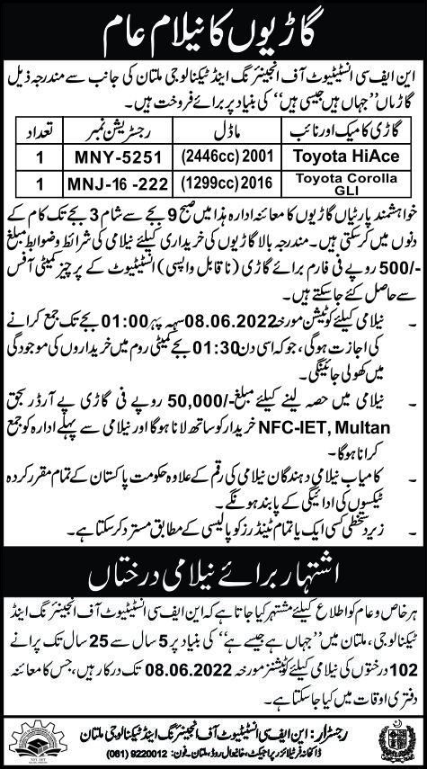
For Auction of Trees (T-28) Sealed Tenders addressed to Chairman Purchase Committee must reach this office on or before above due dates at 11:30 Hrs. and will be opened on the same day at 12:00 Hrs. in the VC Secretariat & Tender Documents for both tenders can be obtained till 08-06-2022 at 10.00 Hrs.

Faisal Amin Engr. Tafzeel Khaliq
Member Chairman Purchase Committee
Ext: 2317 Ext: 2254

