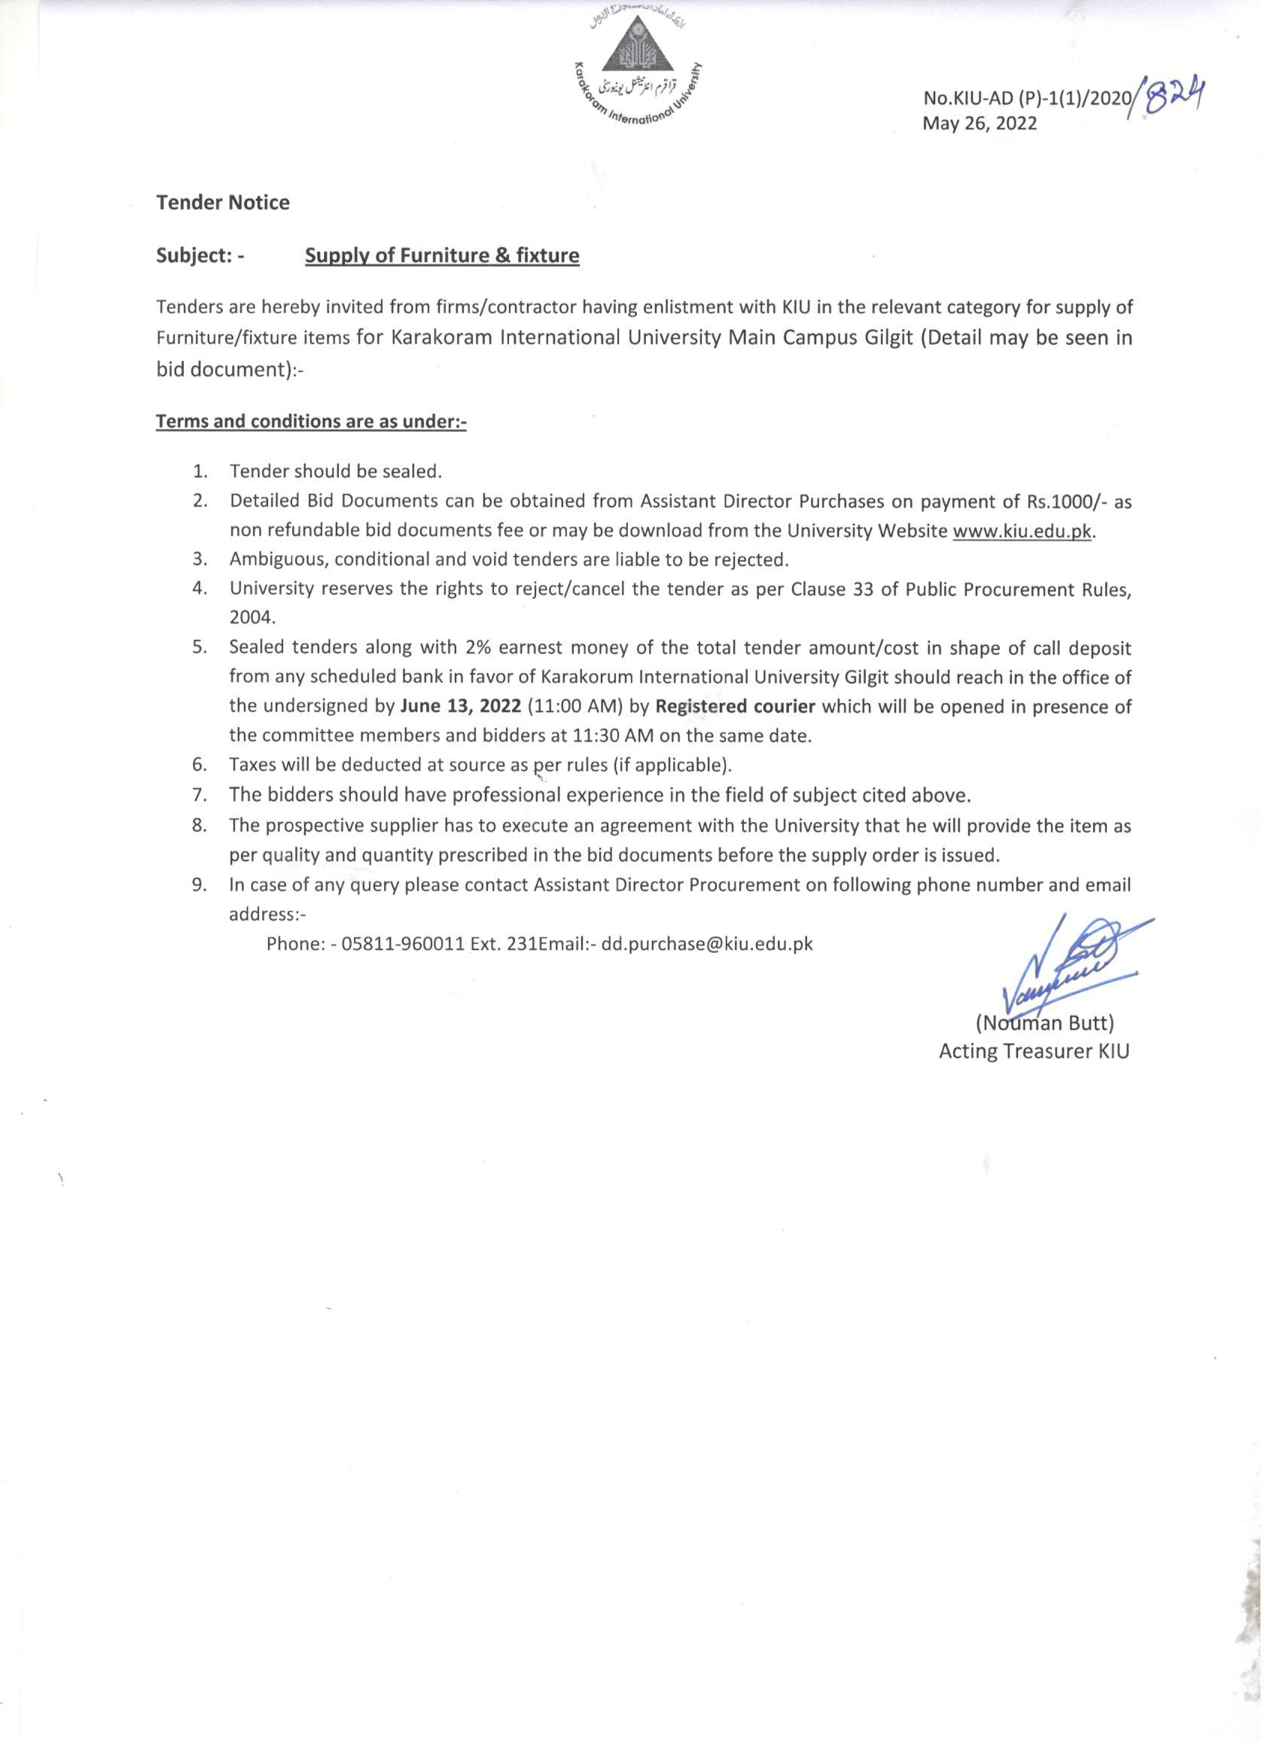

Bid Documents
(RFP)
Name of Work: -Supply of Furniture/fixture items for KIU Main Campus Gilgit


Opening Date : May 26, 2022
Opening Time : 11:30 AM
Venue : University Conference Hall

…………………………………………………………………………………………………………………………..

Karakoram International University
University Road, Gilgit
Website: kiu.edu.pk
Email: dd.purchase@kiu.edu.pk
Telephone No. 05811-960010-13 (Ext No.231) Fax No.05811-960049, 960032
(Price Rs. 1000)

- Definitions:
  - KIU: Karakoram International University
  - RFP: Request for Proposal
  - BOQ: Bill of Quantities
  - FI: Furniture Items
  - Warranty/services of items/parts: All support, repair, replacement etc and services of all items including its fixture.
  - Bidder: The participant/ firm who has submitted the proposal
  - Selected bidder: Bidder selected for award of tender for a particular work.

- General Requirements:
Following are the General Requirements applicable for RFP.
  - The selected bidder will be responsible for the supply and fixing of all items given in BOQ.
  - Selected bidder must ensure that the supplied items are as per approved sample, size & quality.
  - At the time of fixing of furniture items, Selected Bidder must provide main power to fix/complete the work.

- Bids Requirements
The objective of bids requirements is to provide bidders with the information to submit their bid in response of RFP, Bid document. For all categories, bidders must follow requirements for their proposals/bids:
  - For this tender PPRA’S Para 36(a) “single stage one envelop bidding procedure” for open competitive bidding shall be adopted as per public procurement rules, 2004.
  - Bids shall comprise of single envelope including. Technical and Financial Proposal.
  - The selected bidder shall be responsible for one year services without any extra cost or hidden charges for all the items provided.
  - The bidders must have experience in relevant category, Company profile, Location of branch offices, Technical staff details, Project Completed, major Client list, Technical specifications (brochures, etc.)

- Selection procedure
  - The bid found lowest with technical and financial compliance for the quoted items of furniture matching the standard specifications will be awarded the work.

- Evaluation of Proposals
It will be examined in detail whether the items offered by the bidder comply with the specifications of the bidding documents. To facilitate this, items specifications will be reviewed. Technical features/criteria of the Goods detailed in the Specifications will be compared with the bidder's Goods Data submitted with the bid. Other technical information submitted by the bidder (Para 3.4) will also be reviewed for acceptance i.e. relevant experience & expertise in each quoted item etc.
- Meet or exceed specifications
The specifications provided in this RFP are the minimum requirements of KIU. The vendors must meet or may exceed these specifications to meet the actual requirements of this work and its successful practical implementation. But in such case additionally proposed or altered specifications should clearly be highlighted to enable KIU to clearly identify modified specifications.

- Minimum requirements for Service Level Agreements(SLA)
Following requirements for SLA applicable for this RFP:
  - The selected Bidder shall provide 01 years warranty/services and parts replacement etc if any. The bidder shall ensure that all furniture items and its parts are new and free from any sort of defects.
  - Any cause of delay in response and rectification of fault will lead to financial penalties to the selected bidder and details of penalties will be incorporated in SLA.

- Terms of payment
  - Ninety percent (90%) of the contract amount will be paid after successful completion of supply subject to certification of University Inspection Committee to that effect.
  - Ten percent (10%) of the total contract value will be retained as security/ retention money and will be released after completion of warranty from the date of delivery.
  - Income tax in case of local suppliers will be deducted as per rates applicable in GB and in case of suppliers for down country income tax will be applicable as per Federal Govt. rates.

- Liquidated Damages
  - liquidated damages shall be applicable as under:
- A penalty of 0.01% per day of contract cost can be imposed for delays in supply and the firm will not be allowed to participate for any tender in future.
- In case of failure in supply of items, 2% earnest money shall be forfeited and the supplier will be blacklisted as per PPRA rules.

- Terms and Conditions of Successful bidder
  - The selected bidder shall provide the technical documentation for each item in the form of hard copy.
  - The earnest money 2% of the successful bidder shall be deposited in security deposit account of KIU after supply of the items as mentioned in BOQ and will be adjusted in final bill of the supplier
  - All the material required for work completion other than explicitly mentioned in the BOQ of this RFP will be the responsibility of the successful bidder.
  - Successful bidder is bound to deliver all items of BOQ at KIU Main Campus Gilgit, at his own risk and cost.
  - University’s inspection committee will provide clearance certificate for supplied items and reject the item (s), if not found according to the accepted specifications and quality.
  - The University reserves the right to claim compensation for the losses caused by delay in the delivery of equipment.
  - Additional terms and conditions may be added to the work orders/ agreements by KIU.

- General terms and conditions:
The following General terms and conditions apply to all categories of this RFP:
  - A bank draft/pay order equal to 2% of the total bid value from any scheduled bank in favor of Karakoram International University should accompany the tender as earnest money. The tender without earnest money or less than 2% of bid value will be considered as void tender and is liable to be rejected.
  - The earnest money in shape of cheque will not be accepted and bid will be cancelled.
  - Sealed bids supported with technical catalogs with financial bid will be opened on June 13, 2022 at 11:30 AM at University Conference Room.
  - Sealed tenders should be sent via courier services to the Assistant Director Purchases, Karakoram International University, which should reach in at least by 11:00 am in KIU, which will be opened in presence of the committee members and bidders at 11:30 AM on the same date.
  - By hand tenders may not be accepted.
  - Incomplete and conditional tenders will not be entertained.
  - The bidder should be registered with UNIVERSITY; RFP will be issued to the enlisted firms in Furniture items with KIU.
  - The university reserves the rights to reject all or any of the bids as per clause 33 of the Public Procurement Rules, 2004
  - Validity period of the bids shall be 90 days.
  - Ambiguous, conditional and void tenders are liable to be rejected.
  - Rates should be in Pak Rupees separately indicating applicable sales tax, if any.
  - The decision of the University shall be binding on all concerned and will in no case be challengeable at any forum or any court of law.
  - Bids are liable to be rejected, if they are not in line with the terms, conditions and specifications/quality stipulated in this RFP.
  - During the examination, evaluation and comparison of bids the KIU, at its sole discretion, may ask the bidder for clarification of its bid.
  - The request for clarification and response shall be in writing/email and no change in price or substance of the bid shall be sought, offered or permitted.
  - Delivery time for all items is four (4) weeks to six (6) weeks after receipt of supply order.
  - Bids submitted via email or fax will not be entertained.
  - Bidders have to quote only one option, Bids having more than one option will be treated as non-responsive.

- Clarifications:
Queries regarding this RFP shall be submitted in writing to:

Zahid Ali Nouman Butt
Assistant Director Purchases Director Finance
05811-960010-13(ext 231) 05811-960010-13(ext 107)
zahid.ali@kiu.edu.pk nouman.butt@kiu.edu.pk

Certified that the document does not contain any thing in violation of PPRA Rules.

I have read and accept all the terms and conditions. (To be filled by bidder)

Bidder Name: __________________ CNIC No_______________________
Designation: ___________________ Signature: _______________________

BOQ
S.No. | Description | Specs | Qty
1 | Single bed | Single bed size 3'.25"x6'-6" with head and foot board in kail wood head height 3'and foot height 18" to 2' fix with planks 3/4" legs 4"x2.5" wooden frame size 4"x1.5" inside lasani sheet as per approved sample | 200 Nos
2 | Mattress | Mattress size 3'-25"x6'-6" and 4" thick | 200 Nos
3 | Study Table | Study Table along wall size 2'-6"x2' kail wood legs size 2.25"x2.25" with side stretcher 2.25"x1.5" one drawer at top lasani MDF laminated sheet wooden Patti 6"x1.25" along drawer at top as per approved sample | 200 Nos
4 | Common room chair | Common room chair with seat and back cushioned legs 2"x2.25" wooden frame size 2"x2.5" with hand rest in kail wood as per approved sample is attached | 70 Nos
5 | Study Chair steel plastic | Study Chair steel plastic as per approved sample | 200 Nos
6 | Cupboard | Cupboard size 2'-6"x7' width 20" and height 7' made of lasani Mdf sheet wooden frame 1.5"x2.5" wooden Patti 2"x1.25" below shelves back sheet 3/8" thick including lock as per approved sample | 200 Nos
7 | Table for Mess /Dinning | Table for Mess /Dinning Table size 3'-0"x6' top water proof laminated MDF 3/4" sheet with wooden frame 3"x1.5" legs size 3"x3" and height 2'-6" with side stretchers as per approved sample | 14 Nos
8 | Chairs for Mess/ Dinning | Chairs for Mess/ Dinning Hall chair with seat cushioned legs 2.25"x2.25" in kail wood as per approved sample is attached | 84 Nos
9 | Sofa Set | Sofa Set (5 seater warden ) in kail wood seat and back cushioned as per approved sample is attached | 01 Set
10 | Office Table | Officer's Table Warden & RHT size 5'x3' with drawers KIU standard office table | 02 Nos
11 | Revolving Chairs | Officer's Chairs (high Back) for Warden and RHT revolving KIU standard revolving chair | 02 Nos
12 | Visiting Chair | Visiting Chair seat and back cushioned as per KIU approved sample | 05 Nos
13 | Reception Counter | Reception Counter for Main Block height 3' double step with drawers lasani MDF sheet front kail wood strips round shape for 2 persons | 01 No
14 | Steel Cabinets | Steel Cabinets (Double door)size 6'x3'x18" with glass doors as per approved sample | 04 Nos

Note: -Samples can be seen during office hours (Monday-Friday).

Gohar Jamal
Ph. 05811-960010-13 Ext.219
Email: - gohar.jamal@ kiu.edu.pk

