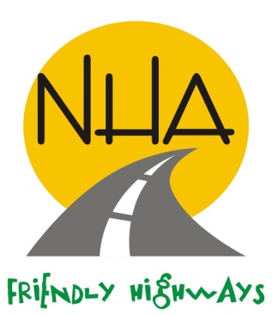
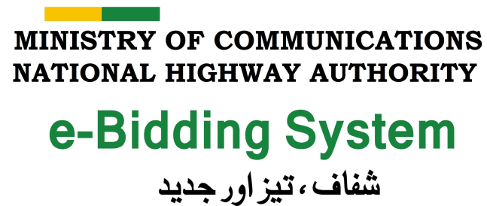
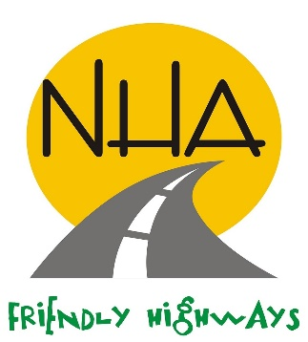

INVITATION FOR e-BIDS

- National Highway Authority (NHA) invites e-bids from eligible construction firms registered with income tax department having valid PEC registration in the Category C-4 for individual bidders only with specialization in CE-01, CE-02 & CE-10 for “Construction of 2.25 Km Missing Link Road on Okara side to connect Rai Mansab Ali Khan Kharal Bridge, approach roads with existing Provincial Highway Network”.

- The bidding shall be done through NHA e-Bidding System. Constructors, having valid PEC registration are required to create their “On-line User Account” for participation in the bidding. User Guide, illustrating the steps to create “On-line User Account”, is available at www.ebidding.nha.gov.pk . Access to ‘NHA e-bidding system’ for bidding, will be granted upon submission of pre-requisite documents as per guide line. Bid submitted, by using NHA e-bidding system, will only be considered, whereas other bids will be rejected.

- Complete set of bidding documents for the above mentioned Work, containing detailed terms & conditions, method of procurement (Single Stage - Two Envelope procedure), submission of e-Bids, Bid Security, bid validity, opening of e-Bid, Evaluation Criteria, etc. will be available on NHA website on June 03, 2022 for downloading free of cost. Bidders are also advised to follow the NHA website for updates of bidding schedule and addendum(s), if any.

- The e-bid must be prepared and submitted through NHA e-Bidding system in accordance with the instructions contained in the bidding documents. Hard copy of e-Bid prepared through NHA e-Bidding system, must reach at the address mentioned below on or before June 16, 2022 until 1100 hours. Technical e-Bids (submitted through NHA e-Bidding system) and envelope containing hard copy of Technical e-Bid, will be opened on the same day at 1130 hours.

- The bidders providing unsubstantiated and/or incorrect information shall be liable to disqualification and/or legal action.

- This advertisement is also available on PPRA website at www.ppra.org.pk.

General Manager (P&CA)
National Highway Authority
Ministry of Communications
28 Mauve Area, G-9/1,Islamabad
Phone: 051-9032727, Fax: 051-9260419
Email: gmpca.nha@gmail.com

-SAY NO TO CORRUPTION-

