PPRA/POF WEBSITES

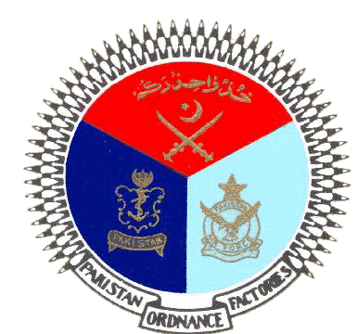 | GOVERNMENT OF PAKISTAN
 | PAKISTAN ORDNANCE FACTORIES
 | WAH CANTT

INVITATION TO BID

- POF-AA Factory invites sealed bids from the original Manufacturers/authorized Dealers/Suppliers (Local) for the supply of following stores:-

T.E NO. & DATE | DESCRIPTION | Qty.
0205-LP-B-51-P-AA,  Dt.28-05-2022 | Electronic / Computer Spare | 01 Item

2. Bidding documents containing item wise detail, specifications and all other terms & conditions are available for the interested bidders at the office of the undersigned OR can also be downloaded from POF website (www.pof.gov.pk) free of cost.
3 The bids completed in all respects, containing technical and commercial offers separately sealed must reach on or before 21-06-2022 but not later than closing time 1200 hrs. The tenders will be opened at 1230 hrs on the same date..

Note:- Local suppliers should be registered with income tax and sales tax department.

Managing Director
Artillery Ammunition Factory
Tele:051-9055-21035 Fax #.0092-51-9271400
E-Mail.mdaa@pof.gov.pk 28-05-2022

