GOVERNMENT OF GILGIT-BALTISTAN
OFFICE OF THE DEPUTY DIRECTOR

POULTRY PRODUCTION
GILGIT-BALTISTAN
_____________________________________________ __ Tel: 05811-922642
No. DDPP- 1/2016
Dated 6th June-2022

To

- The Deputy Director,
Information Department Gilgit-Baltistan.

- The Web Manager,
Public Procurement Regulatory Authority
(for publishing on PPRA Website)

Subject: ADVERTISEMENT.

Please find attached herewith a Tender Notice advertisement F.Y 2022-23 for publication in the news paper as observance of Government advertisement policy.
a | Date(s) for publication (Name of News Paper) | -----
b | No of insertion and the page position | 3rd page, left below one day only
c | Mention the required News paper where client department want to publish the matter | 02 National News Paper (i.e. English, Urdu & 02 local News Paper) as per AGPR requirement & PPRA rules.

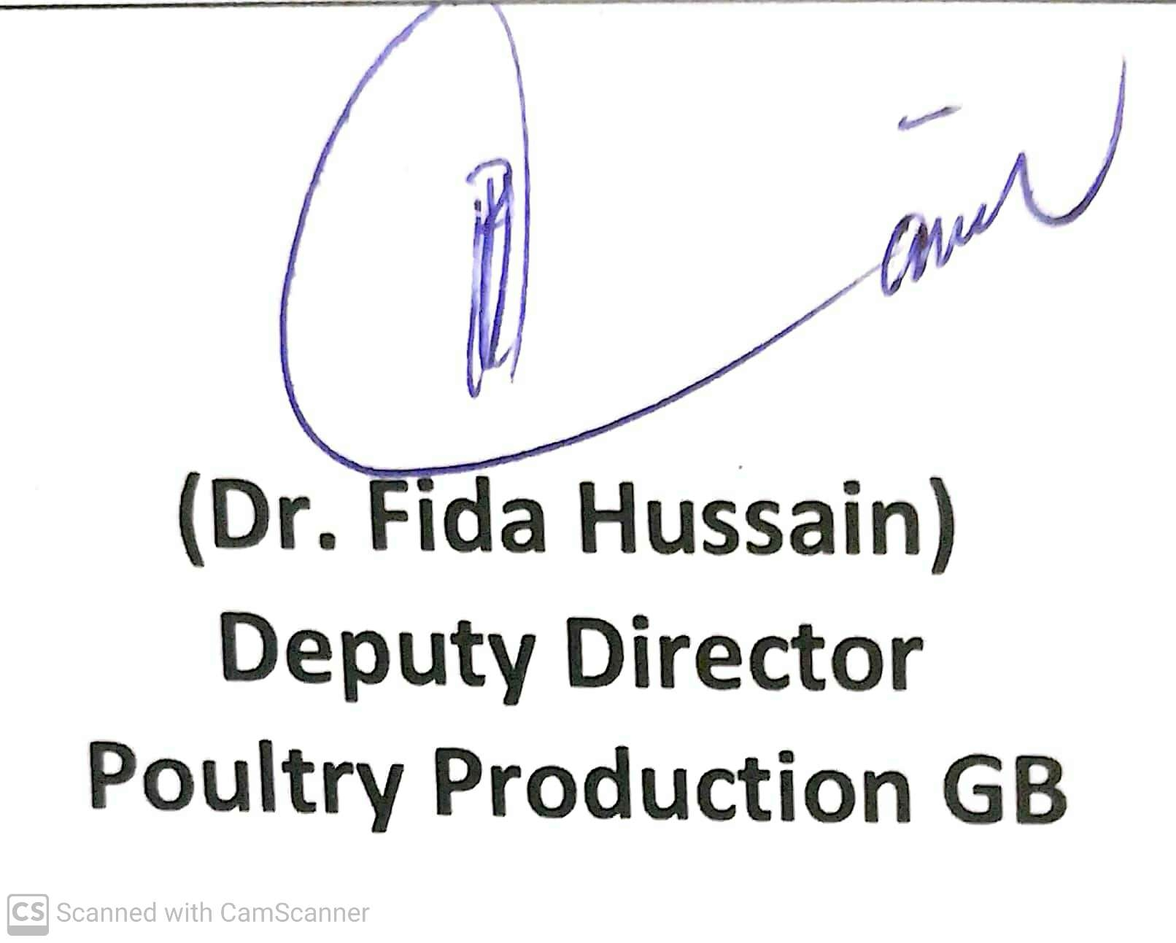

GOVERNMENT OF GILGIT-BALTISTAN
OFFICE OF THE DEPUTY DIRECTOR
POULTRY PRODUCTION
GILGIT-BALTISTAN

TENDER NOTICE
Tender for procurement of under mentioned items needed for this office is hereby invited from the eligible Govt. Contractors/ Firms on the date and time mentioned below which will be opened by the undersigned in presence of the contractors or their authorized agents who care to attend.

S.No | Name of item | Bid value (in million) | Last date/time of receipt of tender | Date/time of opening of tender
1 | Purchase of Poultry Birds | 6,000 | 23.6.2022 (9:30 am) | 23.6.2022(10:00 am)
2 | Dairy /Poultry Feed | 13.000 | 23.6.2022 (10:00 am) | 23.6.2022 (11:00am)
3 | Poultry/ Dairy equipments | 0.100 | 23.6.2022 (10:30 am) | 23.6.2022 (11:30 am)
4 | Poultry/Dairy Medicines/vaccines | 0.500 | 23.6.2022 (11:00 am) | 23.6.2022 (12:00 am)
Conditions:
- Tender rates would be considered/ valid for 30.6.2023
- Rate of each item should be quoted on the basis of F.O.R (Dairy Farm konodass/ Poultry farm Basin, Jutial, Konodass Gilgit).
- Complete bids where details with complete specifications/strength/manufacturer etc if not mentioned will be rejected.
- Delivery time will be 03 weeks from the date of issue of supply order. In case of failure to complete the supplies within stipulated time, total earnest money will be confiscated in favour of the state and supplier will be black listed.
- Rates will be decided for individual items bid basis.
- 3% of the bid value in the form of call deposit issued by a Schedule bank may be deposited in favour of Deputy Director Poultry Production GB; otherwise bids are liable to be rejected technically.
- Supply order will be subject to release of funds and according to the budgetary position.
- Depended Poultry birds to be supplied be on F.O.R regional head quarter basis and 02 days haltage at Regional Head quarter will be responsibility of contractor.
- After acceptance of the bid, a separate agreement deed has to be undertaken between the tenderers and Deputy Director Poultry production GB.
- Income Tax would be recovered from the supplier as per Govt. Rules.
- The Chairman of the relevant tender committee reserves the right to accept or reject in part or whole of the tender without assigning any reasons.
- Bidder will be selected on the basis of his experience and performance in relevant field.
- Provision of bill warranty in case of medicines will be responsibility of the supplier.
- The company/ Firms will have to submit affidavit for not have been blacklisted.
- Tender process will be completed single stage two envelope basis for each component.
- Unrealistic and conditional rates of items will not be entertained.
- The Poultry Feed/ Dairy Feed will be accepted only from registered firms.
- Contractors/Firms will provide affidavit paper dully attested to ensure supply within 03 weeks of time period.

