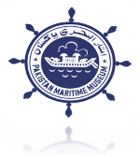

PAKISTAN MARITIME MUSEUM
1. Proposals with detailed technical, design and cost estimates are required from reputed firms for Re-designing, Uplift and Renovation of existing Auditorium and False Ceiling of Conference Room at Maritime Museum Karsaz.

2. Firms may offer proposals for the above requirement. Proposals are to be submitted by 20th June 2022 at 1000 hrs. The proposals will be opened on the same day at 1100 hrs in the presence of firm’s reps at PMM Conference Room.

3. For further details, Contact Tele # 021-48503046, 0332-3111599 or visit Pakistan Maritime Museum.

DIRECTOR GENERAL
Pakistan Maritime Museum
at Habib Ibrahim, Rehmatullah Road, Karsaz, Karachi
INVITATION FOR PROPOSALS

