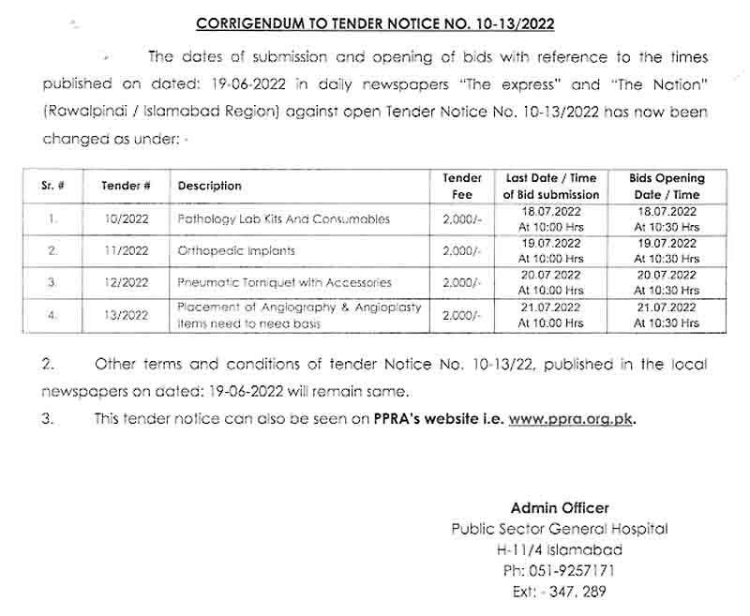
TENDER NOTICE NO. 10-13/2022

TENDER NOTICE FOR PURCHASE OF PATHOLOGY LAB KITS, PNEUMATIC TORNIQUET WITH ACCESSORIES, PNEUMATIC TORNIQUET WITH ACCESSORIES AND PLACEMENT OF ANGIOGRAPHY & ANGIOPLASTY ITEMS NEED TO NEED BASIS THROUGH OPEN TENDER

- A Public Sector Hospital invites sealed tenders from eligible / reputed firms / suppliers registered with income tax / general sale tax department for the purchase of pathology lab kits, Pneumatic Torniquet With Accessories, pneumatic torniquet with accessories and placement of angiography & angioplasty items need to need basis under single stage – two envelopes bidding procedure from the eligible tenderers / suppliers / manufacturers for the following items on FOR basis.
Sr. # | Tender # | Description | Tender Fee | Last Date / Time of Bid submission | Bids Opening Date / Time
1. | 10/2022 | Pathology Lab Kits And Consumables | 2,000/- | 11.07.2022  At 10:00 Hrs | 11.07.2022  At 10:30 Hrs
2. | 11/2022 | PNEUMATIC TORNIQUET WITH ACCESSORIES | 2,000/- | 12.07.2022  At 10:00 Hrs | 12.07.2022  At 10:30 Hrs
3. | 12/2022 | Pneumatic Torniquet with Accessories | 2,000/- | 13.07.2022  At 10:00 Hrs | 13.07.2022  At 10:30 Hrs
4. | 13/2022 | Placement of Angiography & Angioplasty Items need to need basis | 2,000/- | 14.07.2022  At 10:00 Hrs | 14.07.2022  At 10:30 Hrs

- A set of tender documents along with terms and conditions can be downloaded from PPRA website: www.ppra.org.pk at a cost of Rs. 2,000/- separately for each tender payable in the shape of “Pay Order/Demand Draft” in favor of “Sr. Accounts Officer, Public Sector General Hospital, Islamabad”. The Pay Order/Demand Draft and tender request must be submitted along with tender proposals before closing date of tender. No Tender / Proposal will be accepted without Tender Fee.
- This tender can be seen on PPRA website www.ppra.org.pk also.

- The competent authority reserves the right to reject any or all the tenders.

Admin Officer
Public Sector General Hospital
H-11/4 Islamabad
Ph: 051-9257171
Ext: - 347, 289

INSTRUCTIONS

TO FILL UP THE TENDER DOCUMENTS

Technical worksheet

- Download file named “Tender File Pneumatic Torniquet With Accessories” from URL: www.ppra.org.pk for quoting technical specification of “Pneumatic Torniquet With Accessories”.
- Open relevant file.
- Save the file when it is complete to fill up the cells of as many brands as you want to quote.
- Please write “NQ” against non-quoted items in empty cells.
- Technical Proposal should not indicate any price. There will be two different files; one for Technical Proposal only and one for Financial Proposal. All pages of hard copy should be stamped, signed and dated of Technical Proposal. The format of which is contained in the required proposal attached with tender documents available at PPRA website.
- In addition to the hard copy, a soft copy as CD should also be submitted with the technical proposal in MS Excel format.
- The hard and soft copies should be identical.
- Variation in hard and soft copy will not be acceptable.
- Put duly signed / stamped print-outs and CD of “Technical” worksheet in an envelope and name it as “Technical Proposal” along with following documents:
- GST Certificate
- NTN Certificate
- Professional / Trade Tax Clearance Certificate
- Original Bank Draft of Earnest Money amounting to Rs. 200,000/-
- Valid Authority/ Distribution letter
- Original Bank Draft of Rs. 2000/- as Tender Fee
- Agency agreement with manufacturer (foreign / local)

- Properly seal the envelope named “Technical Proposal”.

Financial worksheet

- Open same saved file again as above.
- Take print outs of “Financial” worksheet and sign & stamp each page.
- Write a CD or “Save As” the file in CD for making a soft copy of “Financial” worksheet (Keep it in mind that Technical worksheet will also be included in the saved file).
- Put duly signed / stamped print-outs and CD of “Financial” worksheet in an envelope and name it as “Financial Proposal”.
- Put both the envelopes named “Technical Proposal” and Financial Proposal” in a large envelope and Mark it as “Tender for Orthopedic & Neurosurgery Implants” and properly seal it. Submit the tender documents to the specified address: Head Admin, PAEC General Hospital, H-11/4, Islamabad (PGHI) or directly drop it to the office of Head Admin, PGHI.
TERMS & CONDITIONS
PAKISTAN ATOMIC ENERGY COMMISSION
GENERAL HOSPITAL H-11/4
ISLAMABAD
No. Hosp-1(1385)/22-23 Dated: - - 2022

M/S _
________________________________
________________________________

Subject: TENDER ENQUIRY FOR THE SUPPLY OF “PNEUMATIC TORNIQUET WITH ACCESSORIES” ON ANNUAL RUNNING RATE CONTRACT BASIS FOR FINANCIAL YEAR 2022-23
Dear Sir,
The following instructions may kindly be complied with while forwarding quotations for the supply of “pneumatic torniquet with accessories” on annual running rate contract basis for financial year 2022-23 for PAEC General Hospital, H-11/4, Islamabad.

1. The quotations should be addressed to Admin Officer, PAEC General Hospital, H-11/4, Islamabad. The bidders will submit their offers using single stage two envelopes bidding procedure as per following details:-

- The bid will be comprised of a Single Package containing Two Separate Envelopes. Each envelope will contain separately the “Technical Proposal” and the “Financial Proposal” in both soft and hard copy in the shape of CD and print-outs respectively.

- The separate envelopes should be marked as “TECHNICAL PROPOSAL” and “FINANCIAL PROPOSAL” in bold and legible letters in order to avoid confusion.

- Initially only the envelopes marked “TECHNICAL PROPOSAL” will be opened.

- The envelopes marked as “FINANCIAL PROPOSAL” will be retained in safe custody without being opened until opening date for financial proposals.

- The technical proposal will be evaluated without reference to any Price and any proposal that do not conform to the specified requirements will be rejected.

- No amendment in the Technical Proposal will be permitted during evaluation.

- The Financial Proposal of the bids will be opened publicly at a specified time, date and venue announced and communicated in advance to the bidders of technically accepted bids only. The Financial proposal of the bids found non-responsive or without offered rates will be returned to the respective bidder and would be treated as cancelled.

- The supplier is bound to replace the near expiry stock at least six months before expiry date of supplied items failing which may result in deduction form any outstanding bill/invoice or performance bank guarantee.

General terms & conditions:

2. All the Technical Proposals and Financial Proposals in Separate Sealed Envelopes clearly marked as “ANNUAL RUNNING RATE CONTRACT for Pneumatic Torniquet with Accessories” financial year 2022-23 should reach the undersigned on or before the tender opening date i.e. 13-07-2022 up to 10:00am. Technical bids of Pneumatic Torniquet with Accessories will be opened on 13-07-2022 at 10:30am in Lecture Hall, Additional Block, PAEC General Hospital, Sector H-11/4, Islamabad in the presence of bidders who would have submitted their offers as per instructions/ requirements and intend to be present. In case of falling holiday on the opening date, the tenders will be opened on the next working day at the same time.
3. No tender will be considered if:-

- It is received after the time and date fixed.
- The tender and related documents are not signed.
- The offer is ambiguous.
- Items offered differ in descriptions/requirements/format etc. from those required.
- It is submitted without tender fee, earnest money or with less earnest money as a general policy.

4. Following Documents must be attached with Technical Proposal:-

- GST Certificate
- NTN Certificate
- Profession / Trade Tax Clearance Certificate
- Original Earnest Money
- Valid Authority/ Distribution letter (Items quoted without authority letter will not be considered)

5. The offered rates will remain fix throughout the tender period and must be valid for at least 01 Year plus 3 months. The period is extendable to cater for transition period for award of contract / award letter for the next financial year. The offer must be strictly according to attached specification, generic name etc.

6. Rs. 200,000/- Earnest money in the form of Pay Order/ Bank Draft, in favor of Sr. Accounts Officer, PAEC General Hospital, Islamabad must be attached along with the Technical Offer in separate sealed envelope. Financial proposal should contain only offered price / rate.

7. Earnest money will be returned to the unsuccessful bidders soon after finalization of the financial proposal.

- The supplier is required to submit a certificate that the histopathology items have been stored at facilities in accordance with temperature and environment as specified by the manufacturer of the relevant stores.

9. The supplier is required to present his agency agreement with the manufacturer (local or foreign) to establish linkage with the manufacturers for the products authorized for sale by the distributor. PGHI will have the right to verify authenticity of agency agreement.

10. The quantities to be purchased from the suppliers can be increased or decreased as per requirements of PGHI. The suppliers are to ensure timely delivery of kits as specified failing to which liquidated damages / late delivery (L.D) charges will be applied @ 2% per day subject to a maximum of 10% of the purchase order.

11. Special Instructions:-

- GST may be charged as per Finance (Supplementary) Bill 2021.

- Suppliers/Distributors are bound to submit a valid authority letter/sole distribution certificate for all the quoted brands failing which offer will not be accepted and the same must be attached along with the TECHNICAL PROPOSAL.

- No change will be allowed during the currency of contract in supplier’s distribution and the supply orders will be generated in the name of same supplier quoted in the tender.

- Rates must be quoted in the specified file available on PPRA website. Any proposal submitted without observing the instructions will be rejected.

12. Any correspondence regarding this tender must be addressed to Admin Officer, PAEC General Hospital, H-11/4, Islamabad only. For any additional information contact on telephone numbers mentioned below.

13. The Competent Authority reserves the right to accept or reject any or all the offers.

(Irfan Ahmed Jumani)
Admin Officer
PAEC General Hospital, H-11/4, Islamabad
Phone: 051-9257171 Ext: 289, 347
Fax: 051-9258862

TECHNICAL SPECIFICATIONS OF PNEUMATIC TOURNIQUET
Following are the minimum requirements. Products offered must meet these parameters here in.
  Technical specifications/ composition of tender enquiry
  Compliance on each parameter with detailed substantiation how the offered product meets the requirement. (Simply writing as YES/ Complied
  Remarks, if any
Tropicalization:
Operating temp: Up to 40°C
Storage temp: Up to 60°C
Relative Humidity: Up to 90% non-condensing
  Cuff pressure range: 100 to 450 mmHg
 | Pressure Regulation: 01 to 10 mmHg.
 | Online setting: Increase and decrease in pressure settings in the range 1 to ± 10 mmHg
 | Timer: Range from 03 hours to 20 minutes
 | Internal least count: 20 minutes to 3 hours
 | Alarm: Guides audible alarm on timer reaching set value.
 | Quick release: Pressure is released from the cuff without affecting the timer.
 | Memory: Pressure set in earlier session is stored and displayed when the machine is switched on again.
 | Power: 230 V AC 50 Hz +10% can work on generator and does not require external stabilizer.
 | Stabilizer: In-built
 | Digital display: Digital display of set pressure and time elapsed.
 | Cuffs: 2 sets of different sizes of five cuffs-washable and easy fitting (Pediatric, small, medium, big & large). Big & large cuffs are conical shape. Should be auto-cleavable.
 | Should be provided with dual channel tourniquet where 2 cuffs can be connected independently.
 | Safety deflation mechanism.
 | Technical support & required spares and consumable for 8 years after warranty period are over duly supported by principal.
 | Separate metallic case to keep instrument and accessories and stand with basket/ Mobile trolley should be provided.
 | Safety feature: battery backup should be there for minimum 4 hours
 | Power supply: 230 V ±15% , 50 Hz ± 3%

TERMS & CONDITIONS
Sole distributor certificate must be provided
FDA /CE/ MDD/ MHLW approved
Warranty: 03 years warranty of complete system and 10 years parts availability at component level.

Manual: Two sets each of the following manual in English languages will be provided free of cost in original form.
- Operator/User Manual
- Service Manual
- Power supply schematic circuit diagram, Error code.
- Part list at component level
Note:
- Firm should be local workshop in Rawalpindi/Islamabad and have at least 01 factory trained engineers.

Country of Origin: USA, Europe, Japan

