REGISTERED / IMMEDIATE
Heavy Industries Taxila Project Directorate ARDIC
Taxila Cantonment.
Tel: 051-9315489
Fax: 051-9315151
No. 5646/IT-69/Proc/ARDIC
30 Jun 2022
To: M/s _________________

Subject: Tender Inquiry of Dev of Installation of Heater Assy

Dear Sir,

1. You are requested to please forward your offer for the following: -

Ser # | Particulars/Specifications of the Stores | A/U | Qty | Remarks
 | ARDIC intends to dev installation of Heater Assy. Genuine sample along with drawings will be available for study purpose. Fitment / Functional test shall be performed on dev samples and qualification shall be as per specs / ATPs. Vender shall be liable for complete fitment / integration and functionality of the assembly.Detailed Tech Info and spare parts list is att as per Anx-‘A’ | Nos | 01

Instructions to Bidders
2. Rates will be quoted on FOR Taxila Cantt basis. Offer best competitive price while submitting your quotation.
3. Over writing and cutting of any nature in the quotation will not be accepted.
4. Part-I and Part-II quotations will be enclosed in separate sealed envelopes for each tender inquiry. For identification purpose, the words “TECHNICAL QUOTATION PART-I WITHOUT PRICE” and COMMERCIAL QUOTATION (PART-II) WITH PRICE” shall be written in BLOCK CAPITAL LETTERS on the respective sealed envelopes which will be placed in a large envelope bearing complete details of the tender as under: -
Please forward your quotation not later than 29 July 2022 at 10:30 hours. The address on the envelope will be indicated as under: -

BID REGISTERED
TENDER INQUIRY NO. 5646/IT- 69/Proc/ARDIC dated 30 Jun 2022
TO BE OPENED ON. 29 July 2022

To: PROCUREMENT OFFICER
ARDIC HIT TAXILA CANTT

FROM M/S____________________________
IT FOR _______________________________

5. Delivery of Tender: The tender/bid will be enclosed in a sealed envelope which will be invariably marked with “Bid against Tender Inquiry No. 5646/IT- 69/Proc/ARDIC dated 30 Jun 2022” and complete address. The tender if brought by hand, will be handed over to security staff on duty at ARDIC Gate for placing the same in bid box (available at the gate). The bid will not be brought by hand by any firm while visiting the office of Proc officer (ARDIC). Moreover, if required endorsements are found missing, the bid will be liable for rejection.
6. The bid must be dropped in the bid box, latest by 1030 hours on 29 July 2022, at ARDIC Gate. The bid will be opened same day at 1100 hours in the presence of the available representative of the firms in ARDIC HIT Taxila Cantt. No bid will be entertained / considered after 1030 hours, on the aforementioned date.
7. All papers must be signed and stamped and items not quoted / quoted must be mentioned clearly.
8. All clauses/terms mentioned in this inquiry will be considered accepted by the bidding firms, even if no reference to them is given in the respective offers.
9. Postal order for Rs. 200/- (Rupees Two Hundred) as a tender fee, in favor of MD (ARDIC) HIT Taxila Cantt, will invariably be enclosed with the technical offer, failing which the bid will be ignored.
10. Firms are instructed NOT to send Telex and Fax bids. Such bids/offers would not be accepted.
11. Following confirmation regarding availability of the advance sample be endorsed by all bidders in their quotations: -
“It is confirmed that advance sample against items mentioned at serials ---- of the bid are really available.”
12. Please confirm receipt of the tender inquiry immediately and also intimate your participation or otherwise in this tender inquiry. In case any firm does not wish to bid, then it should return the tender inquiry documents at the earliest.
13. HIT reserves its right to cancel the bidding process with reason but without any obligation to justify such a reason.
14. The store is required to be delivered at Store Sec ARDIC, Taxila Cantt within 60 x days from the date of signing of the contract.
15. The offered price quoted must be firm, final and inclusive of all taxes, packing, handling charges etc and delivery at HIT Taxila Cantt.
16. Offers must remain open valid for 120 days from the date of opening of the tender.
17. The store will be packed in standard grade, worthy of transportation by the means adopted.
18. This inquiry may not be taken as an indication of subsequent supply order and does not in any way commit HIT to purchase the items offered.
19. Warranty period will be one year from the date of issuance of CRV of the stores.
20. In case of failure to supply the stores within the stipulated periods, liquidated damages at the rate of 2% but not less than 1% of amount involved per month and maximum value not more than 10% of contracted store value or a part there-of will be levied.
21. Payment Terms
  - Payments will be made either by CMA (DP), Rawalpindi or CMA (HIT) Taxila Cantt, through cheques against pre-receipted bills (duly affixed with revenue stamps) along with professional tax certificates (attested photocopies) of the suppliers after delivery and acceptance of stores.
  - Partial payments against partial deliveries will not be allowed.
  - The payment to the registered person is linked with active taxpayer status of the Suppliers as per FBR data base. If any registered supplier is not on active Taxpayer list, his payment will be stopped till he / she files his / her mandatory returns and appears on ATL of FBR.
22. HIT reserves the right to increase / decrease the quantity of items, placed on the tender without any reference to the firm.
23. The supplier shall furnish a 5% performance bank guarantee within one month from the date of signing of the contract from scheduled bank in Pakistan against the total value of contract excluding taxes/duties. This bank guarantee must remain valid 12 x months after the stores are put in operation. Performance Bank Guarantee will be released on the completion of warranty period, in case the firm fails to provide a/m performance bank guarantee within the stipulated time period, the contract will be cancelled and bid security will be encashed. Moreover, the contract shall than be awarded to next best evaluated bidder.
24. All Firms participating in the tender will deposit 5% bid security of total quoted value in the shape of CDR / bank guarantee addressing to MD ARDIC Heavy Industries Taxila. The bid security will be provided by the firms in commercial envelope and clear mentioning of the same in the technical quotation will be ensured by the firms, failing which the bid will stand rejected. The bid securities will be returned as under: -
  - Unsuccessful Bidders. Within 15 days of completion / announcement of the bid evaluation result.
  - Successful Bidders. Upon submission of 5% PBG (para 23).
25. The net offered price will be inclusive of 17 % GST as imposed by Government of Pakistan. The offers without mentioning of 17% GST will not be considered. The GST will always be mentioned separately to the base price.
26. Defaulted or Blacklisted firms with any Govt / Semi Govt defence organization cannot be participate in the bid.
27. In case of any dispute regarding the terms and conditions and the quality of stores, the decision of the MD (ARDIC) / Chairman HIT will be considered as final and binding on the suppliers/firms.
28. In case, the contracted firm fails to execute the order within the stipulated time and does not materialize the supply of ordered stores, the supply order/contract would be cancelled at the firm's risk and expense. Expenditure incurred on the re-purchase of offered stores will be recovered from the defaulting firm, under existing procedures.
29. Inspection of the store will be carried out at HIT Taxila Cantt.
30. Samples for consultation / reference will not be provided, however if drawing is available then the same may be handed over to the best evaluated bidder. Samples are displayed in display room for the convenience of the firms.
31. Only registered suppliers / persons who are on Active Taxpayer List (ATL) of FBR are eligible to supply goods/services to government departments. Thus the bidders will submit a certificate to this regard along with the technical bid.
32. Country of Origin: All countries except India, Israel and Taiwan.
33. In case of indigenously / locally manufactures item, the firms should have relevant experience and capacity of manufacturing these parts and should be duly qualified by Quality Control department of ARDIC HIT. Capacity for manufacturing of parts will be verified by a team ex ARDIC HIT.
34. In the case of FOR imported items, the firms are responsible to provide evidence of the agency agreement/certificate of conformance, principal proforma invoice (in original and without price) and OEM certificates of all the items being quoted against this tender inquiry along with countries of origin. Separate OEM certificate for each / major assembly will be provided by the firms. The firms will clearly indicate that all the parts used in the manufacturing (in case of assembling) are brand new from current production. Confirmation to fulfill technical specifications related to imported items on FOR basis must be highlighted in the technical bid.
35. Confirmation of the validity period of the quote, delivery period and warranty period.
36. Confirmation of all technical parameters specified in the IT or confirmation as per sample.
37. Confirmation of manufacturer, brand and approval of advance sample as per specifications mentioned in IT. Manufacturer brand of each item must be highlighted in the bid.
38. IT document can be downloaded from PPRA and HIT website www.hit.gov.pk.
39. Technical assistance will be provided by the firm on requirement basis.
40. After successful conclusion of development contract including qualification of the prototype / 1st Article, following “Yes Obligations” for the qualified firms will be applicable for bulk supply / series procurement contract(s) after approval by HITB as under: -
- Award of “Sole Manufacture Right” for HIT or procurement “Proprietary” status for minimum 3 years, subject to timely development, contract execution performance, quality, cost rationalization and value additions (if any) of development / 1st contract.
- Extension of “Sole Manufacture Right” for HIT or procurement “Proprietary” status beyond 3 years’ subject to timely completion, contract execution performance, quality consistency, cost rationalization and value additions (if any) in previous contract(s).
- Where operationally, financially and technically possible / viable, HIT (developing or procurement agency) may provide estimated required quantities to qualified firm(s) for subsequent needs.
- Qualified firm will not be allowed to participate in any tender of similar items elsewhere (inland and abroad) without prior permission of HITB.
41. Firm(s) will submit commercial offer with “Estimated Itemized Cost (EIC)” of the item including following: -
- Material Cost.
- Manufacturing Cost (including tooling, labour, die, overhead charges etc).
- R&D Charges.
- Service Charges (including transportation, tests/trials, profit etc).
42. After successful development and qualification of final product, the firm will submit the “Final Itemized Cost (FIC)” along with supporting documents / verification proofs for subsequent series / bulk procurement contract(s) of the same item(s). FIC will be mutually negotiated / finalized before conclusion of the development contract. Same will remain valid for one year. FIC will be finalized under following heads: -
- Material Cost
- Imported material with details (specifications, source, cost).
- Local material with details (specifications, source, cost).
- Manufacturing Cost
- Tooling cost with details.
- Labour cost with details of man-hours.
- Die, jigs and fixture cost with details.
- Overhead charges including cost of utilities etc.
- Service Charges (including transportation, in-house tests / trials, profit etc).
- R&D Charges. This will be will be amortized in series / bulk procurement contracts, in case of No Cost No Obligation and No Cost Yes Obligation only. Same must be covered under following heads: -
- Material characterization.
- Modelling and simulation.
- Formulation of drawing and process sheets.
- Software development.
43. FIC will remain negotiable for series / bulk procurement contract(s) after one year based on inflation rate and overall cost variations etc.
44. Final contract would be signed after availability of funds.

SA
AD (Procurement)
(Muhammad Aleem Ahsan)

Anx-A

- Heating System

Heating system is a part of cooling system, its function is to heat the coolant in cooling system before starting the engine in low temperature environment (temperature lower than 5⁰C), so as to make sure that the engine cab be started up in low environment.
- Main Performance Parameters

- Heater:
Pattern Heat by combust Liquid Propellant
Model YJ-Q30/2AS-BT617
Working Temperature ≥ - 25⁰C
Rated Heat Flow 30 KW
Motor Rated Power 105 W
Voltage DC 24 V
Oil Consumption 3.2 kg/h
Flow rate 5000 L/h
Medium Circulate mode Water Pump compulsory circulate
Size 626x320x320
Weight 25 Kg approx
- (1) Water Pump:
Model LB-4A
Flow 2100 L/h
Outlet Pressure Difference ≥ 68.647 kPa
- DC Electric Motor:
Model BDZ-110
Running Speed 7200 ±500 RPM
Rated Torque 0.1472 N.m
Consumption Current ≤ 7 A
- System Components
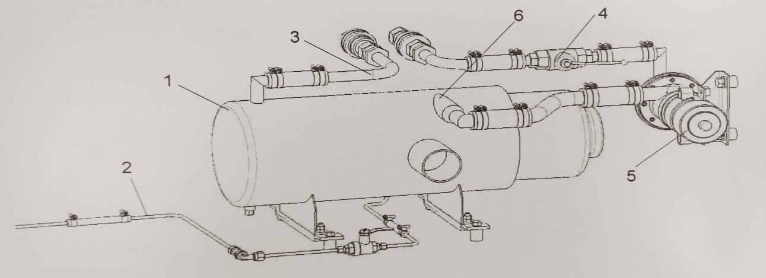
Heating System is installed in the heating compartment on the rear part of left wing plate, which is between the air filter chamber and air bottle chamber. Heating system is composed of heater, water pump, ball valve, fuel pipe lines and coolant pipe lines. The system is connected with cooling system with changeover joint.

- Heater 4. Ball valve
- Fuel supply pipeline 5. Water pump
- Water outlet pipe of heater 6. Water inlet pipe of heater
- Main Components
- Heater
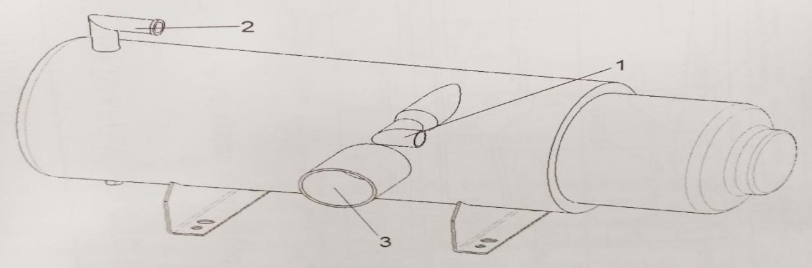
Heater is the core element of heating system, the main function of which is to heat coolant in cooling system through combusting fuel.

      - Water inlet of heater 2. Water outlet of heater 3. Smoke exhaust
- Water Pump
Water Pump is the centrifugal fuel pump of fuel supply system.The function of water pump is to ensure the circulation of coolant in heater.
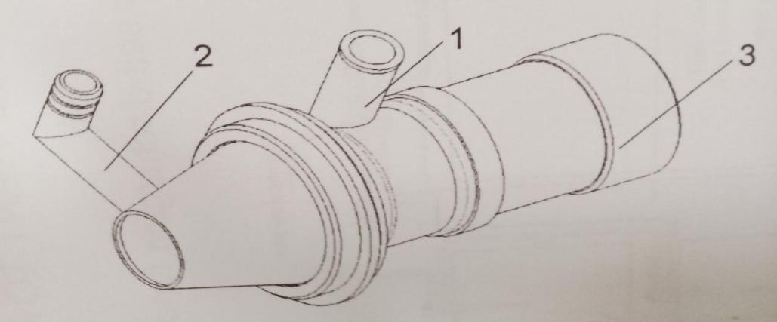

i
- Water inlet of water pump 2. Water outlet of water pump 3. Pump body
- Ball Valve
Ball valve is used for connecting or disconnecting the heating system and cooling system
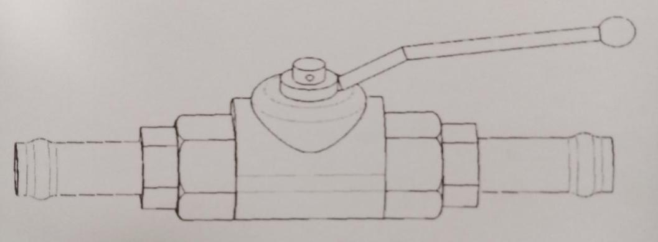

- Working Principle

When heating system is in operation, fuel comes into heater’s muzzle through heater’s fuel pipeline. The fuel is atomized and enters into combustion chamber.Fuel atomized is fired in combustion chamber with spark plug. The combusted fuel heats the coolant, which circulated in heater.
When the heater is in operation, water pump sends the coolant passing through engine to exchanger of heater. The heated coolant flows back to engine, and waste gas produced by combustion will be discharge through smoke exhaust pipeline from compartment hatch.

Spare Parts List:
S# | Nomenclature | A/U | Qty/Tk | Remarks
1 | Fixing clamp | Nos | 4
2 | Clamp | Nos | 18
3 | Clamp | Nos | 12
4 | Clamp | Nos | 8
5 | Bolt | Nos | 4
6 | Bolt | Nos | 4
7 | Bolt | Nos | 2
8 | Bolt | Nos | 2
9 | Nut | Nos | 8
10 | Washer | Nos | 2
11 | Washer | Nos | 6
12 | Bolt | Nos | 4
13 | Pipe joint | Nos | 1
14 | Nut | Nos | 4
15 | Washer | Nos | 6
16 | Washer | Nos | 2
17 | Washer | Nos | 4
18 | Washer | Nos | 4
19 | Ball valve assembly | Nos | 1
20 | Heater YJ-Q30AS-BT617 | Nos | 1
21 | Bracket | Nos | 2
22 | Quick change adapter （YZF-5004） | Nos | 2
23 | Sealing gasket | Nos | 2
24 | Hose | Nos | 2
25 | Hose | Nos | 2
26 | Hose | Nos | 2
27 | Hose | Nos | 1
28 | Heater water inlet pipe | Nos | 1
29 | Bracket | Nos | 1
30 | Sealing gasket | Nos | 4
31 | Fuel switch | Nos | 1
32 | Rubber strip | Nos | 2
33 | Hose | Nos | 2
34 | Fuel/Oil pipe | Nos | 1
35 | Fuel/Oil pipe | Nos | 1
36 | Fuel/Oil pipe | Nos | 1
37 | Clamp | Nos | 1
38 | Connection pipe | Nos | 1
39 | Fuel/Oil pipe | Nos | 1
40 | Connection pipe | Nos | 1
41 | Centrifugal fuel pump | Nos | 1
42 | Fuel/Oil pipe | Nos | 1
43 | Fuel/Oil pipe | Nos | 1
44 | Nut | Nos | 4
45 | Through wall connector | Nos | 1

//
(Items Forty Five Only)

