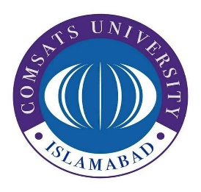
COMSATS University Sahiwal Campus
Purchase and Store Department
COMSATS Road, Off G.T.Road, Sahiwal
Tel: 040-4305666-Ext-128-186 Web: www.sahiwal.comsats.edu.pk

Invitation to Bid
(Tender No. CUI/SWL/Procurement/FY 22-23/02/153)

Procurement of Steel Iron Racks for Examination Section of CUI Sahiwal

- COMSATS University Islamabad, Sahiwal Campus, a public sector organization invites sealed bids from the reputed firms/ general order suppliers registered with income and sales tax departments and who are on active taxpayers list (ATL) of FBR for the work titled “Procurement of 14-Steel Iron Racks for Examination Section of CUI Sahiwal”.
- The procedure of open competitive bidding is Single Stage-One Envelope.
- Bidding documents, which are containing detailed terms and conditions, method of procurement, procedure for submission of bids, bid security, bid validity, opening of bid, evaluation criteria, clarification/rejection of bids, performance guarantee etc. are available for the interested bidders at “Purchase and Store Department, COMSATS Road, Off G.T.Road, Sahiwal”. The non-refundable fee of bidding document is Rs. Rs. 1,000 (One Thousand Rupees Only) in shape of pay order/Demand Draft in favor of CUI, Sahiwal.
- The bidders are required to furnish in the form of Bank deposit / CDR / Pay order equivalent to 2% of the total bid price (refundable) as a Bid Security in favor of “COMSATS University Islamabad, Sahiwal Campus”. Any bid which is not accompanied with bid security shall be rejected by the CUI, Sahiwal as non-responsive and without any right of appeal.
- The bids, prepared in accordance with the instructions in the bidding documents, must reach Purchase and Store department, COMSATS Road, Off G.T.Road, Sahiwal on or before 1430 hours on July 26, 2022 (Tuesday). Bids will be opened at 1500 hours on the same day, in the presence of bidder’s representatives who choose to attend at the same address. This advertisement is also available on the PPRA website at www.ppra.org.pk and on the Campus Website at https://sahiwal.comsats.edu.pk/Procurement/Tenders.aspx

Muhammad Umar Irshad
In-charge Purchase and Store Department
Cell No: 0300-6907240

