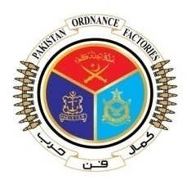
GOVERNMENT OF PAKISTAN

PAKISTAN ORDNANCE FACTORIES
WAH CANTT.

INVITATION TO BID

- POFs-(Supply Chain Management) invites sealed bids from the original Manufacturers / Authorized Dealers / Suppliers registered with Income Tax and Sales Tax Department for supply of 05 x POL items against T.E. No. 0010-LP-CMC-52-PUR-E, Dt. 30-06-2022.

- Bidding documents containing item wise detail, Specifications and all other Terms & Conditions are available for the interested bidders at the office of the undersigned OR can also be downloaded from POF Website (www.pof.gov.pk) free of cost.

- The bids completed in all respects, must reach Bid Centre on or before 25 -07-2022 but not later than closing time 1130 hrs. The Tenders will be opened at 1200 hrs on the same date.

Director Supply Chain Management
Tele: 051-9055-21088
Fax: 051-9314100
E-mail Procurement@pof.gov.pk

