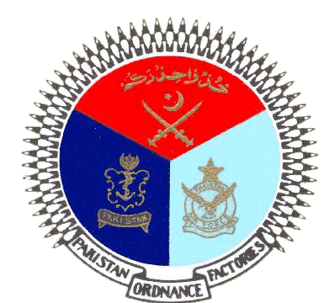 | GOVERNMENT OF PAKISTAN
 | PAKISTAN ORDNANCE FACTORIES
 | WAH CANTT

INVITATION TO BID
- POF-Clothing Factory invites sealed bids from the original Manufacturers/authorized Dealers/Suppliers registered with income tax and sales tax Department for supply of Cloth (03 Items) against T.E No. 009-LP-52-Pur-Clo, dated 28-06-2022.
- Bidding documents containing item wise detail and all other terms & conditions are available for the interested bidders in the office of the undersigned OR can also be downloaded from POF website (www.pof.gov.pk) free of cost.
- The bids completed in all respects, must reach bid center near rabita hall POFs wah cantt on or before 21-07-2022 but not later than closing time 1230 hrs. The Tender will be opened at 1300 hrs on the same date.

General Manager
Clothing Factory
Tel: 051/905522059-60
Fax: 051-9271400

Email: gmclothing@pof.gov.pk

