REGISTERED

No. 6000-B/ 133 /E-6 27 June, 2022

ASSISTANT DIRECTOR
Rizwan Mehmood
PPRA Federal Bank for
Co-operative Building 1st Floor
Sector G-5/2 Near SBP, Islamabad

REQUISITION FOR ADVERTISEMENT - NOTICE OF TENDER

1. Requisition for advertisement of MES Notice of Tender is sent herewith for
up-loading at PPRA website as desired.

2. Necessary bill on account of up-loading may be forward to this Office for payment, please.
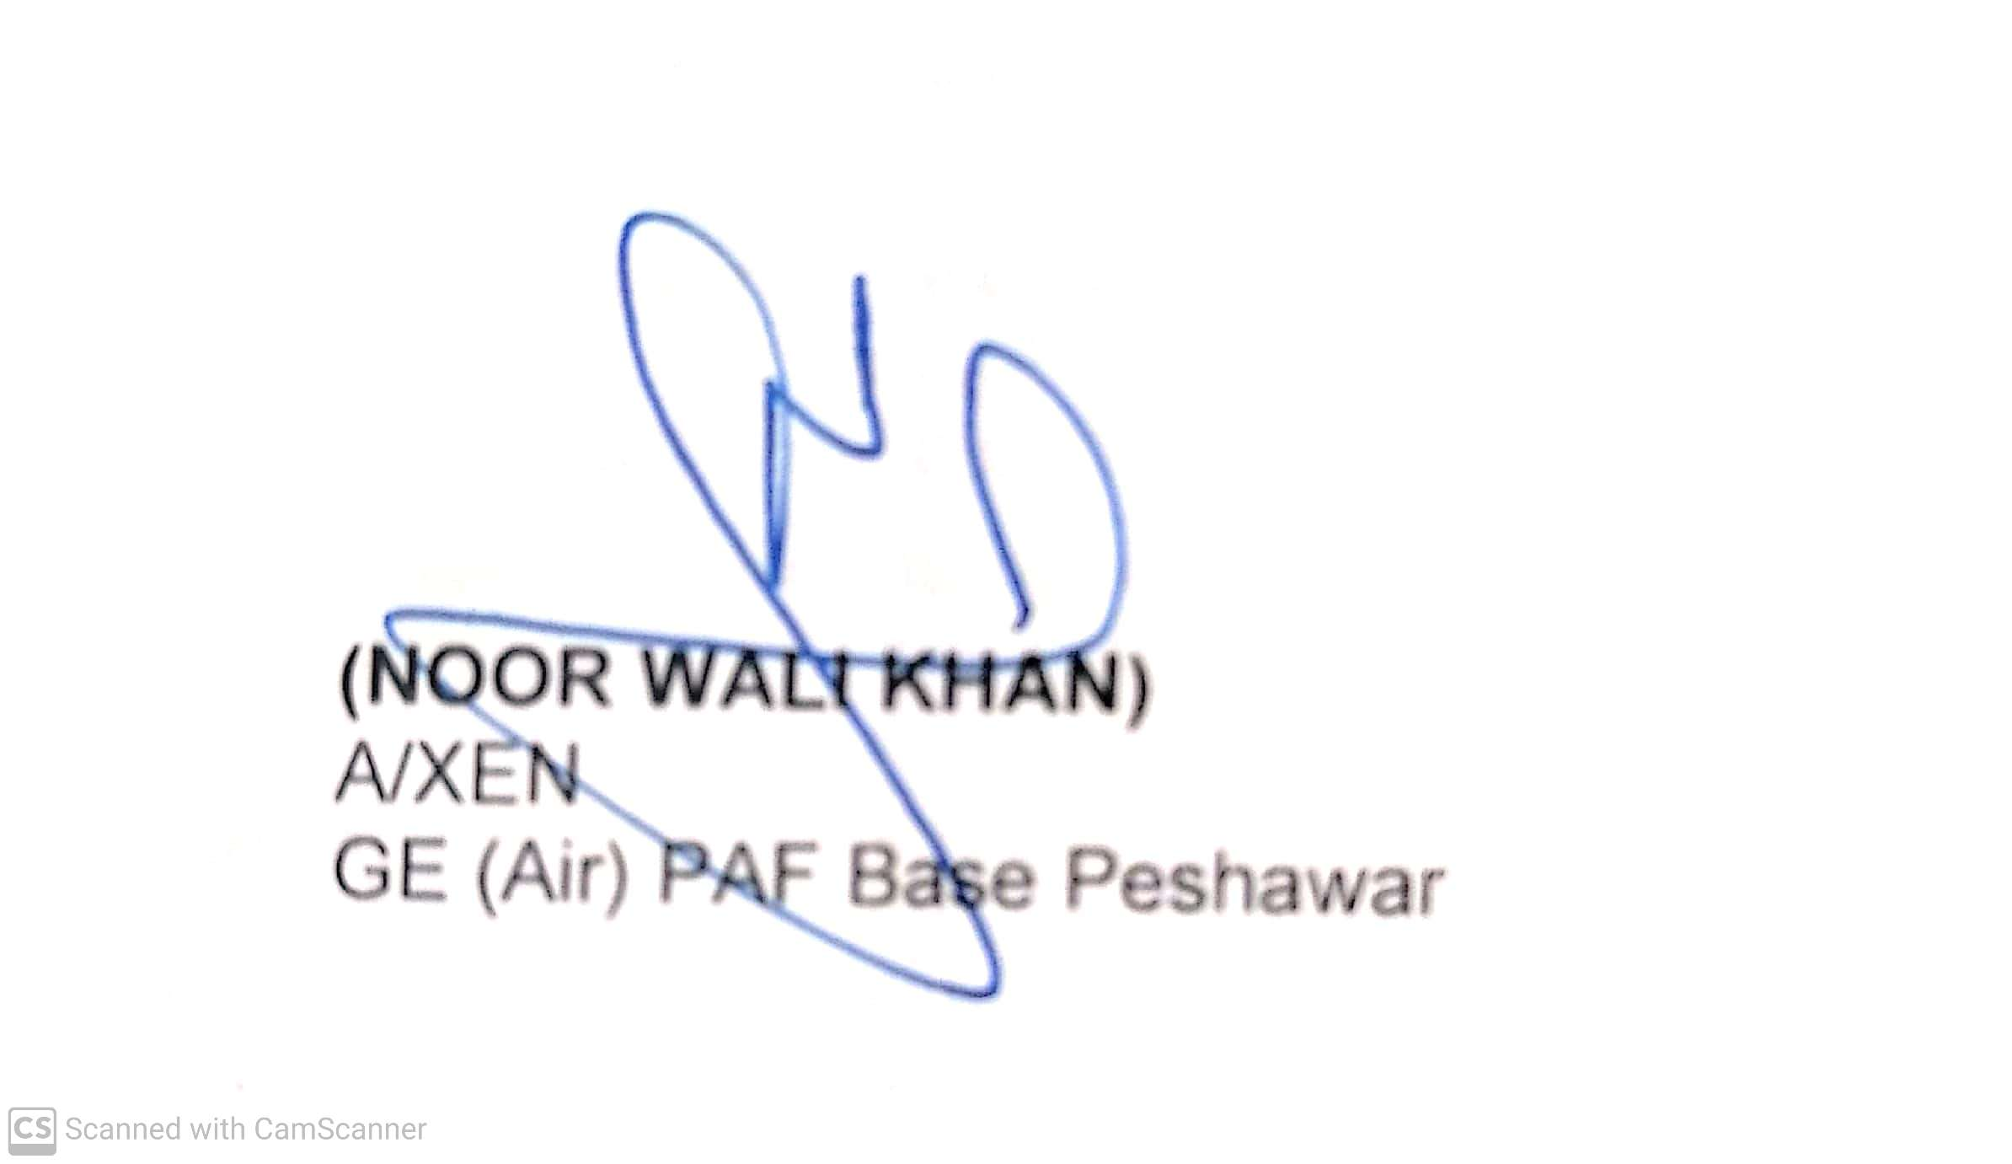
Copy to:-
SDO B&R-I (Local) | Please ensure making of payment on receipt of advertisement bill from respective agencies.

MILITARY ENGINEER SERVICES
NOTICE OF TENDER
01. The office of GE (Air) Base Peshawar invites sealed tenders for the following works in the light of PPRA Rule 13(1) of 2004.
02. |  |  |  |  |  |  |  | (M)
  S/No | Description
   | Provision of certain facilities at PAF Base Peshawar
   | Provision of certain facilities at PAF Base Peshawar
   | Provision of certain facilities at PAF Base Peshawar
   | Provision of certain facilities at PAF Base Peshawar
   | Provision of certain facilities at PAF Base Peshawar
   | Provision of certain facilities at PAF Base Peshawar
   | Provision of certain facilities at PAF Base Peshawar
   | Provision of certain facilities at PAF Base Peshawar
   | Provision of certain facilities at PAF Base Peshawar
   | Provision of certain facilities at PAF Base Peshawar
   | Provision of certain facilities at PAF Base Peshawar
   | Provision of certain facilities at PAF Base Peshawar
   | Provision of certain facilities at PAF Base Peshawar
   | Provision of certain facilities at PAF Base Peshawar
   | Provision of certain facilities at PAF Base Peshawar
   | Provision of certain facilities at PAF Base Peshawar
   | Provision of certain facilities at PAF Base Peshawar
  Rs. (M)
  Rs. 1.600 (M)
  Rs. 1.900 (M)
  Rs. 2.000 (M)
  Rs. 2.500 (M)
  Rs. 2.000 (M)
  Rs. 3.000 (M)
  Rs. 3.200 (M)
  Rs. 3.400 (M)
  Rs. 3.500 (M)
  Rs. 3.400 (M)
  Rs. 3.450 (M)
  Rs. 36.000 (M)
  Rs. 35.000 (M)
  Rs. 36.000 (M)
  Rs. 3.550 (M)
  Rs. 3.450 (M)
  Rs. 3.650 (M)
03. The contractors are required to submit their applications for issuance of tender documents alongwith their complete credentials as shown at (Serial 9). The applications shall be scrutinized and the tender documents will only be issued to the firms who have sufficient experience in the relevant field and satisfy other special conditions required for the job and area. Tenders will only be issued to the scrutinized contractors. The tender must be received by the accepting officer by 1130 Hrs on 20 July, 2022 and will be opened at 1200 Hrs on the same date.
NOTE:-Contractors shall provide certificate that they are not involved in any type of litigation with government Department in the Court of Law and that no special report of Directorate of Inspection and Evaluation (E-in-C’s Branch GHQ) is outstanding against them.
04. All contractors, will certify in writing that they are registered with Pakistan Engineering Council (PEC), and will submit a copy of their registration. Contractors not registered with PEC are ineligible to apply.
05. Contractor born on approved List of MES in Category ‘E’ and also having experience of this type of work may only apply.
06. Contractors who desire may be present at the time of opening of tenders.
07. The accepting officer reserves the right to accept or reject the tender. Rejected tenders will be dealt with as per Para 33 (i) of PPRA Rules.
08. The interested parties can contact GE (Air) PAF Base Peshawar / authorized representative for further details from 0715 to 1335 hours on all working days.
09  Sl No | Name of Work Executed during the Last 2 Years and in Hand | Agency | Amount of Work | Time Allowed (Months) | Date of commencement | Date of Completion | Percentage Progress of work in Hand |  |  | Departmental Performance Report on each Work by the Engineer in Charge
6000-B/ 133 /E-6 dated 27-06-2022

