PRINT MEDIA/PPRA WEB SITE

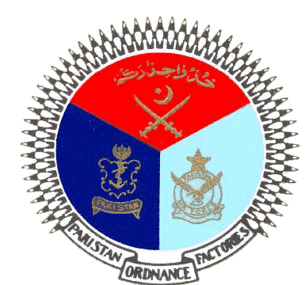 | GOVERNMENT OF PAKISTAN
 | PAKISTAN ORDNANCE FACTORIES
 | WAH CANTT

INVITATION TO BID

- POF-AA Factory invites sealed bids from the original Manufacturers/authorized Dealers/Suppliers registered with income tax and sale tax department for supply of M.S Sheet 16 BG qty.32250 kg against TE No.0003-FP-B-52-P-AA, dated 07-07-2022.
2. Bidding documents containing item wise detail, specifications and all other terms & conditions are available for the interested bidders at the office of the undersigned OR can also be downloaded from POF website (www.pof.gov.pk) free of cost.
3 The bids completed in all respects, containing technical and commercial offers separately sealed must reach on or before 25-08-2022 but not later than closing time 1200 hrs. The tenders will be opened at 1230 hrs on the same date..

Managing Director
Artillery Ammunition Factory
Tele:051-9055-21035 Fax #.0092-51-9271400
E-Mail.mdaa@pof.gov.pk 06-07-2022

