 | NATIONAL TELECOMMUNICATION CORPORATION  Office of Director Development (North) NTC,  Ground Floor, NTC RHQ’s F-5/1 Islamabad.  Ph. 051- 9209293 Fax. 051- 9205526 | 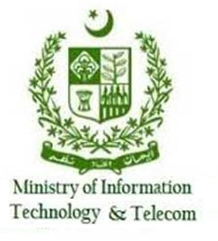

No. Dir Dev (North)/A-18/2017-18 July 07, 2022

Subject: RELEASE OF ADVERTISEMENT

Reference: i. PID letter No. 15(35)/2017-Advt dated 14-Oct-2021
ii. Ministry of I&B letter No. 15(14)/2003-Advt-15-03-2011
iii. PID letter no 15(14)/2003-Advt dated 12-04-2011

Kindly arrange publication of enclosed advertisement notice No. Dir Dev (North)/1551/01/2022-23 (Re-Tender) in the daily leading newspapers. The required information as per referred letters is as under:
Date of Publication | 15-July-2022
Language | 01 x Urdu & 01 x English
Number of Insertions and the Page Position | 01/Ordinary
Target | Ibd-Rwp/Lhr/Khi
Special Position of Form | Nil
Size | 7 x 3
Certificate of availability of funds to meet the expenditure | Sufficient funds are available to pay the bills of this advertisement

2. An early action in this regard will be highly appreciated. The advertisement must be published ONLY in the News papers as per circulation mentioned above (due to our budgetary constraints). Moreover, it is certified that the funds for the said advertisement are available with NTC.

KASHIF NAWAZ
Director Development (North)
NTC Islamabad
To:
DIRECTOR ADVERTISEMENT,
Press Information Department, Islamabad

Email to: pid.classified@gmail.com

E-Mail to: For Posting of Tender Notice on Web Sites
- DD (IT) NTC HQs [with request to post the same on NTC web site
(e-mailed to khalil.akhtar@ntc.org.pk)]
- Deputy Director -III PPRA, Islamabad [with the request to post the same on PPRA web site (e-mailed to info@ppra.org.pk)
For Information: -

- PS to M.D, NTC HQs
- Concerned files

SAY NO TO CORRUPTION
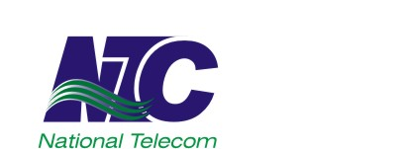 | NATIONAL TELECOMMUNICATION CORPORATION  www.ntc.net.pk
INVITATION TO BID
No. Dir Dev (North)/1551/01/2022-23 (Re-Tender)
- National Telecommunication Corporation, Official IT & Telecom Service Provider of Government of Pakistan, invites sealed bids from reputable OEM authorized firms having relevant experience, registered with tax authorities in Pakistan and Pakistan Engineering Council in Category C-5 or above with Specialization Codes EE07, EE08 and EE09 for the following work:
“Re-Tender for Supply, Installation, Testing and Commissioning of Unified Communication Server, Router, Firewall, Switches, Wireless Access Points with Controller and allied OFC Network for Establishment of LAN Infrastructure at University of Swat, Charbagh Swat”
- Detailed tender documents containing BOQ and tender terms & conditions, can be collected from the office of undersigned during working hours by depositing Rs. 1,000/- in cash (non-refundable).
- Complete bids accompanied by 2% earnest money must reach at office of undersigned which will be opened in presence of representatives of firms who choose to attend as per following schedule:
- Last Date of purchase of tender documents : August 01, 2022
Date & Time for Tender Submission : August 02, 2022 11:00 Hours
Date & Time for Tender Opening : August 02, 2022 11:30 Hours

NTC reserves the right to reject all bids at any time prior to the acceptance of bid as per PPRA’s Rule # 33 (1). This advertisement is also available on PPRA website www.ppra.org.pk and NTC website www.ntc.net.pk
Director (Development) North
Room No. 06, Ground Floor,
NTC Regional Headquarters, F-5/1, Islamabad
 051-9209293,  051-9205526

