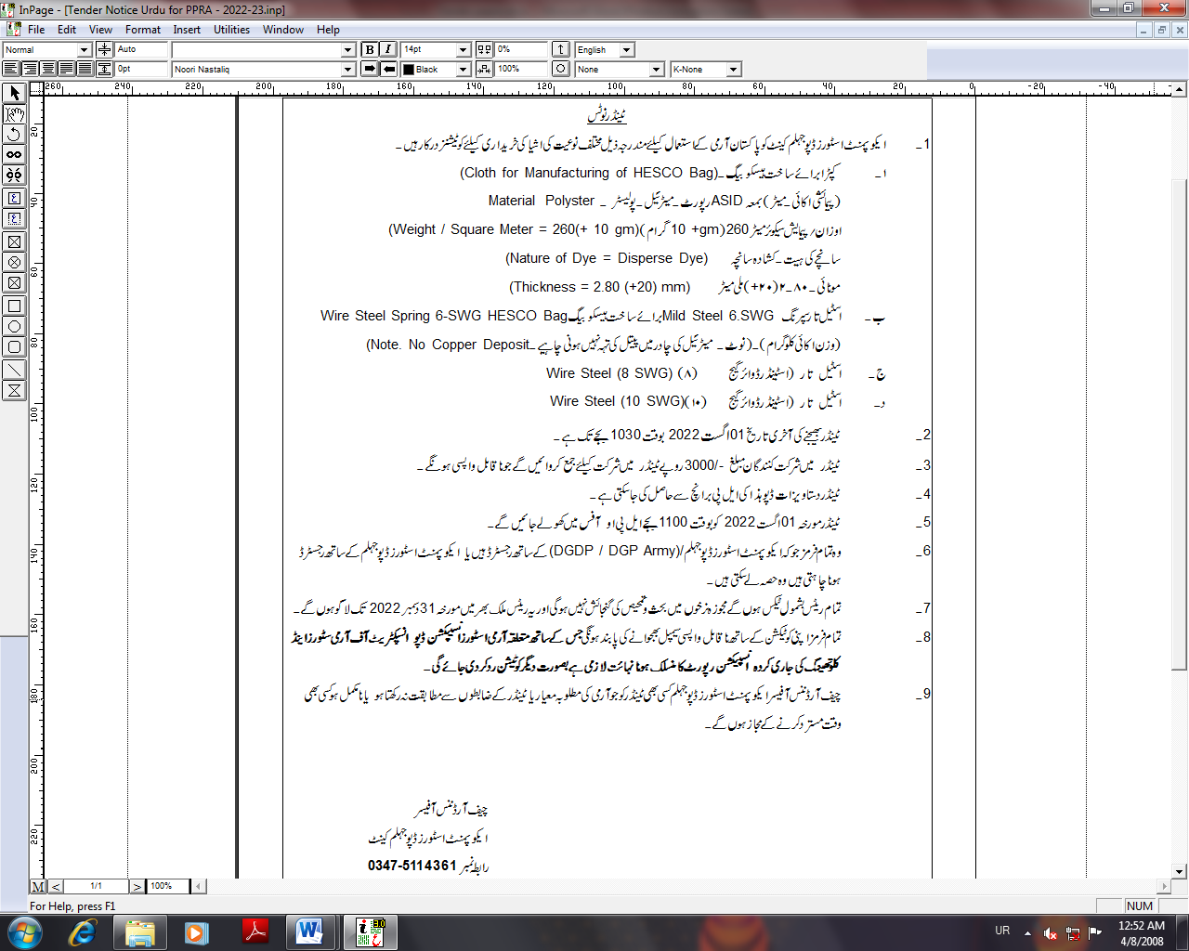

TENDER NOTICE
1. Quotations are invited by Equipment Stores Depot Jhelum Cantt for purchase of following items for use of Pakistan Army:-
Nomenclature Accounting Unit
- Colth for HESCO Bag, Material: Polyester
Weight/Square Meter: 260 (+ 10) Gram Meter
Nature of Dye: Disperse Dye
Thickness: 2.80 (+ 20) mm
- Wire Steel Spring 6 SWG for HESCO Bag Kilogram
with no copper deposit
- Wire Steel (8 SWG) Kilogram
- Wire Steel (10 SWG) Kilogram

2. The last date for submission of tenders will be at 1030 hours on 01 August 2022.
3. A cost in cash Rs. 3000/- (Three Thousand Only) will be deposited along with Tender documents which will be non-returnable.
4 Tender documents can be obtained from Equipment Stores Depot Jhelum Cantt (LP Branch).

5. Tenders will be opened at 1100 hours on 01 August 2022 in Local Purchase Officer Office.

6. All those firms who are already registered with Equipment Stores Depot Cantt/ DGDP/ DGP (Army) or willing to get themselves registered can participate

7. Quoted rates will be non-negotiable, inclusive of all taxes and will be valid throughout Pakistan upto 31 December 2022.

8. All firms will provide item samples (non-returnable) alongwith quotations whose inspection report will be carried out by Army Stores inspection Depot / Inspectorate of Army Stores and Clothing concerned. Otherwise quotation will be rejected.

9. Chief Ordnance Officer Equipment Stores Depot Jhelum Cantt reserves the right to reject any tender inquiry / quoted rates (considered contrary to the spirit of tender competition / incomplete / low quality samples or samples not of required army specification) at any stage.

Chief Ordnance Officer
Equipment Stores Depot Jhelum Cantt
Cell # 0347-5114361

INVITATION TO TENDER

Ser | Part Number | Nomenclature | A/U | Rate
 | KC/PKC-2207 | Cloth of HESCO Bag | Mtr
 | G2/9505-ZO-101-9008 | Wire Steel Spring 6 SWG | Kg
 | G2/9505-ZO-101-3249 | Wire Steel Mild Round 4.064 MM Dia (8 SWG) | Kg
 | G2/9505-ZO-101-3248 | Wire Steel Mild Round 3.251 MM Dia (10 SWG) | Kg

