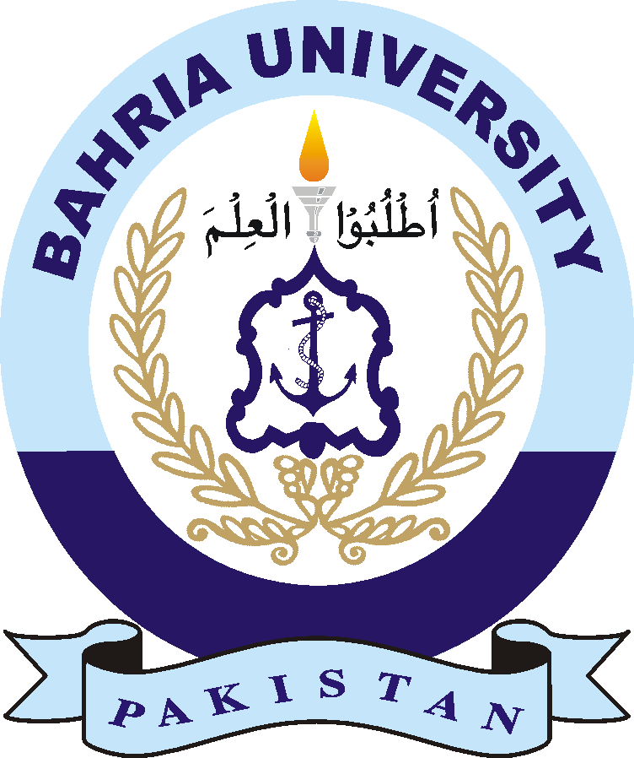
BAHRIA UNIVERSITY HEAD OFFICE ISLAMABAD
Discovering Knowledge

INVITATION TO BIDS

Ref. BU/P&D/Wall/CoE-AI/2022 Dated: 07 July 2022

BRANDING WALL & ORNAMENTATION OF COE-AI AT BAHRIA UNIVERSITY HEAD OFFICE, ISLAMABAD

1. Sealed bids are invited from firms registered with Tax department and valid NTN Number for BRANDING WALL & ORNAMENTATION OF CENTRE OF EXCELLENCE AND ARTIFICIAL INTELLIGENCE (COE-AI) AT BAHRIA UNIVERSITY HEAD OFFICE, ISLAMABAD. Complete detail of work is held in Bidding Documents. Interested firms with relevant experience may purchase bidding documents containing detailed specifications of required works from office of the DD (Development), Head Office Quaid Block Basement Room No.09 against payment through pay order of Rs. 1,000/- (non-refundable) in favour of “Bahria University Islamabad” till 27 July 2022. NTN of BU is 2132767-0.

2. Single stage one envelope tendering procedure shall be followed. Sealed bids supported by Tax registration / professional certificate should reach on / or before 28 July at 1000 hours. Technical bids will be opened on the same day at 1030 hours in the presence of the bidders. Conditional / incomplete bids will be considered Non Responsive. Bids received late from closing date and time will not be entertained. 2% of total bid value as bid security in shape of PO in favour of “Bahria University Islamabad” should be submitted.

3. The bidders are requested to give best quality and final prices inclusive of all applicable taxes & transportation charges etc. Bahria University may reject all bids or proposals at any time prior to the acceptance of a bid or proposal by invoking rule 33 of PPRA-2004.

4. For any further information required, please contact on Ph No. 051-9261930 & 9260002 Ext 1285 & 1638.

Director (P&D)
Bahria University Head Office, Shangrila Road, Sector E-8,
Islamabad
Phone No.051-9261930 Ext 1638 & 1285

