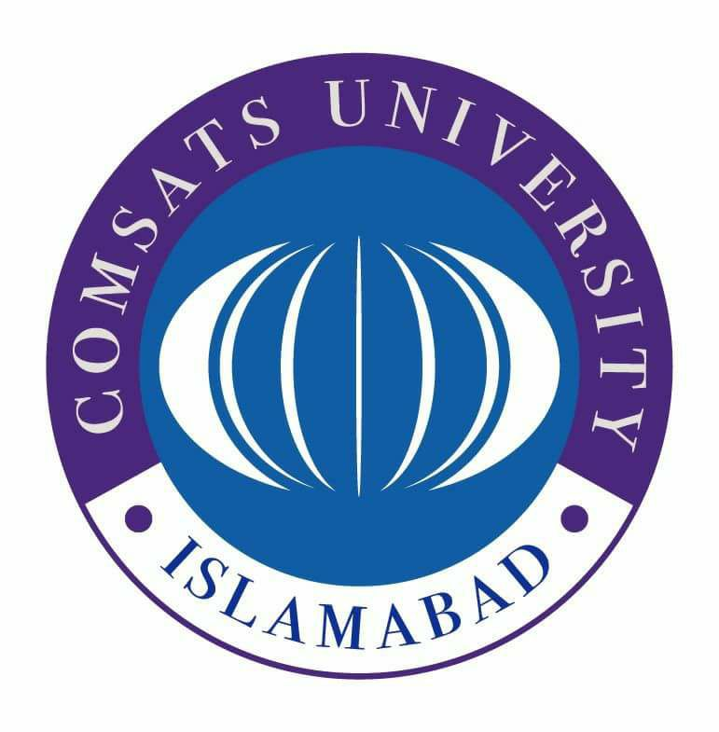
COMSATS University Islamabad,
Sahiwal campus
Works Department
COMSATS Road, Off G.T.Road, Sahiwal
Tel: 040-4305004 Web: www.cuisahiwal.edu.pk

Tender Notice
(No. COMSATS/SWL/WD/1042/22-23/20.07.2022)

- COMSATS University Islamabad (CUI), Sahiwal Campus, a public sector University of Ministry of Science and Technology invites sealed bids from the reputed firms/Contractors registered with Pakistan Engineering Council in appropriate category for the following works: -
  - Repairing of sunny grey marble floor laid at corridors of Management Sciences Department
  - Providing & fixing of Aluminum Glass Partition at visitor’s room / PA to Director’s office
- Bidding documents, which are containing detailed terms and conditions, method of procurement, procedure for submission of bids, bid security, bid validity, opening of bid, clarification/rejection of bids, performance guarantee etc. are available for the interested bidders at “Works Department, COMSATS Road, Off G.T.Road, Sahiwal”. Non-refundable fee of bidding document is
Rs. 1000/- (One Thousand only for each) in shape of pay order/Demand Draft in favor of CUI, Sahiwal Campus.
- The bids, prepared in accordance with the instructions in the bidding documents, must reach at “Works Department, COMSATS Road, Off G.T.Road, Sahiwal” on or before 1030 hours on August 05 (Friday), 2022. Bids will be opened at 1100 hours on the same day, in the presence of bidder’s representatives who choose to attend at the same address. This advertisement is also available on PPRA website at www.ppra.org.pk and on the Campus Website at https://www.sahiwal.comsats.edu.pk/Procurement/Tenders.aspx.

ALI SHAIR
Incharge Works / Assistant Engineer
COMSATS University Islamabad,
Sahiwal Campus
works@cuisahiwal.edu.pk

