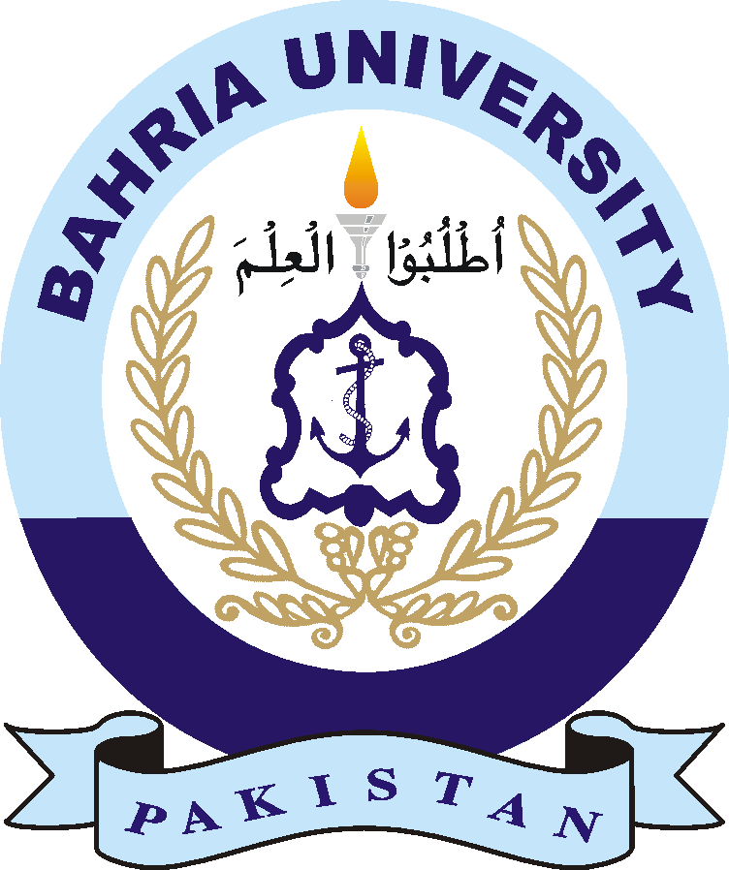BAHRIA UNIVERSITY HEAD OFFICE ISLAMABAD
Discovering Knowledge

TENDER NOTICE
REQUEST FOR PROPOSAL

Ref. BU/BUMDCI/PROJ/DG-01/2022 Dated: July 2022

INSTALLATION AND COMMISSIONING OF 250 KVA DIESEL GENERATOR FOR BUMDCI MEDICAL COLLEGE AT NAVAL ANCHORAGE ISLAMABAD

1. Project Directorate invites sealed bids for Installation, Commissioning, Testing and Training etc of 250 KVA Diesel Generator for BUMDCI Medical college at Naval Anchorage Islamabad as one package / job from firms, original manufactures / their authorized distributors / suppliers in Pakistan registered with relevant Tax Department.

2. Bidding Documents, containing specification detailed terms and conditions, method of procurement, procedure for submission of bids, bid security, bid validity, opening of bid, evaluation criteria, clarification / rejection of bids, performance and guarantee etc are available for the interested bidders at BUMDCI SECRETARIAT, Head Office Building, Quaid Block, Bahria University Islamabad. Price of Bidding Documents is Rs.2,000/- (Rupees Two Thousand only) (non-refundable through pay order) available till 28 July 2022.

3. Pre-bid meeting will be held at 1100 hrs on 28 July 2022 in the office of Project director (BUMDCI) Islamabad Campus along with visit of site. President Technical Scrutiny Committee will also attend the meeting.

4. The bids prepared in accordance with instructions in the bidding documents must reach at BUMDCI Secretariat, Bahria University Head Office Islamabad by 1100 hrs on 10 August 2022 or before. Only technical proposal will be opened on same day at 1130 hrs by the standing purchase committee in Project Director Office in presence of the bidders who may choose to be present. The same will be evaluated by Technical Scrutiny Committee. Date time of opening of financial proposals of shortlisted firms will be intimated later on through mail/phone. The University has the right to reject all or any bid prior acceptance by invoking rule 33 of PPRA. For any information, please contact Project Manager on Phone Number 051-20063696, / 051-9263409 & 051-111-111-028 Ext 1408, 1654.

Project Directorate BUMDCI
President Standing Purchase Committee
Bahria University Head Office Sector E-8,
Shangrila Road, Naval Complex, Islamabad

