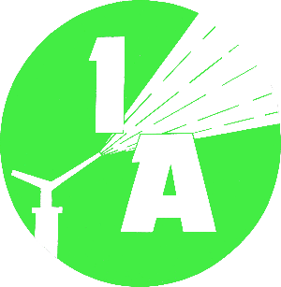
Irrigation Authority
PROCUREMENT NOTICE
(Authorised under Section 16 of the Public Procurement Act 2006)
OPEN NATIONAL BIDDING

Supply, Installation, Testing and Commissioning of a Filtration Plant for Northern Plains Irrigation Project – Phase 1 – Drip Irrigation

Procurement Reference No: OMD/FILTRATIONPLANT/06/22

- The Irrigation Authority invites eligible local Contractors to submit their Bid for the Supply, Installation, Testing and Commissioning of a Filtration Plant for Northern Plains Irrigation Project-Phase 1- Drip Irrigation under this Open National Bidding exercise.

- The bidding documents can be downloaded from the Procurement Policy Office Portal http://publicprocurement.govmu.org

- The pre-meeting/site visit will be held on Friday 8th April 2022 at 10:00 hrs at the Sub Office at Plaine des Papayes.

- Bids must be deposited in the Tender Box situated at the address below on or before Tuesday 26th April 2022 by 14:30 hrs at latest. Electronics bidding shall not be permitted. Late bids will be rejected. Bids will be opened in the presence of the bidders’ representatives who choose to attend in person at the address below at 15:00 hrs on Tuesday 26th April 2022.

- The address referred to, in paragraph 4 above is:
Irrigation Authority
5th Floor, Fon Sing Building,
12, Edith Cavell Street, Port Louis
Tel: 210-6596
Fax: 212-7652
Email: irrig@irrig.org

- The Irrigation Authority may, at any time prior to the acceptance of a bid, reject all bids, or cancel the procurement proceedings without thereby incurring any liability to any bidder.

Date: 24.03.2022

