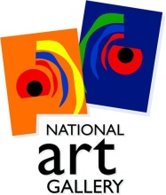
NATIONAL ART GALLERY
Operating under the aegis of the Ministry of Arts and Cultural Heritage
Press Notice
Renting of Office Space for National Art Gallery

1. The National Art Gallery operating under the aegis of the Ministry of Arts and Cultural Heritage intends to rent a building in the range of 500m² to 520m² in the region of Port Louis, Reduit, Rose Hill, Ebene and Quatre Bornes as office space for a period of one (1) year as from the date of taking over of the building and renewable upon mutual agreement of the parties for further periods of one(1) year on such terms and conditions as may be agreed upon by both parties.

2. Bidding documents will be available as from 06 April 2022 by downloading free of charge from the public procurement portal publicprocurement.govmu.org.

3. Deadline for submission of bids has been scheduled on 29 April 2022 up to 10 30 hours.

National Art Gallery
c/o Ministry of Arts and Cultural Heritage
7th Floor, R. Seeneevassen Building, Cnr Pope Hennessy & Maillard Streets,
Port Louis.

Date: 06 April 2022

