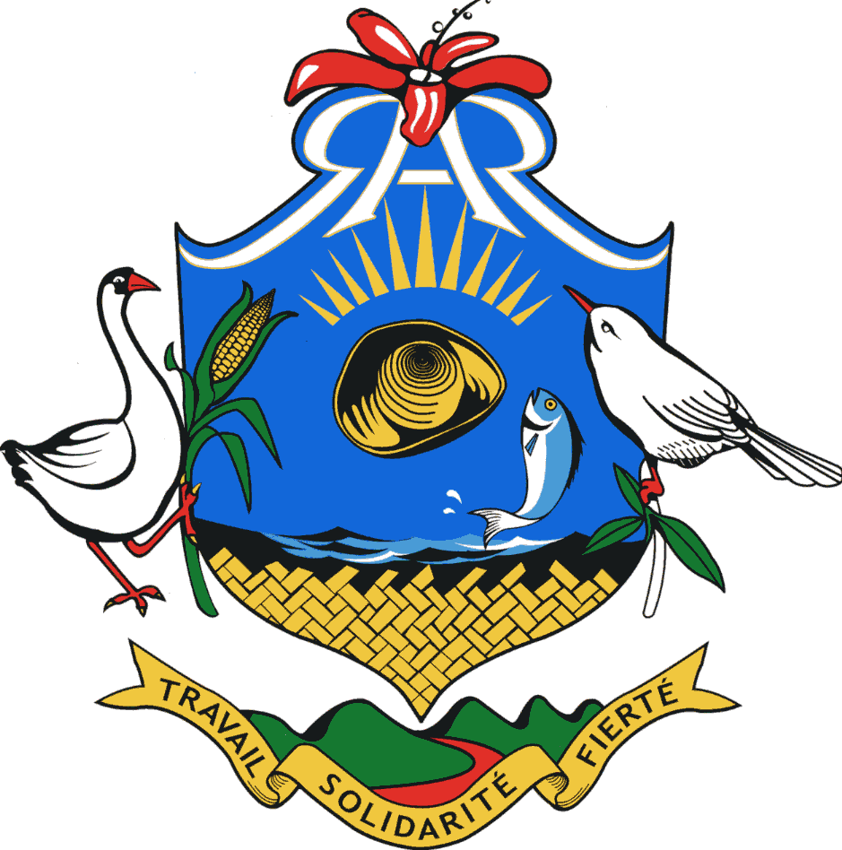

CHIEF COMMISSIONER’S OFFICE
COMMISSION FOR WATER RESOURCES & OTHERS

RODRIGUES REGIONAL ASSEMBLY

INVITATION FOR BIDS

Authorized under Section 16(1) of the Public Procurement Act 2006

OPEN NATIONAL BIDDING (ONB)

RRA/CCO/WR/ONB/G/5 of 2021-2022

The Commission for Water Resources and Others invites Bids from eligible and qualified bidders for the “Supply, Delivery and Commissioning of Water Lorry Tanker, Double Cab Lorry and Lorry with Crane”

The deadline for submission of bids is Thursday, 26th May 2022 up to 13.00 (local time) at latest. Electronic bidding is permitted.

The bidding document may be downloaded from the Procurement Policy Office website: publicprocurement.govmu.org

For further details, please consult the Public Procurement Portal: publicprocurement.govmu.org

Commission for Environment and Others
Ex-Water Company Building
Port Mathurin
Rodrigues
25 April 2022

1st Floor, Mutual Aid Building, Port Mathurin, Rodrigues, Tel: 8321812

