

Open National Bidding
for Works
THE JUDICIARY

Issued on: 29th June 2022

Variable Refrigerant Volume

Air Conditioning System at

New Court House

_______________________________
_______________________________

Procurement Reference No: ONB/10/2021-2022

The Judiciary
Supreme Court Building
Edith Cavell Street
Port-Louis
Tel: 260 4100

Section I: Instruction to Bidders

1.Introduction
The Judiciary also referred as the Employer, invites eligible local contractors to submit their bid for the works described in detail hereunder. Any resulting contract shall be subject to the terms and conditions referred to in this document.

The Works are Variable Refrigerant Volume Air Conditioning System at New Court

House.
Participation is limited to citizens of Mauritius or entities incorporated in Mauritius. Joint
Ventures should be among entities incorporated in Mauritius

  - Clarifications, if any, should be addressed to:
Master and Registrar
Supreme Court Building
Edith Cavell Street
Port- Louis
Tel No.: 260-4100
Email address: cmbujun@govmu.org
The Employer will respond in writing to any request for clarification, provided that such request is received 14 days prior to the deadline for submission of bids.
The Employer shall respond to such request at latest 7 days prior to the deadline set for submission of bids.
1.2 Bidders are advised to carefully read the complete Bidding document, including the Particular Conditions of Contract in Section IV, before preparing their bids. The standard forms in this document may be retyped for completion but the Bidder is responsible for their accurate reproduction.

2. Validity of Bids
The bid validity period shall be ninety (90) days from the date of bid submission deadline.

3. Works Completion Period
The Intended Completion period is fourteen (14) months as from start date.

4. Mandatory Site Visit
Bidders or their designated representatives are invited to attend a pre-bid meeting on Wednesday 13th July 2022 at 10.30hrs at The New Court House. For more information, please liaise with Mr K. Murdamootoo, Office Management Executive, on Tel No. 210-2310. The purpose of the pre-bid meeting will be to clarify issues and to answer questions on any matter that may be raised at that stage.

5. Sealing and Marking of Bids
Bids should be sealed in a single envelope, clearly marked with the Procurement Reference Number, addressed to the Public Body with the Bidder’s name at the back of the
envelope.

6. Submission of Bids
Bids should be deposited in the Bid Box located at The Ground Floor of The Supreme Court Building, Edith Cavell Street, Port-Louis not later than Tuesday 02nd August 2022 at 11.00 hrs. Bids by post or hand delivered should reach the above-mentioned address by the same date and time at latest. Late bids will be rejected. Bids received by e-mail will not be considered.

7. Bid Opening
Bids will be opened by the “Public body” at The Ground Floor of The Supreme Court Building, Edith Cavell Street, Port-Louis at Tuesday 02nd August 2022 at 11.10 hrs. Bidders or their representatives may attend the Bid Opening if they choose to do so.

8. Evaluation of Bids
The Public Body shall have the right to request for clarification during evaluation. Offers that are substantially responsive shall be compared on the basis of evaluated cost to determine the lowest evaluated bid.

9. Eligibility Criteria
To be eligible to participate in this bidding exercise, Bidder should:
- have the legal capacity to enter into a contract to execute the works;
- be duly registered with the CIDB under the grade that would allow him to perform the value of works for which he is submitting his bid. ( Note 1)
- not be insolvent, in receivership, bankrupt, subject to legal proceedings for any of these circumstances or in the process of being wound up;
- not have had your business activities suspended;
- not be under a declaration of ineligibility by the Government of Mauritius in accordance with applicable laws at the date of the deadline for bid submission or appearing on the ineligibility lists of African Development Bank, Asian Development Bank, European Bank for Reconstruction and Development, Inter-American Development Bank Group and World Bank Group;
- not have a conflict of interest in relation to this procurement requirement; and
- have a Business Registration Card.

Note 1 Sub-contractors undertaking works are also subject to registration with CIDB as applicable to Contractors.

10. Qualification and Experience Criteria
Bidders should have the following minimum qualifications and experience:
(a) valid registration certificate with the CIDB under the grade that will enable the contractor to perform the works quoted for, under the following classes: Mechanical Works and Electrical Works;
(b) experience in two works of a similar nature over the last 5 years, each of value not less than MUR 10 Millions;
(c) One Registered CRPE Professional Engineer with at least five years post registration experience in Electrical and Mechanical Ventilation / Building Services;

(d) minimum amount of liquid assets and/or credit facilities net of other contractual commitments of the Bidder of MUR One Million.

11. Contents of bid
The Bid shall comprise the following:
(a) duly filled Bid Submission Form;
(b) duly filled Priced Bill of Quantities
(c) duly filled Qualification Information Form and attachments required
(d) report on the financial standing of the Bidder for the last three years, such as certified copies of Financial Statements or Audited Accounts as filed at the
Registrar of Companies before the deadline set for submission of bids
(e) Valid Registration certificate with the CIDB, as applicable
(f) Signed C.V of CRPE Registered Engineer;
(g) Documentary evidence of liquid assets and/or credit facilities (Note 1);
(h) Any other documents deemed necessary as per the requirements of this bidding document

Note 1
Bidders to demonstrate access to, or availability of, financial resources such as liquid assets, lines of credit, and other financial means, other than any contractual advance payments to meet the overall cash flow requirements for the contract and its current commitments. Documentary evidence may comprise but not limited to Bank certificate, Certificate from Auditors, Certificate from a Professional Accountant registered with MIPA, Certificate from Insurance companies.

12. Joint Venture
Bids submitted by a joint venture of two or more firms as partners shall comply with the following requirements:
- the Bid shall include all the information required as per the Qualification
Information form for each joint venture partner;
- the Bid shall be signed so as to be legally binding on all partners;
- the Bid shall include a copy of the agreement entered into by the joint venture
partners defining the division of assignments to each partner and establishing that all partners shall be jointly and severally liable for the execution of the Contract in accordance with the Contract terms; alternatively, a Letter of Intent to execute a joint venture agreement in the event of a successful bid shall be signed by all partners and submitted with the bid, together with a copy of the proposed agreement;
- one of the partners shall be nominated as being in charge, authorized to incur liabilities, and receive instructions for and on behalf of any and all partners of the joint venture; and
- the execution of the entire Contract, including payment, shall be done
exclusively with the partner in charge.

13. Prices and Currency of Payment
Bidders should quote for the whole works. Prices for the execution of works shall be quoted and fixed in Mauritian Rupees. Items for which no rate or price is entered by Bidders, shall not be paid for by the Public Body when executed and shall be deemed covered by the other rates and prices in the Bill of Quantities.
Bids shall cover all costs of labour, materials, equipment, overheads, profits and all associated costs for performing the works, and shall include all duties. The whole cost of performing the works shall be included in the items stated, and the cost of any incidental works shall be deemed to be included in the prices quoted. Bidders are required to submit their bid prices exclusive of VAT.

14. Bid Securing Declaration
Bidders are required to subscribe to a Bid Securing Declaration in the Bid Submission Form.

15. Margin of Preference
Margin of Preference shall not apply.

16. Award of Contract
The Bidder having submitted the lowest evaluated responsive bid and qualified to perform the works shall be selected for award of contract. Award of contract shall be by issue of a Letter of Acceptance in accordance with terms and conditions contained in Section IV: General Conditions of Contract and Particular Conditions of Contract.

17. Performance Security and signing of contract
Within twenty-eight (28) days of the receipt of the Letter of Acceptance from the Employer, the successful Bidder shall furnish a Performance Security, in the amount equal to 10% of the Bid price (exclusive of VAT), in accordance with the conditions of contract, using for that purpose the Performance Security Form included in Section V Contract Forms.
The contract agreement shall be signed within 28 days after the successful bidder receives the letter of acceptance unless the parties agree otherwise.
Failure of the successful Bidder to submit the above-mentioned Performance Security or sign the contract within the required time may constitute sufficient grounds for the annulment of the award.

18. Notification of Award and Debriefing
Prior to the expiration of the period of bid validity, the Employer shall, for contract amount above Rs 15 million, notify the selected bidder of the proposed award and accordingly notify unsuccessful bidders. Subject to Challenge and Appeal, the Employer shall notify the selected Bidder, in writing, by a Letter of Acceptance for award of contract. Until a formal contract is prepared and executed, the notification of award shall constitute a binding Contract.
The Public Body shall after award of contract, exceeding Rs 1 million and up to Rs 15 million, promptly inform all unsuccessful bidders in writing of the name and address of the successful bidder and the contract amount.
Furthermore, the Public Body shall attend to all requests for debriefing for contract exceeding Rs 1 million, made in writing within 30 days the unsuccessful bidders are informed of the award.

19. Advance Payment
The Public Body shall provide an Advance Payment on the Contract Price as stipulated in the General Conditions of Contract. The Advance Payment shall be guaranteed by an Advance Payment Security as per the format contained in Section V.
The Advance Payment shall be limited to 10% percent of the Contract Price, less any provisional and contingencies sums.

20. Integrity Clause
The Public Body commits itself to take all measures necessary to prevent corruption and ensures that none of its staff, personally or through his/her close relatives or through a third party, will in connection with the bid for, or the execution of a contract, demand, take a promise for or accept, for him/herself or third person, any material or immaterial benefit which he/she is not legally entitled to.

21. Rights of Public Body
The Judiciary reserves the right:
(a) to split the contract as per the lowest evaluated cost per lot; and
(b) to accept or reject any bid or to cancel the bidding process and reject all bids at any time prior to contract award without incurring any liability to the Public body.

22. Challenge and Appeal
Unsatisfied bidders shall follow procedures prescribed in Regulations 48, 49 and 50 of
the Public Procurement Regulations 2008 to challenge procurement proceedings and award of procurement contracts or to file application for review at the Independent Review Panel.
    - The address, Tel. No. & Email address to file Challenges in respect of this procurement is:
Master & Registrar
Supreme Court Building
Edith Cavell Street
Port-Louis
Mauritius
Tel No: 260-4100
Email: mnunhuck@govmu.org

    - The address to file Application for Review is:
The Chairperson
Independent Review Panel,
5th Floor,
Belmont House
Intendence Street
Port Louis
Tel : +230 2602228
Email : irp@govmu.org

Section II: Bidding Forms

Note: Bidders are required to fill all the forms in this section and submit as part of their bid. Non-submission of any form may lead to rejection of the bid
Bid Submission Form

Date: _______________
Bid’s Reference No.: _______________
Procurement Reference No:……………………

To:

We, the undersigned, declare that:

- We have examined and have no reservations to the Bidding Documents, including Addenda issued;
- We offer to execute in conformity with the Bidding Documents the following Works: ____________________________________________________________;
- The total price of our Bid excluding VAT is: _____________________(MUR):
- Our bid shall be valid for a period of ninety (90) days from the date fixed for the bid submission deadline in accordance with the Bidding Documents or up to ………………., whichever is later, and it shall remain binding upon us and may be accepted at any time before the expiration of that period;
- We hereby confirm that we have read and understood the content of the Bid Securing Declaration attached hereto and subscribe fully to the terms and conditions contained therein, if required. We understand that non-compliance to the conditions mentioned may lead to disqualification.
- If our bid is accepted, we commit to obtain a Performance Security in accordance with the Bidding Document;
- We, including any subcontractors or suppliers for any part of the contract, do not have any conflict of interest in accordance with ITB 8;
- We are not participating, as a Bidder in more than one bid in this bidding process;
- Our firm, its affiliates or subsidiaries, including any Subcontractors or Suppliers for any part of the contract, has not been declared ineligible under the laws of Mauritius;
- We have taken steps to ensure that no person acting for us or on our behalf will engage in any type of fraud and corruption as per the principles described hereunder, during the bidding process and contract execution:

- We shall not, directly or through any other person or firm, offer, promise or give to any of the Public Body’s employees involved in the bidding process or the execution of the contract or to any third person any material or immaterial benefit which he/she is not legally entitled to, in order to obtain in exchange any advantage of any kind whatsoever during the tender process or during the execution of the contract.
- We shall not enter with other Bidders into any undisclosed agreement or understanding, whether formal or informal. This applies in particular to prices, specifications, certifications, subsidiary contracts, submission or non-submission of bids or any other actions to restrict competitiveness or to introduce cartelisation in the bidding process.
- We shall not use falsified documents, erroneous data or deliberately not disclose requested facts to obtain a benefit in a procurement proceeding.
We understand that transgression of the above is a serious offence and appropriate actions will be taken against such bidders.

- We understand that this bid, together with your written acceptance, shall constitute a binding contract between us, until a formal contract is prepared and executed;
- We understand that you are not bound to accept the lowest evaluated bid or any other bid that you may receive; and
- If awarded the contract, the person named below shall act as Contractor’s Representative:
Name:
In the capacity of:
Signed:
Duly authorized to sign the Bid for and on behalf of:
Date:
Seal of Company

Appendix to Bid Submission Form

Bid Securing Declaration

By subscribing to the undertaking in the Bid Submission Form:
I/We accept that I/we may be disqualified from bidding for any contract with any Public Body for the period of time that may be determined by the Procurement Policy Office under section 35 of the Public Procurement Act, if I am/we are in breach of any obligation under the Bid conditions, because I/we:
- have modified or withdrawn my/our bid after the deadline for submission of bids during the period of bid validity specified by the Bidder in the Bid Submission Form; or
- have refused to accept a correction of an error appearing on the face of the bid; or
- having been notified of the acceptance of our bid during the period of bid validity, (i) have failed or refused to execute the Contract, if required, or (ii) have failed or refused to furnish the Performance Security, in accordance with the Instructions to Quote.
I/We understand this Bid Securing Declaration shall cease to be valid (a) in case I/we am/are the successful bidder, upon our receipt of copies of the contract signed by you and the Performance Security issued to you by me/us ; or (b) if I am/we are not the successful Bidder, upon the earlier of (i) the receipt of your notification of the name of the successful Bidder; or (ii) thirty days after the expiration of the validity of my/our bid.
In case of a Joint Venture, all the partners of the Joint Venture shall be jointly and severally liable.

Qualification Information
[The information to be filled in by bidders in the following pages shall be used for purposes of post-qualification or for verification of prequalification as provided for in ITB Clause 6. This information shall not be incorporated in the Contract. Attach additional pages as necessary. Pertinent sections of attached documents should be translated into English. If used for prequalification verification, the Bidder should fill in updated information only.]

1. Individual Bidders or Individual Members of Joint Ventures | 1.1 Constitution or legal status of Bidder: [attach copy]  Place of registration: [insert]  Principal place of business: [insert]
1.2 Bidder shall provide [insert number] of works of a nature and amount similar to the Works performed as Contractor over the last 5 years.

Project/Contract name and country | Name of client and contact person | Type of work performed and year of completion | Value of contract  (national currency )
(a)

(b)

1.3 Proposed subcontracts and firms involved. Refer to General Conditions of Contract Clause 7.

Sections of the Works | Value of subcontract | Subcontractor  (name and address) | Experience in similar work
(a)

(b)
[Bidders have to ascertain that sub-contractors executing works are duly registered with the CIDB in accordance with CIDB Act 2008.

1.4 Name, address, and telephone, telex, and facsimile numbers of banks that may provide references if contacted by the Public Body.

2. Additional 2.1 Bidders should provide any additional information Requirements requested in the Bidding Document.

Section III: Statement of Requirements

SECTION A
SCOPE OF WORKS

- INSTALLATION TO COMPLY WITH THIS SPECIFICATION
This Specification details the intrinsic properties (including materials and workmanship) required of an air conditioning installation.

The installation shall comply in every respect with this Specification unless otherwise specified in the Particular Specifications, the Drawings and/or the Standard/Guidance Drawings relating to a particular job or modified by written instruction of the Engineer.

The Bidder should firstly check that he is in the possession of a complete set of Bid Documents and by reference to index and content summary pages; he should ensure that all pages are in correct sequence and that none is missing. Any discrepancy or other irregularity should be immediately notified to the Client.

The BOQ and schedule has been prepared with a view to provide a common basis for biding. Before submission of bid, it is deemed that the Bidder has acquainted himself with all conditions prevailing on site. All the Specifications, Priced Activity Schedule, Drawings are complementary and should be read accordingly. The Bidder is advised to carry out measurement and check the quantities of materials. In case of discrepancies, omissions or errors, the Bidder shall inform the Director of Energy Services Division prior to submission of the bid. No extra claim shall be entertained afterwards on this issue.

The Bidder is advised to read carefully these instructions and to ensure that he has complied therewith in all respects on submitting the bid.

- SCOPE OF WORKS
The scope of works shall consist of but not limited to the supply, installation, testing and commissioning of the following:
- Supply and installation of Cables, Distribution Boards, Double Pole Switches, cable management and switchgears necessary for the Air Conditioning System
- Sizing, Supply and installation of Variable Refrigerant Volume (VRV) systems
- Testing & Commissioning

The contractor shall supply, install, test and commission Air Conditioning Works and Equipment in the manner set out in the non-exhaustive specifications or where not set out, to the satisfaction of the ESD Engineer and all reasonable variations on site shall be carried out in accordance with such directives as the Engineer may give. It is to be understood that the project shall be completed for the fixed sum bided and accepted inclusive of any item which might not be elaborated in the Specifications, Priced Activity Schedules (Bill of Quantities / Breakdown of Contractor’s Price), Drawings but deemed necessary for the completion of the project and proper functioning of the System / Equipment.

- VOLTAGE COVERED BY THIS SPECIFICATION
Unless otherwise specified, all apparatus, equipment, materials and wiring shall be suitable for use with a Single Phase/3-phase and neutral, 4-wire, 400/230 VAC ± 6%, 50 Hz.

- SITE VISIT
Bidder is advised to visit the site before submission of bid so as to be fully acquainted with the nature of the site and extent of work involved. Bidder shall contact the Client Ministry/ESD for site visit arrangement.

- INSTALLATION TO COMPLY WITH REGULATIONS
The electrical installation shall comply with the latest edition of the following statutory obligations and regulations together with any amendments made thereto:
- Code of Practice for the Electricity (Wiring) Regulations issued by the Mauritius Standards Bureau.
- Electricity Act 2005
- Central Electricity Board Requirements
- IEC, ISO, EN, BS EN and BS
- Government Fire Services Requirements
- Code of Practice for Energy Efficiency of Electrical Installations

- SAFETY REQUIREMENTS
The electrical installation shall comply with all regulations on safety aspects issued by the followings:
- Occupational Safety and Health Act 2005 and Occupational Safety and Health Amendment Act 2009
- Manual issued by the Ministry of Labor, Industrial Relations and Employment
- IEC, ISO, EN, BS EN and BS.

- CASE OF CONFLICT
In case of conflict between the technical requirements of this Specification and any other requirements, the following order of preference shall apply:

- The Electricity Act 2005
- The Particular Specification and/or the contract documents
- This Specification and the Standard/Guidance Drawings
- Code of Practice for Electricity (Wiring) Regulations
- Central Electricity Board Requirements
- IEC, ISO, EN, BS EN and BS

Should the Bidder conclude from the bid document that there exists any inconsistency, discrepancy or conflict within the content thereof of figures and words indistinct or be in doubt as to the true meaning of any part of the Bid Documents, he must notify the Client for clarification, prior to the submission of the bid.

- SITE EXIGENCIES
The selected Contractor shall respect security arrangements in force at the site and shall seek necessary permission and security pass for yard access if any for execution of the work. The Contractor shall carry out works outside normal office hours where the works are disruptive to the proper operation of the Court and where deemed acceptable and authorized by Client during normal working hours. The prospective bidder shall allow for all cost for carrying out the works after normal working hours. Claims for overtime works shall not be entertained. The site shall be kept tidy and no materials/refuse shall be kept which may cause obstructions.

Contractor to make appropriate arrangements with the Client concerning use of existing power, water supplies and toilet facilities prior start of works.

Contractor shall provide necessary protection to the building structure and surroundings, existing equipment and furniture. He shall be responsible for making good any damage caused to the satisfaction of Client, without increase in Contract Price. Otherwise, these costs shall be deducted from amount due to the contractor.

Contractor shall provide proper security against work hazards.

Any operation that may cause nuisance to the occupants of the building, appropriate arrangements must be made with the Client. Switching off of power supply shall be carried out only after normal working hours.

On particular days, Client may request the Contractor to stop all site works and the latter shall abide accordingly.

Therefore, Contractor shall take into account of working overtime or outside normal working hours, provision of additional workforce and resources in order to meet the schedule completion date. All works to be performed outside normal working hours must receive prior approval from the Client.

Bidders shall include for all the above within their tendered price. Under no circumstances, the Contractor shall be entitled to extension of time except for valid reasons which he will prove and justify. Any granted extension of time shall be without any extra costs.

SECTION B
GENERAL REQUIREMENTS ON MATERIALS, EQUIPMENT AND WORKMANSHIP

- MATERIALS & EQUIPMENT

Equipment/materials for this project shall be as per Specifications / Schedules or as indicated on the Drawings. Bidder shall specify clearly the Make of various equipment/materials they propose to use. These shall be accompanied by original documentations, catalogues, samples, etc., to enable the Director of Energy Services Division (ESD) to approve or otherwise.
The decision of the Director of ESD shall always be final and no materials/equipment shall be supplied / installed in the project without the approval of the Engineer.

  - INTERNATIONAL STANDARDS
Material and equipment shall be of high quality, and shall comply with, where applicable, the appropriate International Standard Specifications prepared by IEC or ISO Technical Committees together with any amendments made thereto.

  - OTHER STANDARD SPECIFICATIONS
When material or equipment complying with other international standard specifications is offered, the Contractor shall satisfy the Engineer that the quality of the equipment offered is equal to or better than that specified in the appropriate International Standards (IEC/ISO).

  - THE INTERNATIONAL SYSTEM OF UNITS (SI)
The International System of Units (Système International d’ Unités) of weights and measures shall be used for all electrical materials and equipment.

  - SELECTION OF EQUIPMENT
Selection of equipment shall be based on this Specification, the Particular Specification, and technical data contained on the Drawings for a particular installation.
Where items of equipment are interconnected to form an integral part of the complete electrical installation, their characteristics of performance and capacities shall be so matched as to give safe, reliable, efficient and economical operation of the complete electrical installation.
Whenever equipment is called for in the Particular Specifications or Drawings for the electrical installation of a particular job, all this equipment shall conform to the energy efficiency requirements.

  - EQUIPMENT CATALOGUE AND MANUFACTURER’S SPECIFICATION
Equipment catalogues and manufacturers’ specifications related to the proposed equipment shall be in the English or French language, be specific and shall include all information necessary for the Engineer to ascertain that the equipment complies with this Specification and Drawings. Data and sales catalogue of a general nature will not be accepted.
Equipment catalogues and manufacturers’ specifications must be submitted for the examination and agreement of the Engineer before any equipment is ordered.

- WORKMANSHIP

  - TRADESMEN
All electrical work shall be carried out by or under the direct supervision of a CRPE Registered Engineer appointed by the Bidder.
All tradesmen shall be experienced in the trade and the work carried out shall be consistent with the good practice in Mauritius and to the satisfaction of the ESD Engineer.

  - TOOL AND INSTRUMENT
Proper tools shall be used for carrying out the electrical installations.
Calibrated, adequate and accurate testing/measuring instruments shall be used to demonstrate compliance of the electrical installations with the relevant specifications and regulations. The Engineer has the right to stop any work on which the correct tools and/or instruments are not being used.

  - SAFETY ON SITE
Work shall be carried out in such a manner as to comply with all the ordinances, regulations and, etc., as listed in Section A: Para 6.0 together with any amendments made thereto.

- LABEL AND NOTICE

  - INSCRIPTION OF LABEL AND ENGRAVING
Inscription of label and engraving shall be in English characters. Details shall be submitted to the Engineer for agreement prior to engraving.

  - MATERIAL FOR LABEL
Label shall be of white plastic with black or red lettering engraved as required. Where distribution board is fitted with labels provided by the manufacturer of the distribution board, these labels may be used in lieu of the white plastic label provided that they are of equivalent quality and approved by the Engineer.

  - FIXING OF LABEL
Label shall be fixed to switchgear and distribution board by screws. Where drilling and tapping of the equipment is impracticable, approved means of glue fastening may be used subject to prior approval of the Engineer.

  - ENGRAVING FOR ELECTRICAL ACCESSORY
The front plate of each switch socket or control switch feeding an essential circuit or a fixed electrical appliance, such as water heater, cooker, wall-mounted fan, wall-mounted radiator, room cooler, etc., shall be engraved according to the appliance being controlled. Details of the inscription shall be submitted to the Engineer for approval.
Additional engraving to other electrical accessories will be specified in the Particular Specification and/or order by the Engineer.

  - WARNING NOTICE
Warning notices shall be provided as required by the Electricity Ordinance and the Code of Practice for the Electricity (Wiring) Regulations. In addition, the following warning notices shall be provided at the appropriate positions:
- A label having minimum size of 65 x 50mm marked with the words ‘DANGER - ELECTRICITY’ in not less than 5 mm high to be fixed on every container or enclosure of ancillary equipment operating at voltages exceeding “low voltage”.
- A label to be fixed in such a position that any person gaining access to the live parts of an item of equipment or enclosure, which are not capable of being isolated by a single device and not provided with an interlocking arrangement to isolate all circuits concerned, will be adequately warned of the need of taking special precautionary measures to use the appropriate isolating devices.
- A label with the words ‘FOR EQUIPMENT OUTDOORS’ for each socket outlet intended to supply equipment used at outdoors or area outside the same equi-potential zone.

  - OTHER LABELS AND NOTICES
Other labels and notices as required by the Code of Practice for the Electricity (Wiring) Regulations shall be provided where appropriate.

SECTION C
TECHNICAL SPECIFICATIONS

PART C1 - ELECTRICAL

- ENCLOSURES
Enclosures shall include all necessary components and accessories to form a complete assembly which shall be firmly fixed in position in the enclosure.
Ample space shall be allowed for cabling. All cables shall be bottom entry.
Switchgears shall be arranged neatly in rows. All components shall be totally concealed with only the toggles shall protrude through the cover plate of the distribution board.

Required characteristics:
- Metal with polyester coating or Reinforced Polyester
- Conform to IEC 60529 or equivalent
- Wall mounted
- Hinged lockable plain door
- At least two (2) Closing Points per door
- Minimum IP55
- Minimum IK09
- Fitted with chassis and standard DIN Rails
- Adequate natural / forced ventilation
- Sized to allow minimum 30% of spare capacity excluding terminals connections

- SWITCHGEARS

C1.2.1 MINIATURE CIRCUIT BREAKER
Miniature Circuit Breaker (MCB) shall be to BS3871, designed for installation on standard profile DIN EN50, 022 rails or screw fixing on mounting plate. Number of poles shall be according to as mentioned in schematic diagrams.

The Contractor shall ensure that breaking capacities of the switchgear proposed match the requirements of the installation (Minimum 10kA on header and 6kA on final circuits).

C1.2.2 RESIDUAL CURRENT DEVICES
Residual Current Devices shall be to BS4293 with rated residual operating current of 30mA.

C1.2.3 ISOLATOR SWITCH
Isolating Switch (TPN) shall be wall-mounted to BS5429 with terminal shields and padlock integrated in the handle complete with weatherproof enclosure, as a separate unit. Contact indication shall be fully visible.
- CABLE WAYS
Cables shall comply with BS 6500 and IEC 60502. Cables shall be of 1 KV grading conductors of high conductivity copper wires. The cabling between the Main Distribution Panel/Board and various distribution boards shall be of PVC/SWA/PVC/XLPE/Cu insulated and of specified sizes as per schematic drawings.
Colour code of cable shall be as follows:
First phase (L1) | Brown
Second phase (L2) | Black
Third phase (L3) | Grey
Neutral (N) | Blue
Earthing (E) | Yellow-Green

The cables shall be routed mostly in fire-retardant conduits, PVC trunking, or as specified. The cables shall be neatly grouped without any crossing and shall be properly clipped at recommended interval of 1 metre and at bends or fixed at 500 mm interval for trunkings. All cabling shall be complete with end terminations, cable glands, lugs, etc. Bending radii of cables shall conform to British Standards.
The wirings for external accessories shall be done internally as far as possible. Whenever these are not possible, these shall be done in continuous UV stabilized PVC conduits or cable trays to the Engineer’s satisfaction.

C.13.1 CONDUIT
Wiring for final circuits shall, unless otherwise specified, be carried out in non-armoured 1kV grade three core PVC insulated cables manufactured in accordance with BS 6004. Cables shall be stranded copper conductor and self-coloured insulation to BS 6746.
All cables shall be within new fire retardant surface conduits or PVC trunking. Within the
conduit, circuits shall be bunched at reasonable intervals and shall be properly labelled. They shall be supplied with cable straps at 2000mm intervals. Inspection boxes shall be provided to permit periodic inspections and maintenance works.
Conduits of adequate dimension shall be used in order to satisfy cable space factor. Separate twin conduits shall be used in offices for power and data cables.
Bidder shall use all the manufacturer’s standard fittings (e.g. bends, tees, end plates) for the conduits and trunking.

C1.3.2 SURFACE
White PVC conduit shall be used on exterior surface of buildings. Conduit of adequate dimension shall be used in order to satisfy cable space factor. These shall be securely fixed using saddles, copper screws and rawl plug at regular 500mm intervals.

- ACCESSORIES

C1.4.1 DOUBLE POLE SWITCH
Double pole switches, white moulded type, for Air conditioners shall be to BS3676 rated at 25A minimum current switching capacity.

PART C2 - HVAC

- AIR CONDITIONER

- Capacity / Load Calculation:
- The equipment selected shall be able to provide an average room temperature of 22°C & 50% relative humidity for an average outdoor temperature of 34°C and relative humidity of 85%.
- The bidder may be requested to submit as part of the offer a load calculation to show the required capacity of the equipment being proposed based on the load calculation made by the bidder; any deviation from the tender specifications shall be clearly brought out in the offer.
- If required, equipment of greater size may be installed to achieve the above requirement. The specified cooling loads is only for reference.

AC Requirements
Description | Feature | Specified
Indoor Unit | Mounting | Wall
Indoor Unit | Mode of Operation | Fan / Cool / Dehumidify
Indoor Unit | Noise Level | Max 45dB(A) 1 m from unit on high-speed setting
Indoor Unit | Air Outflow | Horizontal
Indoor Unit | Air Deflection | Orientable
Indoor Unit | Fan Speed | Variable : 3 speed and Automatic mode
Indoor Unit | On-Unit Control | One Touch
Indoor Unit | On-Unit Display | Mode of Operation, Temperature
Indoor Unit | Remote Control | Wireless with LCD Display
Indoor Unit | Filter | Washable
Outdoor Unit | Compressor Type | Inverter Technology
Outdoor Unit | Condenser Fins | Protected against corrosion – marine grade
Outdoor Unit | Casing | Suitable for use in tropical climate – marine grade
Outdoor Unit | Mounting Brackets | Hot dip galvanized
Outdoor Unit | Refrigerant Isolation | Valve
Outdoor Unit | Mounting Base | Reinforced Concrete slab minimum 150mm with anti-vibration pads
Refrigerant | Ozone Friendly | R 410A
Power  Requirement | Outdoor Unit | Three – Phase, 4 – Wire, 400V a.c. at 50Hz
Power  Requirement |  | Energy Efficient
Certifications |  | Preferably all units to be EUROVENT certified  During evaluation, a margin of 20% will be considered favourably for EUROVENT certified equipment

Equipment Installation

- The Contractor shall have to undertake the electrical installations from the Outdoor Unit to the MDB in Basement via a distribution board with Miniature Circuit Breakers for each outdoor unit. The electrical wiring and control wiring from the indoor unit to the outdoor unit shall be enclosed within a separate white trunking of suitable dimensions and securely fixed to the wall.
- The Contractor is expected to execute a very good trunking work by making use of any trunking accessories such as internal angle, end cap, junction and others. Cables and piping on roof should be enclosed in a cable tray with covers.
- All the refrigerant pipes (which be vapour sealed) shall be thermally insulated inside and outside the building. All exposed piping outside the building shall be enclosed in a metal tray.
- The Indoor Units shall be provided with suitable drainpipes, with sufficient slope for perfect drain. The drainpipes shall be leak proof and be securely fixed as and where required on the wall inside and outside the building. U-trap shall be used, where necessary.
- The Air-Conditioner shall be equipped with remote control by means of which the Air-Conditioners may be switched on and off, the temperature and fan speed may be controlled and from which one may read the room, office temperature via a LCD display.
- The Air-Conditioner shall be equipped with appropriate service valves along the refrigerant pipes so as to allow isolating and separating the indoor unit from the outdoor unit without any loss of refrigerant.

Civil and Associated Works
- The installation of the Air-Conditioners necessitates civil works including painting and masonry works (drilling of a hole in order to pass the pipes) and/or modification of window panes/frames/metal work which shall be undertaken by the successful bidder.
- Any opening shall be properly sealed in order to avoid leakage or loss of cool air. All broken surfaces for installation of air conditioner must be made good by the Contractor including paint and decorative works.
- Any supports, mounting brackets, cable tray etc… shall be supplied and installed by the Contractor.
- The outdoor unit of the Air-Conditioner shall be fixed on a reinforced concrete slab base (150mm height) if the unit is to be mounted on the roof.
- All necessary plumbing works shall be included in the quotation, and shall be undertaken by the Contractor.
- Any support, ladder, scaffolding, tools and equipment required for installation must be provided by the Contractor.

Warranty Period
- The warranty period for the Air-Conditioning System shall be 3 years. These warranty period shall be effective only as from the date of successful commissioning of the Air Conditioner.
- Maintenance on a quarterly basis shall be provided during the three years’ warranty period. Repair works to the equipment during Warranty/Maintenance period shall be completely free of charge or included in the rate of the air conditioner or elsewhere and shall include spare parts, labour, gas charging, tools, transport, and any other items required. Quarterly report must be submitted to the client and copy to Director, Energy Services Division.
- No other claim whatsoever for servicing, maintenance, repair works, spare parts, labour, gas charging, tools, transport, or any other items will be considered during the Warranty /Maintenance period.
- The bidder is required to submit a five years’ maintenance contract (including the spare part list prices) with the bid which shall be considered after the 3 years’ warranty period.

Maintenance
The bidder shall carry out maintenance on the whole system as follows:
Three quarterly servicing (once every three months)
This shall include and not limited to the following:
- Cleaning of air filters, drains etc…
- Checking of amperage, refrigerant charge, overall performance of units, insulation and vapour seal.
- Curing of excessive noises as required by client
- Attending leakages
- Any other item not mentioned above but recommended by the manufacturer in the maintenance manual.

One annual general servicing
This shall include the quarterly servicing and not limited to the following:
- Cleaning of air filters, evaporators, condenser coils by pressure water jets.
- Lubricate moving parts
- Cleaning, repainting of outdoor units, metal bases and supporting brackets (one coat of primer, one coat of undercoat and one of cold galvanized paint.)
- Recharging of refrigerant where necessary.
- Check operation of all valves
- Check operation of all measuring instruments.
- Any other item not mentioned above but recommended by the manufacturer in the maintenance manual.

GENERAL NOTES:

- The position of the indoor/outdoor units may be subject to changes, if any, and this shall be considered by the bidder when quoting. Note that no variation will be accepted upon this item after award of this contract. A site visit must be made before quoting. The contractor has to liaise with the Energy Services Division (ESD) before execution of work to finalise and confirm the exact position of the Air conditioning units.
- Original leaflet containing technical data or copies with bidder’s seal should be attached to the quotation as proof of compliance with specification.
- Make and country of origin of the Air-Conditioner shall be specified in addition to the country of assembly.
- Testing shall be carried out by the contractor in the presence of the ESD representative for one week after completion of installation works. The equipment has to operational for a minimum of one week (test run period) without any issues to be considered successfully commissioned.
- Bidder is advised that the equipment should be made available earliest possible.

VRV System
There shall be a VRV systems and the capacities are as follows:

Indicative VRV System: 6 x 61 kWc

SN | Room | Location | Est. Surface Area (m2) | Indicative AC Rating Required
0.1 | Legal Aid | G. Floor | 34.2 | 30,000
 |  |  | TOTAL | 30,000
1.1 | Magistrate Chamber 3rd Division | 1st Floor | 27.5 | 24,000
1.2 | Revenue Office | 1st Floor | 12.4 | 12,000
1.3 | Magistrate Chamber 1st Division | 1st Floor | 26.0 | 18,000
1.4 | District Clerk 1st Division | 1st Floor | 20.8 | 18,000
1.5 | Clerk Office 1st Division | 1st Floor | 43.2 | 36,000
1.6 | Principal Court Officer P.L. South | 1st Floor | 14.7 | 12,000
1.7 | Prosecutions Office | 1st Floor | 11.4 | 12,000
1.8 | Chief Court Office | 1st Floor | 28.0 | 24,000
1.9 | Usher's Office | 1st Floor | 34.8 | 24,000
 |  |  | TOTAL | 180,000
2.1 | Magistrate Chamber No. 6 | 2nd Floor | 16.5 | 12,000
2.2 | Magistrate Chamber No. 7 | 2nd Floor | 18.6 | 12,000
2.3 | Magistrate Chamber No. 8 | 2nd Floor | 17.0 | 12,000
2.4 | Magistrate Chamber Int. Court | 2nd Floor | 18.8 | 18,000
2.5 | Magistrate Chamber No. 4 | 2nd Floor | 28.6 | 24,000
2.6 | Magistrate Chamber No. 3 | 2nd Floor | 20.1 | 18,000
2.7 | Despatch Office No. 3 | 2nd Floor | 20.0 | 18,000
2.8 | ASP Office | 2nd Floor | 18.4 | 18,000
2.9 | Chief Clerk Office No. 2 | 2nd Floor | 19.0 | 18,000
2.10 | Prosecution Office No. 4 | 2nd Floor | 20.5 | 18,000
2.11 | Clerk Office (West) | 2nd Floor | 15.19 | 12,000
2.12 | Counter | 2nd Floor | 25.0 | 24,000
2.13 | Registry Intermediate Court | 2nd Floor | 90.0 | 3 x 24,000
2.14 | Court Manager | 2nd Floor | 16.5 | 12,000
 |  |  | TOTAL | 288,000
3.1 | Vice President Intermediate Court Civil Division | 3rd Floor | 25.0 | 24,000
3.2 | Attendant + Files Room | 3rd Floor | 16.1 | 12,000
3.3 | Courtroom No. 12 | 3rd Floor | 74.9 | 2 x 30,000
 |  |  | TOTAL | 96,000
4.1 | Usher | 4th Floor | 17.5 | 18,000
4.2 | President Industrial Court | 4th Floor | 41.5 | 36,000
4.3 | Court Manager | 4th Floor | 12.0 | 12,000
4.4 | Chief Court Usher | 4th Floor | 11.2 | 12,000
4.5 | Registry Industrial | 4th Floor | 18.0 | 18,000
4.6 | Staff Mess Room | 4th Floor | 22.5 | 18,000
4.7 | Courtroom No. 16 | 4th Floor | 75.6 | 2 x 30,000
 |  |  | TOTAL | 174,000
5.1 | Judge Mess Room (East) | 5th Floor | 13.0 | 12,000
5.2 | Confidential Secretary (East) | 5th Floor | 10.8 | 12,000
5.3 | Judge Mess Room (West) | 5th Floor | 13.0 | 12,000
5.4 | Magistrate Office | 5th Floor | 10.4 | 12,000
5.5 | Magistrate Office | 5th Floor | 16.0 | 12,000
5.6 | Police Office | 5th Floor | 10.5 | 12,000
5.7 | Registry Financial Crime Division | 5th Floor | 165.0 | 2 x 30,000 + 2 x 36,000
5.8 | Transcriber Office (Digital Recording) | 5th Floor | 76.0 | 1 x 30,000 + 1 x 36,000
 |  |  | TOTAL | 270,000
 |  | GRAND TOTAL |  | 1,038,000

- DC Inverter VRV cooling unit with at least two compressor units on a master/slave mode.
- The units shall be tropicalized models, Corrosion resistance materials on both metal and electronic parts suitable for external use in marine atmosphere and exposed to salt sprays.
- The outdoor unit shall be placed on a reinforced concrete slab base (150mm height) if the unit is to be mounted on the roof.
- The unit shall have anti-vibration mountings.
- High efficiency full DC Inverter compressors.
- Internal thermal protection of the fan and compressor winding
- Liquid line filter drier
- Low noise DC fan motor
- The refrigerant employed shall be ozone friendly and shall be in line with the Montreal Protocol
- High and low pressure cut-outs
- Stop valves (gas and liquid) with brazed connections as well as branch lines
- Aluminium ‘blue fin coil’ or similar of high corrosion resistance and copper tubes
- Noise level for outdoor unit shall clearly be given
- Thermal, overload and phase imbalance protection for compressor motor
- Any other items not listed above but required for the commissioning and proper functioning of the condensing unit. This shall also include all pipe works
- Communication module to be installed for allowing the VRVs to be connected to a PC/laptop. All communication cables to be submitted. A digital notebook shall also be provided with all the required softwares and passwords.

Note: A surge arrester (min 10KA) shall be installed to protect the equipment.

- Indoor Unit
- Aluminium fin coil with copper tubes.
- Galvanised steel panels
- Removable condensate drain pan & washable filters, easily accessible
- Thermal protection of the fan motor
- Refrigerant lines to braze onto copper tubes
- Horizontal or vertical discharge as found appropriate on site
- The unit shall have stamped louvers for entry of return air
- Panels shall be fully removable and it shall be possible to have access to the internal components without affecting the normal operation of the unit.
- The installation of the indoor units shall be of good quality and refrigerant pipe and condensate drain should be thermally insulated and installed in appropriately sized cable trays.

- Transportation of the unit
The attention of bidders is drawn to the fact that the unit has to be installed on the roof of the building. The installation site shall be inspected by the bidder to ensure that they are suitable for their proposal.
The successful bidder shall be responsible for all accidents and damage arising out of the transfer, including any dismantling and reassembly, of the unit to the top of the building (which may require lifting equipment like a crane) and bidders shall be deemed to have taken into consideration in their offers any expenditures (insurance, renting of crane, etc.) in this connection. On award of the contract the successful bidder may have to submit proof of this coverage.

Training
The successful bidder shall organize a comprehensive training by an air-conditioning expert who is responsible for the operation and maintenance of the VRV. The training shall be divided into categories as listed below: -

- Maintenance of the VRV
- Tutoring by expert for the maintenance
- Effective step for replacing of consumable such as oil, filter, refrigerant
- Steps for Pump down of UNITS

- Operation of the VRV
- Detail explanation on the electronic control system
- Start and stop of the system
- Setting of parameters for different configuration and weather conditions
- Connection of external laptop/computer to the control system for viewing the parameters
- Reprograming of the system
- Reviewing overall settings to check system is operating efficiently

- Troubleshooting of the arising faults in the AC system
- Tutoring about alarm and critical faults
- Resetting procedures
- Diagnosis of the alarms/faults and action to be taken

- After Sale service
- Introduction with the team who is responsible for spare part
- Provide list of available spare parts and lead time for availability of same

- Test Results
- Testing of the system
- Viewing of test result
- Acknowledge the good operation of the system
- Provide required changes if result is not good

The training shall be for a minimum of 5 days for ESD personnel and users.

Certificate, Documentation with photos and videos of the training shall be submitted to each participant at the end of the training.

The bidder shall include all related costs in the schedules of prices under item ‘supply of new VRVs’.
Testing shall be carried out by the contractor in the presence of the ESD representative in two phases:
Pre-Test: After successful completion of installation & one-week trial run
Final Test: Two week after Pre-Test.
The equipment has to operational for a minimum of two weeks (test run period) without any issues to be considered successfully commissioned.

SPARE PARTS
The bidder shall provide the following spare parts:
Description | Qty | Rate | Amount  (Excl. VAT)
Indoor PCB | 3
Pipe temperature sensor | 5
Gas pipe temperature sensor | 5
Ambient temperature sensor | 5
Fan Motor | 2
EEV | 2
Swing Motor | 2
Transformers | 2
Water Pump c/w motor | 2
Float Switches | 4
Amount to be included in Air Conditioning Part of Priced Activity Schedule

SECTION D
HANDING OVER PROCEDURES

- THE HANDOVER

After the system is practically installed with all accessories, components, spares, training and tools provided complete with satisfactory testing and all drawings, instructions, charts and maintenance manuals are provided, the system must therefore be commissioned and handover to the Client.

- TESTS
The Contractor shall ensure that each part of the installation is intrinsically safe and properly isolated. On completion of the installations, the Contractor shall carry out tests in the presence of ESD Engineer or his representatives. The following tests shall be performed as a minimum:

- Earth impedance test
- Insulation resistance of all cables.
- Earth resistance test.
- Polarity test.
- Continuity tests
- Operation of protective devices
- RCD tripping time
- Load test
- AC Tests

Arrangements for testing including supply of test equipment shall be the responsibility of the Contractor. Test and measuring equipment used shall be of good quality.

- MAINTENANCE MANUAL

The Contractor shall submit three (3) copies of Manual and Test Certificates for the installed system. The manual shall preferably be of A4 paper size with stiff plasticized cover and colored cover for each sub-section and easy-referenced detailed index.

The manual shall include all operating, certificates and maintenance instructions for the equipment installed with the following, where applicable:
- Plant with nameplate details
- Legend of color coding of all services
- Internal wiring diagrams of equipments and panels
- Procedures for fault finding
- Procedures to adopt if an item fail in its operation
- Itemized list of all essential and secondary spares
- Index of all drawings
- Records of performance tests
- Switchgear
- Other systems not mentioned here but relevant to present job.

The manual may contain all details relating to manufacturer (standard operating and maintenance instructions or leaflets). Where the equipment is non-standard, the manufacturer shall give information for the manual. “Hand-out” cards supplied by the manufacturer with the equipment shall be fixed to walls adjacent to the equipment.

The complete set shall be signed by a Registered CRPE Engineer.

- DRAWINGS

Throughout the progress of works, information necessary for preparing the drawings shall be recorded accordingly. Progress drawings shall be made available for inspection and checking upon request.

The drawings shall illustrate the following:
- Position of all equipment
- Sizes, types and routes of all cables and conduits
- Reference number of all circuits and accessories.

All drawings must be submitted for approval to the Engineer and thereafter the following set shall be provided:

- Complete set of drawing on approved plastic material
- Two (2) complete set of as-made prints on paper
- One set of all drawings shall be provided on writable 64GB USB pen drive. This set must be in editable format. Soft copies of the equipment’s manual and operational information should be provided.

SECTION E
PRICED ACTIVITY SCHEDULES

- INTRODUCTION

All prices quoted under this section shall be on a fixed price basis. They shall be seemingly to include all the work specified and/or shown on the drawings included in this document.

The Activity Schedules is intended to serve as a guide for Bidder to price the Work. No claims due to omission and/or ambiguity shall be considered.

All works are to be carried out in compliance with specifications and documents. Completed works shall be to entire satisfaction of the Engineer.

The prices shall include:
- Cost of materials and equipment necessary for each item and delivered on site
- Cost of labour and transport
- Scaffoldings, tools, transportation, storage, travelling, waste and others

Costs covering overheads, financing, insurances, guarantee and profit shall be included in the prices quoted.

The client reserves the right to exclude any item quoted in the Priced Activity Schedule and adjust the price of Bid Summary accordingly. The Client may also use figures given in the Priced Activity Schedules to appreciate and compare the Bids and for assessing cost for partial execution or valuation of extras and omissions.

Contingencies shall be expended by the Engineer as may be directed in writing and not otherwise. The Client may pay all or part of contingency sum and any unused part may be deducted from the Contract Price.

- ACTIVITY SCHEDULES

Refer to next page.

PRICED ACTIVITY SCHEDULE
Item | Description | Unit | Qty | Rate (Rs) | Amount (Rs)
A | POWER SUPPLY
A1 | Supply, install, connect, wire, test and commission the following distribution panel c/w all switchgears as per schematics
A1.1 | DB.VRV on Roof with incoming isolator and outgoing MCB as per number of compressors | Lot | 1
A1.2 | DB.VRV-L0 | Lot | 1
A1.3 | DB.VRV-L1 | Lot | 1
A1.4 | DB.VRV-L2 | Lot | 1
A1.5 | DB.VRV-L3 | Lot | 1
A1.6 | DB.VRV-L4 | Lot | 1
A1.7 | DB.VRV-L5 | Lot | 1
A2 | Supply, install, connect, wire, test and commission the following feeder cables c/w support, cable trays and conduit/trunking
A2.1 | From DB.VRV to compressors as per manufacturer’s recommendation but not less than 5C10mm² + CPC | Lot | 1
A2.2 | From MDB to DB.VRV as per manufacturer’s recommendation but not less than 5C120mm² + CPC | Lot | 1
A2.3 | From MDB to DB.VRV-L0 (5C25mm² + CPC) | Lot | 1
A2.4 | From DB.VRV-L0 to DB.VRV-L1 (5C25mm² + CPC) | Lot | 1
A2.5 | From DB.VRV-L1 to DB.VRV-L2 (5C25mm² + CPC) | Lot | 1
A2.6 | From DB.VRV-L2 to DB.VRV-L3 (5C25mm² + CPC) | Lot | 1
A2.7 | From DB.VRV-L3 to DB.VRV-L4 (5C25mm² + CPC) | Lot | 1
A2.8 | From DB.VRV-L4 to DB.VRV-L5 (5C25mm² + CPC) | Lot | 1
SUB-TOTAL 1 to c/f to Main Collection
A3 | Final circuit wiring from respective DBs to double pole switches
A3.1 | Level 0
A3.2 | Level 1
A3.3 | Level 2
A3.4 | Level 3
A3.5 | Level 4
A3.6 | Level 5
A4 | Supply and install Double Pole Switches at indoor units.  DPs should not be accessible to users and used for maintenance purposes only. | Lot | 1
B | AIR CONDITIONNING SYSTEM
B1 | Supply, design, size and install air conditioning system c/w duty-standby compressor arrangement, indoor units, control cables, spares, Anti-UV Paint, wired controller, remote control and related equipment as described in specifications. Cost shall include spare parts  The bidder shall be required to perform quarterly servicing during Defects Liability Period. | Lot | 1
B2 | Labelling, Testing and Commissioning incl. liaison with Client | Lot | 1
B3 | Training | Lot | 1
B4 | Any other items not mentioned above but required to complete the work (Give details)
 | 1
 | 2
 | 3
SUB-TOTAL 2 to c/f to Main Collection

MAIN COLLECTION

Description | Amount
SUB-TOTAL 1
SUB-TOTAL 2
Contingency | 250,000
SUB-TOTAL 3
VAT (15%)
TOTAL

- SCHEDULE OF MATERIALS

The Bidder is required to complete this table stating the equipment/materials he intends to use for executing the Work.

Description | Make / Country of Origin | Model | Reference
MCB/MCCB/Isolator
RCD
Distribution Boards
Isolator
Multi-core cable
Single Core Cable
Trunking/Conduit
Double Pole Switches
Variable Refrigerant Volume (VRV) System

N.b. Bidder to submit catalogues and technical brochures of proposed equipment with the Bid. Proposed materials shall be of reputable make – manufacturer should have a valid ISO9001 or updated certification. Client may request necessary documentation to validate the manufacturer’s reputation.

B. DRAWINGS
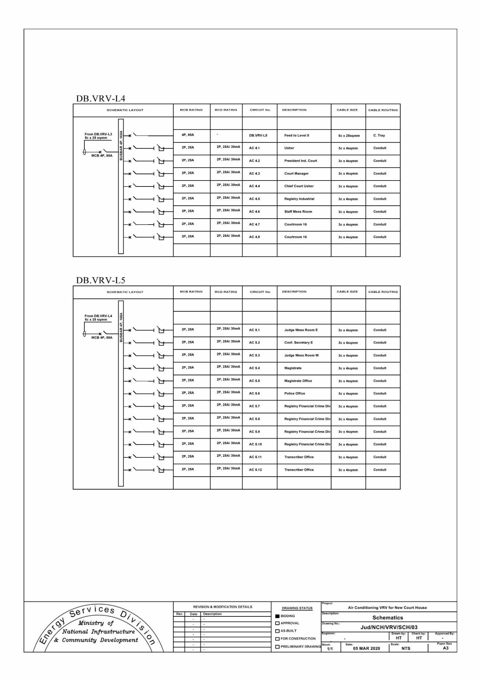
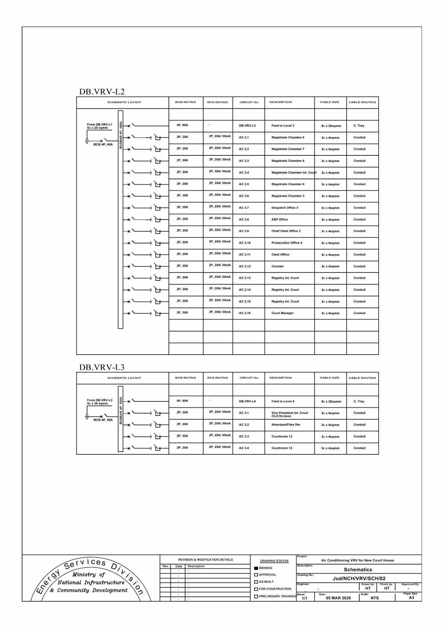

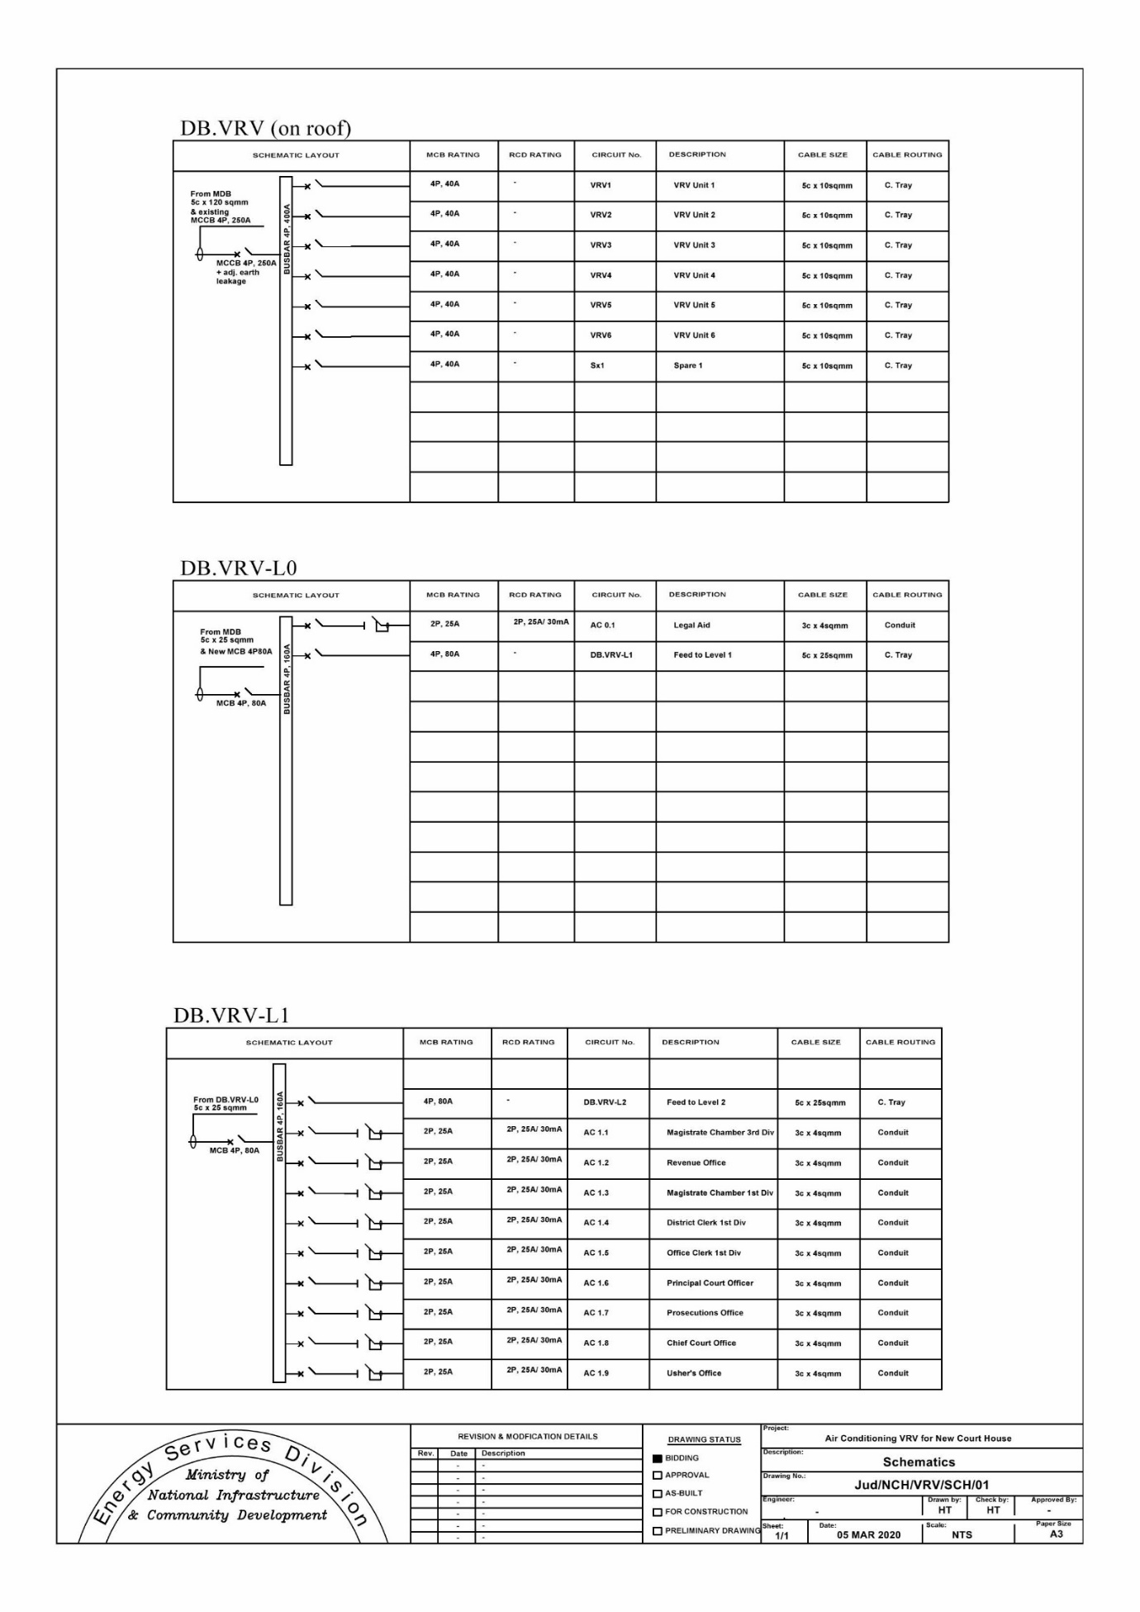

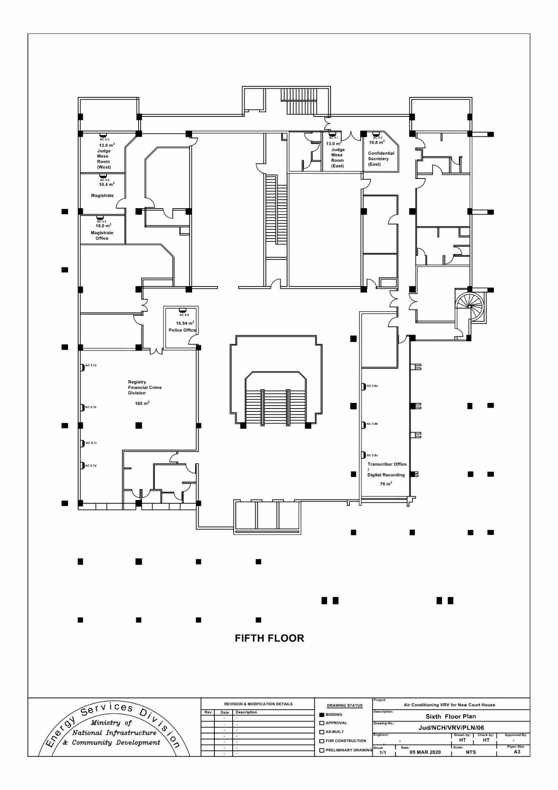

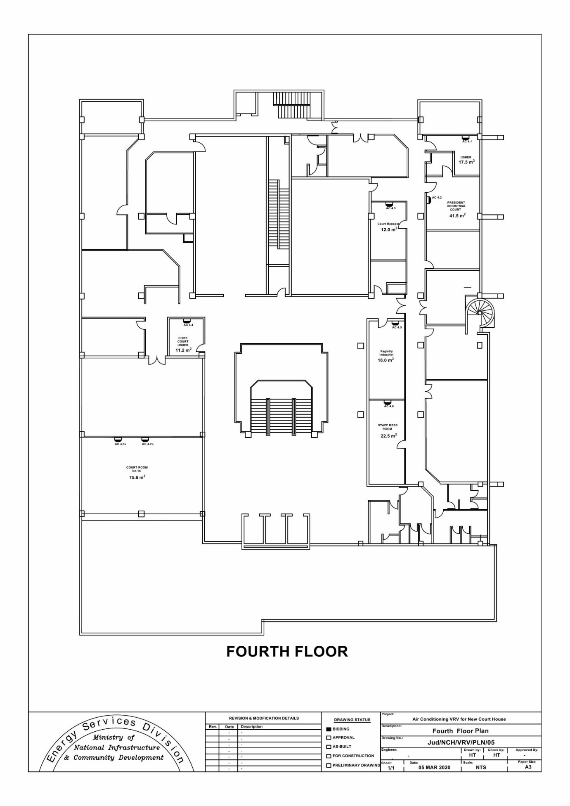

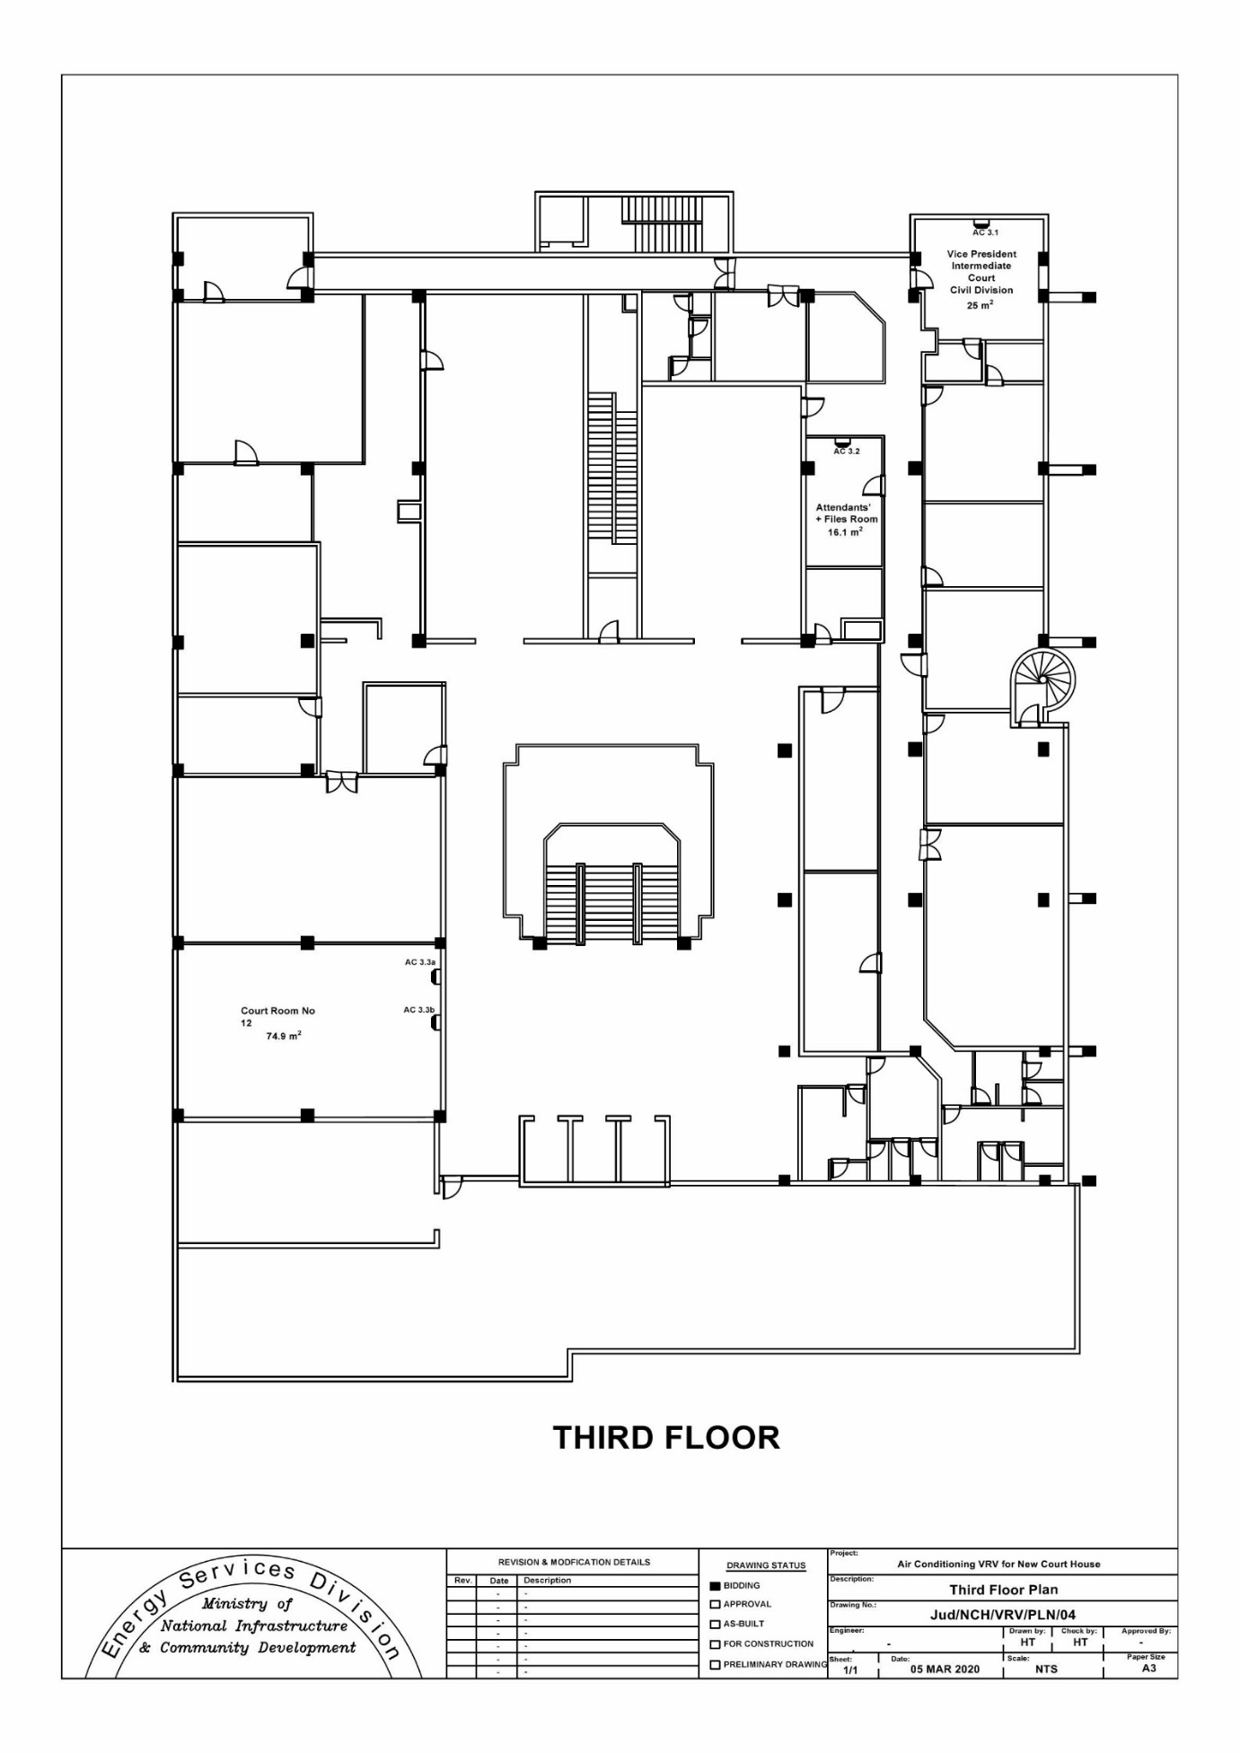

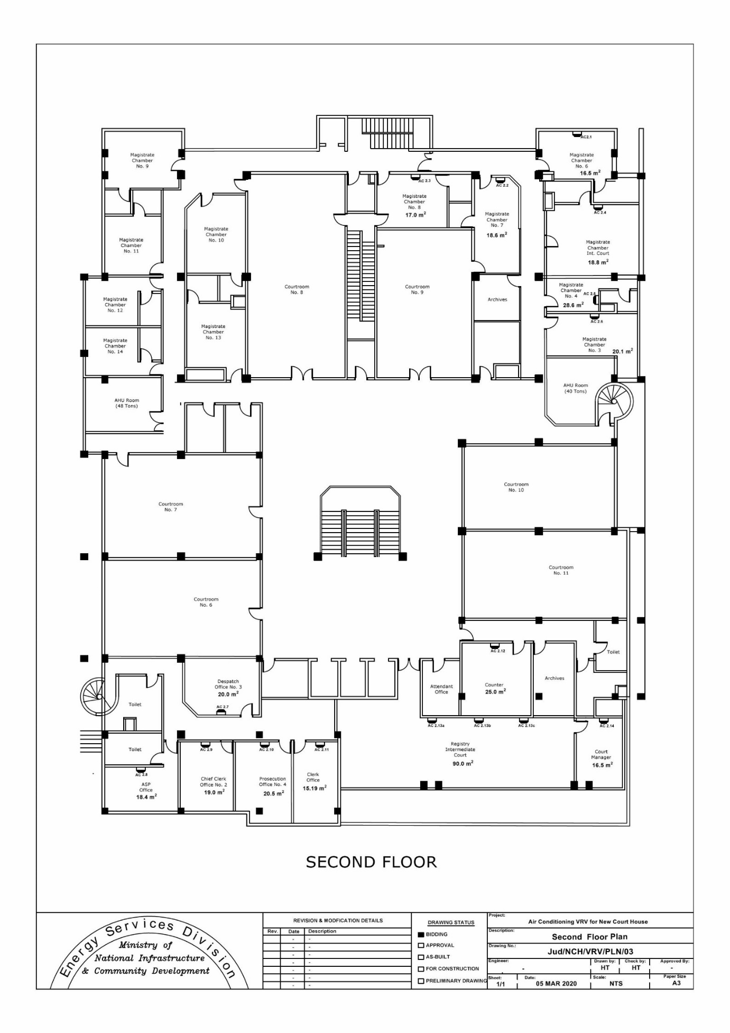

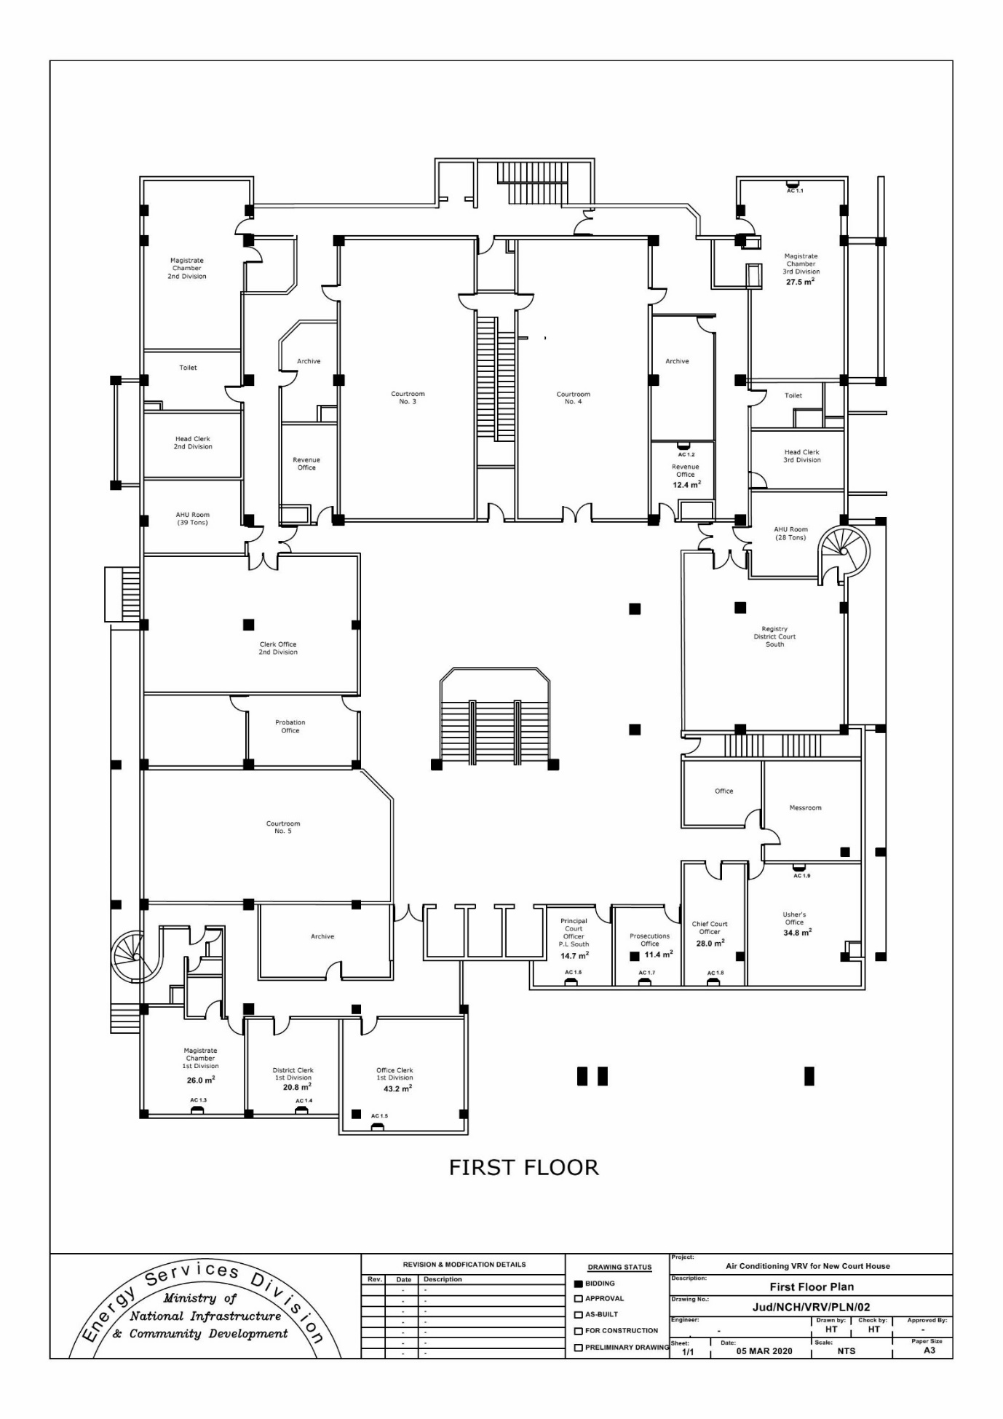

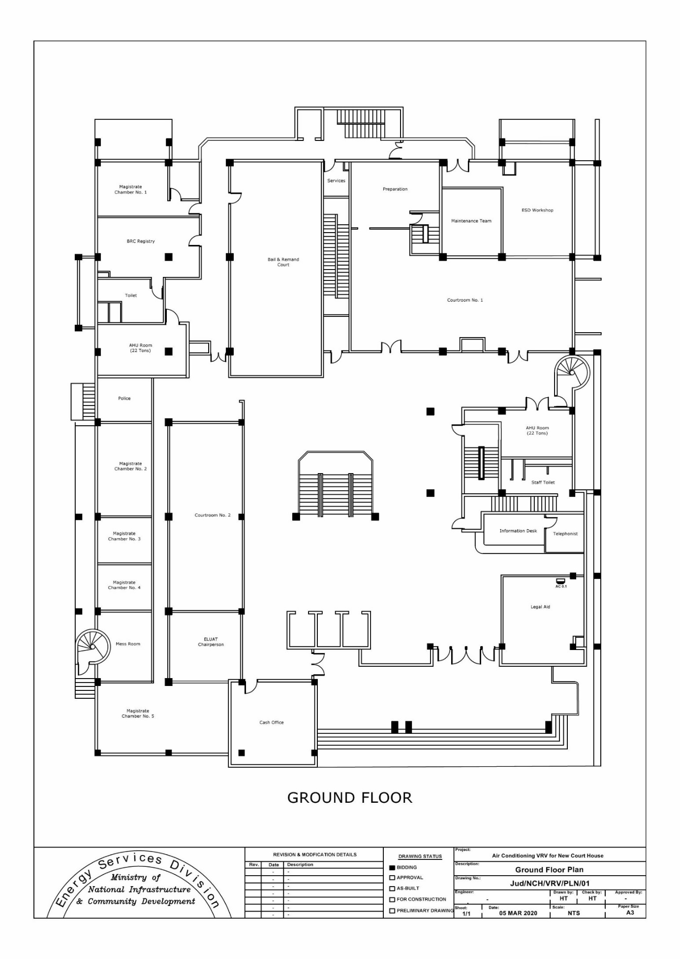

Section IV: General Conditions of Contract and Particular Conditions Of Contract

Any resulting contract shall be placed by means of a Letter of Acceptance and shall be subject to the General Conditions of Contract (GCC),
(Ref: W/GCC10/12-21), for the Procurement of Works (available on website ppo.govmu.org) except where modified by the Particular Conditions of Contract below.
Procurement Reference Number: ONB/10/2021-2022
The clause numbers given in the first column correspond to the relevant clause number of the General Conditions of Contract.

Particular Conditions of Contract
A. General
GCC 1.1 (r) | The Employer is The Judiciary.
GCC 1.1 (v) | The Intended Completion Date for the whole of the Works shall be fourteen (14) months as from Start date.
GCC 1.1 (y) | The Project Manager is The Energy Services Division, Ministry of National Infrastructure and Community Development.
GCC 1.1 (aa) | The Site is located at The New Court House.
GCC 1.1 (dd) | The Start Date shall be fourteen (14) days after handing over of site.
GCC 1.1 (hh) | The Works consist of but not limited to the supply, installation, testing and commissioning of the following:  (a) Supply and installation of Cables, Distribution Boards, Double Pole Switches, cable management and switchgears necessary for the Air Conditioning System  (b) Sizing, Supply and installation of Variable Refrigerant Volume (VRV) systems  (c) Testing & Commissioning.
GCC 2.2 | Sectional Completions are: Not Applicable.
GCC 2.3(i) | The following documents also form part of the Contract: NONE
GCC 3.1 | The language of the contract is English  The law that applies to the Contract is the law of Mauritius.
GCC 5.1 | The Project manager may delegate any of his duties and responsibilities.
GCC 8.1 | Schedule of other contractors: Client´s appointed personnel and contractors for operation and maintenance of Building Services
GCC 13.1 | Except for the cover mentioned in (d)(i) hereunder, the other insurance covers shall be in the joint names of the Contractor and the Employer and the minimum insurance amounts shall be:  (a) for the Works, Plant and Materials: (for the full amount of the works including removal of debris, professional fee etc...)  (b) for loss or damage to Equipment: (for the replacement value of the equipment that the contractor intends to use on site until the taking over by the Employer).  (c) for loss or damage to property (except the Works, Plant, Materials, and Equipment) in connection with Contract Rs.10 Millions  (d) for personal injury or death:  - of the Contractor’s employees: [The Contractor shall take an adequate insurance cover for its employees for any claim arising in the execution of the works].  (ii) of other people: Rs. 15 Millions.  (e) for loss or damage to materials on-site and for which payment have been included in the Interim Payment Certificate, where applicable.  The Contractor shall choose to take the insurance covers indicated above as separate covers or a combination of the Contractor’s All Risks coupled with the Employer’s liability and First Loss Burglary, after approval of the Employer. All insurance covers shall be of nil or the minimum possible deductibles at sole expense of the contractor.
GCC 14.1 | Site Data are: not available.
GCC 20.1 | The Site Possession Date shall be: After signature of Contract Agreement by both parties.
GCC 23.1 &  GCC 23.2 | Appointing Authority for the Adjudicator: No Adjudicator shall be appointed for this Contract.
GCC 24. | In case a dispute of any kind arises between the Employer and the Contractor in connection with, or arising out of, the contract or the execution of works or after completion of works and whether before or after repudiation or other termination of Contract, including any dispute as to any opinion, instruction, determination, certificate or valuation of the Employer’s Representative, the matter in dispute shall, in the first place, be referred in writing to the employer’s representative, with a copy to the other party.  The Employer and the Contractor shall make every effort to resolve the dispute amicably by direct informal negotiation. If, after twenty-eight (28) days, the parties have failed to resolve their dispute or difference by such mutual consultation,  then either the Public Body or the Contractor may give notice to the other party of its intention to refer the matter to  “ the competent courts of Mauritius”
B. Time Control
GCC 25.1 | The Contractor shall submit for approval a Program for the Works within 28 days from the date of the Letter of Acceptance.
GCC 25.3 | The period between Program updates is twenty-eight (28) days.  The amount to be withheld for late submission of an updated Program is 5 % of Contract Amount.
C. Quality Control
GCC 33.1 | The Defects Liability Period is: Three (3) years as from the date of successful commissioning of the Air Conditioning System.
GCC 34.1 | Delete sub-clause 34.1 and replace by the following:  Should any defect arise during the contractual period and up to the end of the Defects Liability Period and the Contractor fails to correct the Defect within the time specified in the Project Manager’s notice, this shall constitute a breach of the Contractor’s obligations under the contract. The Project Manager shall assess the cost of having the defect corrected and recover the money from monies due to the contractor or from the Performance Security.
GCC 39.7 | Interim Payment for Plant and Material on site is not applicable.
D. Cost Control
GCC 40.1 | Amend clause 40.1 by replacing 21 days by 7 and 42 days by 28 days.
GCC 41.1 (l) | Cyclone Class III or above.
GCC 43.1 | The currency of the Employer’s country is: Mauritian Rupees.
GCC 44.1 | The Contract is not subject to price adjustment.
GCC 45.1 | The rate for retention money is 10% of the amount payable to the Contractor.
GCC 46.1 | The liquidated damages for the whole of the Works are 0.5% per week.  The maximum amount of liquidated damages for the whole of the Works is 3% of the Contract price.
GCC 47.1 | The Bonus for the whole of the Works is not applicable.
GCC 48.1 | The Advance Payments shall be: Maximum of 10% of contract value and shall be paid to the Contractor within 7 days after signature of the Contract and submission of the Advance Payment security by the contractor no later than 28 days.
GCC 49.1 | The Performance Security amount is 10% of contract sum.
E. Finishing the Contract
GCC 56.1 | The date by which operating and maintenance manuals are required is prior to commissioning. The date by which “as built” drawings are required is prior to commissioning.
GCC 57.2 (g) | The maximum number of days is: 60 days
GCC 59.1 | The percentage to apply to the value of the work not completed, representing the Employer’s additional cost for completing the Works, is 25%.

Section V- Contract forms

Performance Security

......................Bank/Insurance Company’s Name and Address of Issuing Branch or Office….....................................................

Beneficiary: .............................................Name and Address of Public Body................................................................
Date..............
PERFORMANCE GUARANTEE No.: ..........................................................................................
We have been informed that ..................................[name of the Contractor] ............................ (hereinafter called "the Contractor") has entered into Contract No.............[reference number of the Contract] ............ dated........ with you, for the execution of ......................................[name of Contract and brief description of Works] ....................(hereinafter called "the Contract").

Furthermore, we understand that, according to the conditions of the Contract, a performance security is required.

At the request of the Contractor, we ................................. [name of Bank/Insurance Company] ..................hereby irrevocably undertake to pay you any sum or sums not exceeding in total an amount of .......... [amount in figures (amount in words)] ........................................... such sum being payable in the types and proportions of currencies in which the Contract Price is payable, upon receipt by us of your first demand in writing accompanied by a written statement stating that the Contractor is in breach of its obligation(s) under the Contract, without your needing to prove or to show grounds for your demand or the sum specified therein.

This guarantee shall expire and returned to us not later than twenty- one days from the date of issuance of the Defects Liability Certificate, calculated based on a copy of such Certificate which shall be provided to us, or on the................................day of .................................., .................., whichever occurs first. Consequently, any demand for payment under this guarantee must be received by us at this office on or before that date.

………....................................................Seal of bank/Insurance Guarantee and

Signature(s).............................................................

Advance Payment Security
[Bank’s/ Insurance Company’s Name, and Address of Issuing Branch or Office]

Beneficiary: [Name and Address of Employer]
Date:
Advance Payment Guarantee No.:
We have been informed that . . .. . [name of the Contractor] . . . . . (hereinafter called “the Contractor”) has entered into Contract No. . . . . . [reference number of the Contract] . . . . . dated . . . . . .. . with you, for the execution of . . . . . . [name of contract and brief description of Works] . . . . . (hereinafter called “the Contract”).
Furthermore, we understand that, according to the Conditions of the Contract, an advance payment in the sum . . . . . [name of the currency and amount in figures] ¹. . . . . . (. . .. . [amount in words] . . . . . ) is to be made against an advance payment guarantee.
At the request of the Contractor, we . . .. . [name of the Bank/Insurance Company] . . . . . hereby irrevocably undertake to pay you any sum or sums not exceeding in total an amount of . . .. . [name of the currency and amount in figures] *. . . . . . (. . . . . [amount in words] . . . . . ) upon receipt by us of your first demand in writing accompanied by a written statement stating that the Contractor is in breach of its obligation under the Contract because the Contractor used the advance payment for purposes other than the costs of mobilization in respect of the Works.
It is a condition for any claim and payment under this guarantee to be made that the advance payment referred to above must have been received by the Contractor on its account number . . .. . [Contractor’s account number] . . . . . at . . .. . [name and address of the Bank/Insurance Company] . . . . . .
The maximum amount of this guarantee shall be progressively reduced by the amount of the advance payment repaid by the Contractor as indicated in copies of interim statements or payment certificates which shall be presented to us. This guarantee shall expire, at the latest, upon our receipt of a copy of the interim payment certificate indicating that eighty (80) percent of the Contract Price has been certified for payment, or on the . . . day of . . . . . .. , . . . . . ², whichever is earlier. Consequently, any demand for payment under this guarantee must be received by us at this office on or before that date.
. . . . . . . . . . . . . . [Seal of Bank/Insurance Company and Signature(s)] . . . . . . . . . . . . . .
Note –
All italicized text is for guidance on how to prepare this demand guarantee and shall be deleted from the final document.
1 The Guarantor shall insert an amount representing the amount of the advance payment denominated either in the currency(ies) of the advance payment as specified in the Contract, or in a freely convertible currency acceptable to the Employer.
2 Insert the expected expiration date of the Time for Completion. The Employer should note that in the event of an extension of the time for completion of the Contract, the Employer would need to request an extension of this guarantee from the Guarantor. Such request must be in writing and must be made prior to the expiration date established in the guarantee. In preparing this guarantee, the Employer might consider adding the following text to the form, at the end of the penultimate paragraph: “The Guarantor agrees to a one-time extension of this guarantee for a period not to exceed [six months][one year], in response to the Employer’s written request for such extension, such request to be presented to the Guarantor before the expiry of the guarantee.

Letter of Acceptance

[ on letterhead paper of the Employer]

. . . . . . . [date]. . . . . ..

To: . . . . . . . . .. [ name and address of the Contractor] . . . . . . . . ..

Subject: . . . . . . . . .. [Notification of Award Contract No]. . . . . . . . . . .

This is to notify you that your Bid dated . . . . [insert date] . . . . for execution of the . . . . . . . . . .[insert name of the contract and identification number, as given in the Appendix to Bid] . . . . . . . . . . for the Accepted Contract Amount of .Rs . . . . . . . .[insert amount in numbers and words and name of currency], exclusive of VAT, as corrected and modified in accordance with the Instructions to Bidders is hereby accepted by (insert name of Public Body).

You are requested to furnish the Performance Security in accordance with the General Conditions of Contract, using for that purpose of the Performance Security Form included in Section V (Contract Forms) of the Bidding Document.

Authorized Signature:

Name and Title of Signatory:

Name of Agency:

Attachment: Contract Agreement

Contract Agreement
THIS AGREEMENT made the . . . . . .day of . . . . . . . . . . . . . . . . ., . . . . . . ., between . . . . . [name of the Employer]. . . . .. . . . . (hereinafter “the Employer”), of the one part, and . . . . . [name of the Contractor]. . . . .(hereinafter “the Contractor”), of the other part:
WHEREAS the Employer desires that the Works known as . . . . . [name of the Contract]. . . . .should be executed by the Contractor, and has accepted a Bid by the Contractor for the execution and completion of these Works and the remedying of any defects therein,
The Employer and the Contractor agree as follows:
1. In this Agreement words and expressions shall have the same meanings as are respectively assigned to them in the Contract documents referred to.
2. The following documents shall be deemed to form and be read and construed as part of this Agreement. This Agreement shall prevail over all other Contract documents.
    - the Letter of Acceptance
    - the Bid
    - the Addenda Nos . . . . . [insert addenda numbers if any]. . . . .
    - the Appendix to the General Conditions of Contract
    - the General Conditions of Contract;
    - the Specification
    - the Drawings; and
    - the completed Schedules,
3. In consideration of the payments to be made by the Employer to the Contractor as indicated in this Agreement, the Contractor hereby covenants with the Employer to execute the Works and to remedy defects therein in conformity in all respects with the provisions of the Contract.
4. The Employer hereby covenants to pay the Contractor in consideration of the execution and completion of the Works and the remedying of defects therein, the Contract Price or such other sum as may become payable under the provisions of the Contract at the times and in the manner prescribed by the Contract.
IN WITNESS whereof the parties hereto have caused this Agreement to be executed in accordance with the laws of Mauritius on the day, month and year indicated above.
Signed by: |  | Signed by:
for and on behalf of the Employer |  | for and on behalf the Contractor
in the presence of: |  | in the presence of:
Witness, Name, Signature, Address, Date |  | Witness, Name, Signature, Address, Date

