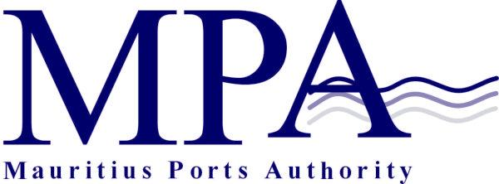
PROCUREMENT NOTICE
OPEN ADVERTISED BIDDING
(Authorised under Section 16 of the Public Procurement Act 2006)
PROVISION OF TRAINING TO CREW AND PILOTS ON TUG OPERATIONS AND TOWAGE (PORT LOUIS HARBOUR)

The Mauritius Ports Authority (MPA) is pleased to invite sealed bids from qualified local and overseas bidders for the Provision of Training to Crew and Pilots on Tug Operations and Towage (Port Louis Harbour), as more fully described in the bidding document.

Bidders, specialized in the field, who are willing to participate in this exercise may contact the office of:

The Manager, Administrative Services
Mauritius Ports Authority
H. Ramnarain Building
Mer Rouge, Port Louis
Republic of Mauritius
Tel: + 230 206 5400
Fax: +230 240 0856
Email: info@mauport.com

A complete set of bidding documents will be submitted to eligible and qualified bidders via email.

Submission of bids
Bid in sealed envelopes clearly marked “Contract MPA 560/2022 – Provision of Training to Crew and Pilots on Tug Operations and Towage (Port Louis Harbour), should be addressed to the Director General, Mauritius Ports Authority, 1st Floor, H. Ramnarain Building, Mer Rouge, Port Louis, Republic of Mauritius.

Deadline for the submission of bids
Bids should be either deposited in the bid box located in the Chief Officer’s Office, Mauritius Ports Authority, 1st floor, H. Ramnarain Building, Mer Rouge,Port Louis, Republic of Mauritius or submitted by registered post or courier so as to reach the Mauritius Ports Authority on or before Tuesday 2 August 2022 up to 14.00 hours (Mauritian time) at latest.

Bids will be opened on the same day at 14.15 hours (Mauritian time) in the presence of bidders or their representatives who choose to attend.

Bids received after the specified closing date and time will not be considered.

The Mauritius Ports Authority reserves the right to accept or reject any bid and to annul the bidding process and reject all bids at any time prior to award of the Contract, without thereby incurring any liability to any Bidder.

Mauritius Ports Authority
H. Ramnarain Building
Mer Rouge, Port Louis
Republic of Mauritius
Tel: +230 2065400
Fax: +230 2400856
Email: info@mauport.com

1 July 2022

